Organisational Behaviour

* Unit I

#### Introduction to Organisational Behaviour

#### Definitions of OB

#### Characteristics of OB

#### Nature of OB

#### Perception

#### Personality

#### Learning

#### Case studies

**INTRODUCTION**

*Organizational Behavior has included two terms in it. Therefore, these two terms should be detailed first before diving into the title in question.*

→ Organization: It is a group of people who are collected to work for a common goal with collective efforts. Organization works through two concepts i.e. coordination and delegation among its group members. Delegation is necessary to allocate group members with equal work according to their capability, and coordination is required to achieve organizational goal with precision.

→ Behavior: It is a verbal or physical response shown by a person as a consequence of the impact of his/her surroundings. Individual Behavior varies in accordance with their mental reactivity to particular circumstances because of their deeply imbibed morals and value system.

→ Organizational Behavior: Organizational Behavior is the observation of individual and/or group Behavior in response to the other individuals or group as a whole. It studies Behavior of people or group to know their attitude towards particular circumstances.

#### Definitions:

*“Organisational behaviour is a subset of management activities concerned with understanding, predicting and influencing individual behaviour in organisational setting.”*

—Callahan, Fleenor and Kudson.

*“Organisational behaviour is a branch of the Social Sciences that seeks to build theories that can be applied” to predicting, understanding and controlling behaviour in work organisations.”*

—Raman J. Aldag.

*“Organisational behaviour is the study and application of knowledge about how people act within an organisation. It is a human tool for human benefit. It applies broadly to the behaviour of people in all types of organisation.”*

— Newstrom and Davis.

*“Organisational behaviour is directly concerned with the understanding, production and control of human behaviour in organisations.”*

—Fred Luthans.

“*Organisational behaviour is a field of study that investigates the impact that individuals, groups and structure have on behaviour within the organisations for the purpose of applying such knowledge toward improving an organization’s effectiveness.”*

—Stephens P. Robbins

* **Fundamental Aspects Of Organizational Behavior:**

There are various aspects of Organizational Behavior which it has to deal with, to know the soul of particular Organization. Below mentioned are some of the fundamental aspects of Organizational Behavior-

1. **People:** This element is the soul of the Organization because people work to achieve the target of Organization and Organization works to fulfill the needs of individual or group of individuals. The word ‘people’ can be anyone who is working inside the Organization, like employees or any external person like supplier, customer, auditor, or any government official.

**2) Structure:** It is the body of the Organization which is to be taken care of to bring coordination between different levels of Organization, because Organization does not work aloof and is dependent on people which again work on the concept of division of labor. So, there is always a hierarchy in Organization which if not properly dealt with can mess the system because of nil scrutiny and flow of control.

#### Characteristics of Organisational Behavior: *From The Above Definitions, The Following Features of Organisational Behaviour Emerge*:

**1. Behavioral Approach to Management:**

Organisational behaviour is that part of whole management which represents the behavioural approach to management. Organisational behaviour has emerged as a distinct field of study because of the importance of human behaviour in organisations.

**2. Cause and Effect Relationship:**

Human behaviour is generally taken in terms of cause and effect relationship and not in philosophical terms. It helps in predicting the behaviour of individuals. It provides generalizations that managers can use to anticipate the effect of certain activities on human behaviour.

**3. Organisational Behaviour is a Branch of Social Sciences:**

Organisational behaviour is heavily influenced by several other social sciences viz. psychology, sociology and anthropology. It draws a rich array of research from these disciplines.

**4. Three Levels of Analysis:**

Organisational behaviour encompasses the study of three levels of analysis namely individual behaviour, inter-individual behaviour and the behaviour of organisations themselves. The field of organisational behaviour embraces all these levels as being complementary to each other.

**5. A Science as well as an Art:**

Organisational behaviour is a science as well as an art. The systematic knowledge about human behaviour is a science and the application of behavioural knowledge and skills is an art. Organisational behaviour is not an exact science because it cannot exactly predict the behaviour of people in organisations. At best a manager can generalize to a limited extent and in many cases; he has to act on the basis of partial information.

**6. A Body of Theory, Research and Application:**

Organisational behaviour consists of a body of theory, research and application which helps in understanding the human behaviour in organisation. All these techniques help the managers to solve human problems in organisations.

**7. Beneficial to both Organisation and Individuals:**

Organisational behaviour creates an atmosphere whereby both organisation and individuals are benefitted by each other. A reasonable climate is created so that employees may get much needed satisfaction and the organisation may attain its objectives.

**8. Rational Thinking:**

Organisational behaviour provides a rational thinking about people and their behaviour. The major objective of organisational behaviour is to explain and predict human behaviour in organisations, so that result yielding situations can be created.

* **Elements of OB**

PEOPLE

(Individual & group)

EXTERNAL ENVIRONMENT

ORGANIZATIONAL STRUCTURE

TECHNOLOGY

**Individual:** The most important element of OB. OB studies the behavioural of individual (or in a group) and the various factors influencing the behavior and its effects on organization.

**Group:** Group can be formal, informal, small, large, official, unofficial in nature. Group is dynamic ever changing in nature.

**Organization structure:** OB establishes various post & positions for people in organization & thus creates a professional relationship in between them.

**Technology:** Use of technology also influences human behavior

**External environment:-** Organization is a part broader external environment. Environment affects the organization through technological or scientific developed, social, cultural and Govt. actions.

* **Disciplines of OB**

Organizational behavior is a applied behavioral science which is drawn from number of behavioral disciplines like:

1. **Psychology:** Psychology is the study and understanding of human mind and thinking and the behavioral aspects based on such thinking. Psychology tries to measure, explain at times even modify the behaviour of human beings & animals. It includes personality, perception, learning, motivation, attitude etc.
2. **Sociology**: Sociology addresses the study of group behaviours. It studies the behaviour of the people in the fellow human beings in a group. It studies how much people are socially active. It includes group dynamics, communication, leadership conflict management, formal and informal organizations etc.
3. **Anthropology**: It is the study of human cultures its history and evaluation. It deals both the development of human values, systems, norms, sentiments etc. It also studies the impact of organizational culture on the behaviour of employees. It deals with individual culture, organizational culture.

Besides these three are some other disciplines such as social psychology, law, economics, practical science, engineering etc.

* **Foundation/Assumptions of OB**

1. **Individual differences**: Each individual differs with each other in different ways like intelligence, physique, personality, thinking behaviour etc and organization has to follow different styles to deal with them and to get the work done. OB begins with individual and studying their distinct behaviour.
2. **A Whole Person**: OB is based the concept that when a person is appointed only his/her skill is not hired but their social background, bikes, dislikes, pride etc, are also hired. Managers should try to develop a work place a home away from none and should focus to provide a better person in terms of growth and development.
3. **Caused Behaviour**: OB lays on the concept that behaviour of individuals towards any other person, thing or a situation is caused due to some reason behind it. Behaviour of the employee depends on thinking of his/ her towards the situation as right or wrong.
4. **Human dignity**: This concept is based on ethical philosophy- at treating human beings differently from other factors of production with complete respect in humanity & dignity not as the economic tool.
5. **Organizations are social systems**: OB treats organizations as the social system having both psychological & social needs & roles like individuals. Two types of social system exist in organizations formal and informal social system and organization environment is dynamic in nature with all the parts of system being interdependent & influenced with each other.

* **Approach to study OB**

1. **Human Resources Approach**: This approach recognize fact that human resources is the central and most important resources of any organization and should be developed towards high competency, creativity so that they can contribute to the success of the organization. This approach is also called supportive approach.
2. **Contingency Approach**: This approach assumes that there is no best way available in any organizational situations and each situation is contingent or influenced by many other variables. Appropriate managerial action on any situation depends on various elements related to that situation.
3. **Systems Approach**: Systems approach vie all its parts or activities as interrelated.
4. **Productivity approach**: Productivity is the ratio output input shows the efficiency and effectiveness of organization. It is expressed in terms of economic inputs and outputs but human and social inputs and outputs are also important OB decision involve human, social and economic issues and so productivity is the significant part of literature of OB.
5. **Internationalism**: Internationalism studies that how people select interpret behaviour in various situations to determine individuals' behaviour.

* **Nature of Organisational Behavior:**

## ****Importance of Organizational Behavior:****

1. It builds better relationship by achieving people, organizational, and social objectives.
2. It covers a wide array of human resource like behavior, training and development, change management, leadership, teams etc.
3. It brings coordination which is the essence of management.
4. It improves goodwill of the organization.
5. It helps to achieve objectives quickly.
6. It makes optimum utilization of resources.
7. It facilitates motivation.
8. It leads to higher efficiency.
9. It improves relations in the organization.
10. It is multidisciplinary, in the sense that applies different techniques, methods, and theories to evaluate the performances.

## ****Limitation of Organizational Behavior:****

1. **Behavioral bias:** It further causes dependence, dis-contentment, indiscipline, and irresponsibility.
2. **Law of diminishing returns:** It says that beyond a certain point, there is a decline in output even after each additional good or positive factor.
3. **Unethical practices and manipulation of people:** Knowledge of motivation and communication acquired can be used to exploit subordinates in an Organization by the manipulative managers.

* **Challenges of OB:**

# Perception

* **Introduction**
* **Test our skills**
* **Definitions**
* **Features**
* **Perception Process**
* **Factors influencing Perception**
* **Importance of Perception**
* **Introduction to Perception**

Perception is the process of gathering, organizing and interpreting the sensory impressions regarding the world. Individuals give the meaning to any event, object or person on the basis of their perception.

* Perception of the individual makes difference in understanding the instances or events and hence the interpretation may be different person to person and even from the objective reality.
* This means that perception is the subjective judgment of nay person towards the environment which can be substantially different from one person to another. For instance, current working environment of nay organization may be satisfactory to some employee whereas may be cause of job turnover to some others
* Some employees may perceive that the organization in which they are currently working can fulfill their expectation whereas that can be too low to that their organization is paying competitive pay and benefits while some others may think it is poor while the reality may be different.
* **In this way, perception can be viewed as the individual way of explaining the environment on the basis of information collected through sensory organs. Perception is a complex cognitive process by which different people interpret the stimulus or situation they are faced with.**

**Test your Perception Skills:-**

* **What do the images show?**
  1. **Is it a 6 or is it a 9?**

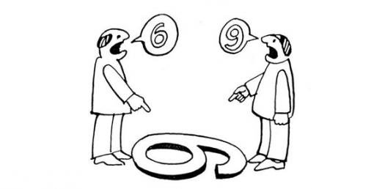

* 1. **What does the image show?**



* 1. **How many sticks do you see?**

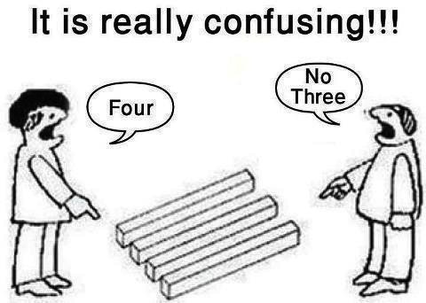

* 1. **Half full or half empty?**

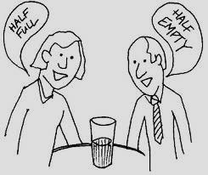

* ***What is Perception?***

1. “The process of selecting, organizing and interpreting information in order to make sense of the world around us.”
2. “the dynamic and complex way in which individuals select information (stimuli) from the environment, interpret and translate it so that a  meaning is assigned which will result in a pattern of behaviour or thought”
3. *Perception is an intellectual process of transforming sensory stimuli to meaningful information. It is the process of interpreting something that we see or hear in our mind and use it later to judge and give a verdict on a situation, person, group etc.*

* **It can be divided into six types**
* **Of sound** − the ability to receive sound by identifying vibrations.
* **Of speech** − the competence of interpreting and understanding the sounds of language heard.
* **Touch** − Identifying objects through patterns of its surface by touching it.
* **Taste** − the ability to receive flavor of substances by tasting it through sensory organs known as taste buds.
* **Other senses** − they approve perception through body, like balance, acceleration, pain, time, sensation felt in throat and lungs etc.
* **Of the social world** − It permits people to understand other individuals and groups of their social world.

***Example*** *– “A” goes to a restaurant and likes their customer service, so she will perceive that it is a good place to hang out and will recommend it to her friends, who may or may not like it. “A’s” perception about the restaurant is good.*

## Features of Perception in OB

Perception is the way of interpreting the events or information received from environment. From above discussion, we can summarize the following features of perception:

1. **Psychological or cognitive process:** Perception is purely mental process in which individual receives information from environment filters them on the basis of cognition. Perception is basically learning process.
2. **Individual indifference:** Perception may be different person to person as it is based on individual psychology and way of interpretation. Same thing, person or event may be favorable to some while unfavorable to some other person. This is because of way of thinking and interpreting the stimuli.
3. **Different from reality:** Perception may be different from real world. Individual make perception on the basis of what she/he thinks about the reality but not on the basis of reality itself. For instance, most of us perceive that sun rises in the east and sets in the west but the reality is neither sun rises not it sets. Neat and tidy people are perceived as good human but reality may be different.
4. **Affected by motivation and personality:** Perception is affected by motivation of individual and personality. Individual perceive what they want to perceive. Personality of the people is backed by knowledge and hence the perception is also affected by level of knowledge.
5. **Perception can be developed:** Perception can be developed or changed through learning. Formal education, training and experience improve and even sometimes change the perception of the individual.
6. **Basis of individual behavior:** Behavior of individual is backed by perception. No behavior can be expected without perception. Individual show the behavior as she/he perceives about event, object or person.

* **Perception Process**

### Receiving

Receiving is the first and most important stage in the process of perception. It is the initial stage in which a person collects all information and receives the information through the sense organs.

### Selecting

Selecting is the second stage in the process. Here a person doesn’t receive the data randomly but selectively. A person selects some information out of all in accordance with his interest or needs. The selection of data is dominated by various external and internal factors.

* **External factors** − the factors that influence the perception of an individual externally are intensity, size, contrast, movement, repetition, familiarity, and novelty.
* **Internal factors** − the factors that influence the perception of an individual internally are psychological requirements, learning, background, experience, self-acceptance, and interest.

Individualsgenerally do not assimilate each and everything they observe, as they observe so they engage in process of selectivity. Selection is the fundamental step in perceptual process. Individual collects bits and pieces of information, not randomly, but selectivity depending on the interests, background, experience, attitudes, etc.

Selective perception process involves two psychological principles:

1. **Figure Ground Principle.** In thefield of perception, certain factors are considered significant which give a meaning to the person, and certain other which are either unimportant for a person or cannot be studied are left as insignificant. The meaningful and significant portion is called the “figure” and the insignificant or meaningless portion is labeled as the “ground”.

Figure-ground perception refers to the tendency of the visual system to simplify a scene into the main object that we are looking at (the figure) and everything else that forms the background (or ground). The concept of figure-ground perception is often illustrated with the classic "faces or vases" illusion, also known as the Rubin vase. Depending on whether you see the black or the white as the figure, you may see either two faces in profile (meaning you perceive the dark color as the figure) or a vase in the center (meaning you see the white color as the figure).





* 1. **Relevancy.** Relevancy is an important criterion for selective perception. People selectively perceive things that are relevant to their needs wants, and desires.

### Organizing

Keeping things in order or say in a synchronized way is organizing. In order to make sense of the data received, it is important to organize them.

We can organize the data by −

* Grouping them on the basis of their similarity, proximity, closure, continuity.
* Establishing a figure ground is the basic process in perception. Here by figure we mean what is kept as main focus and by ground we mean background stimuli, which are not given attention.
* Perceptual constancy that is the tendency to stabilize perception so that contextual changes don’t affect them.

The perceived inputs (incoming stimuli) are organised into meaningful pictures to the perceiver. Organising the information that is incoming into a meaningful whole is called “organisation”. This process is also labeled as “gestalt process”. Gestalt is a German word meaning, “to organise”. There are different ways by which people organise the perceived inputs, object events, e.g., grouping, closure and simplification.

1. **Grouping.** Grouping is possible depending on the similarity or proximity. The tendency to group people or things that appear to be similar n certain ways, but not in all, is a common mean of organising the perception.
2. **Closure.** Peoplewhen faced with incomplete information have a tendency to fill in the gaps themselves. When presented with a set of stimuli that are incomplete, people fill in the missing parts and make it more meaningful. The tendency to organise perceptual stimuli so that they form a complete message is known as ‘closure’.
3. **Simplification.** Whenever people are overloaded with information they try to simplify it to make more meaningful and understandable. Simplification occurs when the perceive subtracts less salient information and concentrates on important one.

### Interpreting

Finally, we have the process of interpreting which means forming an idea about a particular object depending upon the need or interest. Interpretation means that the information we have sensed and organized is finally given a meaning by turning it into something that can be categorized. It includes stereotyping, halo effect etc.Interpretation isan important mechanism of perception. It is a subjective and judgmental process and is influenced by many factors such as halo effect, stereotyping, attribution, impression and inference, projection etc. These may also lead to perceptual distortion.

1. **Halo effect.** It is the processof using a single trait of individual and drawing a general impression about him. It has an important implication for evaluation employees in an organisation. These employees with certain features are rated highly on other characteristics also. But halo effect leads to negative effects also.

**The halo effect is more marked:**

1. When the traits to be perceived are unclear in behavioral expressions.
2. When the perceived does not frequently use the traits.
3. When the traits have moral implications.

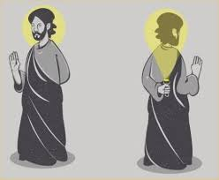

For instance, a stunning blonde female candidate for personal secretarial position may be viewed by male interviewers as an intelligent and highly skilled in typing. The fact may be that she is dull and poorly skilled in typing and stenography. What really happened here is that a single trait i.e., beauty has outclassed other traits and the interviewer generalized the other traits and perceived her to be beautiful in typing also? Halo effect is also labeled as halo error, because it causes the full appraisal to be biased one. To take some more examples, the worker who is always fifteen minutes early is perceived by the boss to be competent; the attentive student is perceived by the professor to be learning a lot significant.



1. **Stereotyping.** It meansjudging people on the basis of the characteristics of the group. According to Lippmann” stereotyping” is not simply the assignment of favorable or unfavorable traits perception.

The basic advantage of stereotyping is that it helps the perceiver to simplify the complexity of the perceived world. The trouble with stereotyping is that when we perceive people as members of a particular group or category, we do not recognize them as individual; we do not see their unique characteristics and problems.

Stereotyping is particularly critical when meeting new people, since we know so little bout them and we tend to characterize them according to certain categories on the basis of age, sex, occupation, caste, religion and ethnic background.

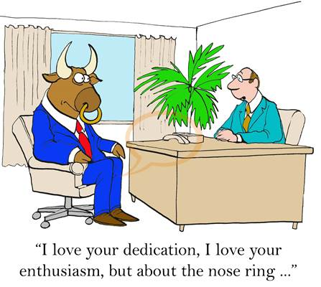

**Other factors for interpretation**

1. **Attribution.** Whenpeople given cause and effect explanation to their behaviour, it is known as attribution.
2. **Impression.** People often form impression of others on the first sight. Even before knowing any of their personality traits they start having impression and assessing. This sometimes leads to perceptual distortion. We shall discuss this aspect later in detail.
3. **Inference.** There is a general tendency on the part of people of judges other on limited information. For example, an employee might be sitting at his desk throughout the working hours without doing anything an employee might be sitting at his desk throughout the working hours without doing anything but it may be inferred that he is hardworking.
4. **Projection.** It is veryeasy to judge others if we assume that they are similar to us. For example, if we want freedom, challenge and responsibility in our job, we assume that other people is want the same. This tendency to attributes one’s on characteristics and attributes to other people is called as projection. It is to be noted that when manager engage themselves in projection, they compromise their ability to respond to individual differences. They tend to see people as more homogenous than they really are.

* **Perceptual Selectivity :**

1. **Self-concept:** The way a personviews the world depends a great deal on the concept or image he has about himself.
2. **Beliefs.** Aperson’s beliefs have profound influence on his perception which means that a fact is conceived not on what it is but what a person believes it to be.
3. **Expectations: -** Expectations are related with the state of anticipation of a particular behaviour from a person. Even in the organizational setting, expectations affect people’s perception.
4. **Inner Needs.** A person’s perception is determined by his inner needs. The need is a feeling of tension or discomfort when one thinks he is missing something own when he feels he has not quite closed a gap in his knowledge.
5. **Response Disposition.** Response disposition refers to a person’s tendency to perceive familiar stimuli rather than unfamiliar ones.
6. **Perceptual Defense.** It refers to thescreening of those elements, which create conflict and threatening situation in people.
7. **External factors.** Perceptual selectivity is also affected by external characteristics of stimulus situation, whether person or thing. Various factors such as intensity, size, contrast, repetition, motion, and novelty and familiarity affect he selectivity by forcing the subject to take, or not to take, attention to these objectives.
8. **Perceptual Distortion.** Perceptual distortion is a position where the person does not perceive the thing, particularly person, as it may be.

* **Factors Influencing Perception**

Stimuli play a significant role in the perceptual procession as various factors relating to the perceptual process have been studies by various experts. The factors influencing perceptions are perceiver characteristics, objects and situation. However, they can be categorized under specific heads such as perceive characteristic, internal and external factors, stimuli factors etc.

1. **Perceive Characteristics**

Perception depends upon how an individual views the objects and situations. Some employees may perceive the work place as incorporating favorable working conditions, while others may perceive it as a place of good pay. The perception is not always actual or accurate; however it is the viewing of the reality which differs from person to person according to their respective characteristics.

The perception of the object are influenced not only by individual characteristics but also by the characteristics of the employees, the manager’s personality and employees views on the basis of perception of the work place.

The characteristics of employees such as attitude, motives, interests, habits, experience, values, expectations, learning and personality, have a bearing or great influence on formation of perception.

1. **Influence of Internal External Factors**

There are number of external and internal factors which influences the perception and these are discussed below:

1. **Internal Factors.** The internal factors like needs and desires of individuals, individual personality influencing perception include and the experience of people.
2. **Needs and desires.** Dependingon the needs and desires of an individual, the perception varies.
3. **Personality.** Individualpersonality has a profound influence on perceived behaviour as for example.
4. Secure individuals tend to perceive others as warm, not cold.
5. Individuals do not expose by expressing extreme judgments of others.
6. Persons who accept themselves and have faith in their individuality perceive things favorably.
7. Self-accepting individuals perceive themselves as liked, wanted and accepted by others.

The age, sex, race, dress. If the perceiver is female and the stimulator is made, the perceiver gets some influence only if she prefers male. Otherwise, the perception will be distorted. The ethnic personalities have some influence on perception.

1. **Experience.** Experienceand knowledge has great influence on perception. Successful experience enhances and boosts the perceptive ability and lead to accuracy in perception of a person whereas failure erodes self-confidence. A young employee takes time to understand the object and situation. Experienced employees generally understand objects quickly and correctly. But, in contradictory situations, it is difficult to correct aged employees, whereas the young employees are easily moulded towards achieving the objectives of the organisation.
2. **External Factors.** The external factors, which influence the perception are ; size, intensity, frequency, status, etc.
3. **Size.** The bigger thesize of the perceived stimulus, the higher is the probability that it is perceived. Size attracts the attention of an individual. It establishes dominance and enhances perceptual selection. The maintenance staff may pay more attention to a big machine then to a small one, even though smaller one costs as much and in as important to be operation. In advertising, full page spread attracts more attention than a few lines in the classified sections.
4. **Intensity.** Researches on human behaviour have revealed that the more intense the stimuli the higher attention and recognition in the perceptual process. A strong voiced Manager has more impact on supervisors and employees. It observed that managers use voice modulation to get attention of employees. Intensity attracts to increase the selective perception. Advertisers users intensity to gain customer’s attraction. The intensity varies as per need of the organisation. The same type of intensity may not be useful for all the situations and objects.
5. **Frequency.** Repeatedexternal stimulus is more attention attracting than a single time. Managers send reminders regularly to reprimand the behaviour of erring employees. As advertises also repeat the advertisement to bring it to notice of customers.
6. **Status.** Perception is also influenced by the status the perceiver. High status people can exert greater influence on perception of an employee than low status people.
7. **Contrast.** Stimuli thatcontrast with the surrounding environment are more likely to be attention catching than the stimuli that blend in.

Fig. illustrates the note of perceptual principle. The black circle on the right appears larger than the one on the left because of the background circles. In fact both black circles are of the same size. In a similar manner, plant safety sings which have black lettering on a yellow background or white lettering on a red background are attention drawing. Training managers utilize this factor in organizing training programs in places for away from work places to create contrast atmosphere.

1. **Nature.** By nature we mean, whether the object in visual, auditory etc. It is commonly known that pictures attract attention more readily than words. Further a picture with human beings attracts more attention than a picture of inanimate objects. A rhyming auditory passage attracts attention more readily than the same passage presented as a narrative.
2. **Stimulus Factors :**

It is important to discuss the various factors associated with stimulus which influence the perception by individuals and these are discussed below.

1. **Similarity.** Otherthings being equal, similar things tend to be perceived as belonging together. For instance, all students with long hair and bearded may be perceived as revolutionaries.

**Principle of Similarity**

Everybody perceives two sets of four squares and one set of four circles in mentioned above Seldom people will say two horizontal lines, each consisting of squares and circles.

1. **Proximity: -** Otherthing being equal, thing near each other tends to be perceived as belonging together.

**Principle of Proximity**

The usual perception is three rows of four circles rather than four columns of three circles in mentioned above

1. **Continuity.** Stimuli that forma complete or symmetrical figure or good form tend to be grouped as parts of a whole.

**Principle of Continuity**

The above arrangement of circles is usually perceived a hexagonal object rather than three rows of two each in mentioned above

1. **Context.** Theenvironment or the setting of an object often determines how a thing will be perceived. A classic example found in most psychology books is the reversible figure is a vase or goblet. It the background is seen as white, the figure is two black profiles. This is also known as Figure Ground Principle.

The figure ground principle states that the relationship of a target to its background influences perception. In other words, perceived objects stand out as separable from their general background.

* **Attribution THEORY:**

When people attach cause-and-effect explanation to their behaviour, it is known as attribution. The more directly the particular action is attributable to the behaviour the more is the intensity f perceptual judgment by a manger.

Attribution is an important factor in perception because it creates a tendency to visualize identical behaviours differently.

For instance, if two employees arrive in the office one hour late, one explains late due to scooter repair on route, other attributes the hospitalization of his wife. Manager evaluates these two situations differently and is generally convinced by the case than the repair of the scooter.

Attribution Theory has been proposed to develop explanation of the ways in which we judge people differently, depending upon on what incoming we attribute to a given behaviour. According to this theory the judgment depends largely on three factors:

**(i) Distinctiveness**

**(ii) Consensus, and**

**(iii) Consistency.**

* **Glimpse of attribution theory**

When individuals observe the behavior of others, they attempt to explain this behavior by determining its cause (s). We can make either internal attribution (personality, skills, motivation) or external attributions (luck, politics, situational constraints). Attribution Theory explains when we are likely to make internal versus external attribution. Internal attributions are likely when:

1. The behavior is **Distinctiveness,** that is, do we observe the same behavioral pattern in a variety of situations or contexts (e.g., at work, at parties, etc.)?
2. There is **Consensus**, when the behaviour is different from that of others in the same situation.
3. We observe **Consistency** in the behavioral pattern across time.
4. We do not see any viable external (situational) causes of the behaviour **(Externality).** AttributionTheory also suggests that we tend to make three typical attribution errors. These are:

* **Fundamental Attribution Error-** tends to attribute behaviour to internal rather than external causes, even when the cause is situational in nature.
* **Actor-Observer Error-** tends to attribute the behaviour of other to internal causes and the attribute our own behaviour to external causes.
* **Self-serving Error-** We tend to take credit for successes (self-internal attribution), and blame failures on others, fate, bad luck, or factors beyond our control (self-external attribution).

**Some Organisational Implications of Attribution Biases**

Biased assessments of others and of ourselves can occur in many ways in organisational situations. A work group is likely to blame other groups or departments when failure occurs on the job. Here, the self-serving bias is not very conducive to cooperation between groups to behaviours that try to find the true cause of failure. Performance appraisal is another situation where attribution biases operate. The attribution errors can create serious disagreement amongst the various raters about what they perform well or poorly.

## Importance of Perception in OB

(i) Perception is very important in understanding the human behaviour, because every person perceives the world and approaches the life problems differently- Whatever we see or feel is not necessarily the same as it really is. It is because what we hear is not what is really said, but what we perceive as being said. When we buy something, it is not because it is the best, but because we take it to be the best. Thus, it is because of perception, we can find out why one individual finds a job satisfying while another one may not be satisfied with it.

(ii) If people behave on the basis of their perception, we can predict their behaviour in the changed circumstances by understanding their present perception of the environment. One person may be viewing the facts in one way which may be different from the facts as seen by another viewer.

(iii) With the help of perception, the needs of various people can be determined, because people’s perception is influenced by their needs. Like the mirrors at an amusement park, they distort the world in relation to their tensions.

(iv) Perception is very important for the manager who wants to avoid making errors when dealing with people and events in the work setting. This problem is made more complicated by the fact that different people perceive the same situation differently. In order to deal with the subordinates effectively, the managers must understand their perceptions properly.

Thus, for understanding the human behaviour, it is very important to understand their perception, that is, how they perceive the different situations. People’s behaviour is based on their perceptions of what reality is, not on reality itself. The world as it is perceived is the world that is important for understanding the human behaviour.

**Personality**

* **Introduction**
* **Traits**
* **Characteristics**
* **Theories Of Personality**

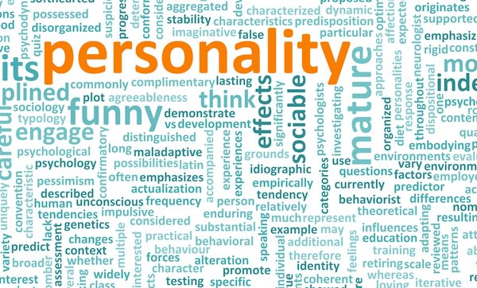

**The word personality is derived from a Greek word *“persona”* which means “to speak through.” Personality is the combination of characteristics or qualities that forms a person’s unique identity. It signifies the role which a person plays in public. Every individual has a unique, personal and major determinant of his behavior that defines his/her personality.**

* **Personality trait is basically influenced by two major features –**

**1. Inherited characteristics:** The features an individual acquires from their parents or forefathers, in other words the gifted features an individual possesses by birth is considered as inherited characteristics. It consists of the following features −

* Color of a person’s eye
* Religion/Race of a person
* Shape of the nose
* Shape of earlobe

**2. Learned characteristics:** Nobody learns everything by birth. First, our school is our home, then our society, followed by educational institutes. The characteristics an individual acquires by observing, practicing, and learning from others and the surroundings is known as learned characteristics.

Learned characteristics includes the following features −

* **Perception** − Result of different senses like feeling, hearing etc.
* **Values** − Influences perception of a situation, decision making process.
* **Personality** − Patterns of thinking, feeling, understanding and behaving.
* **Attitude** − Positive or negative attitude like expressing one’s thought

## Traits of Personality:

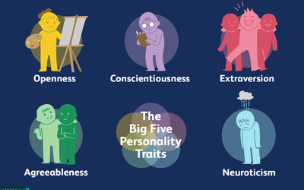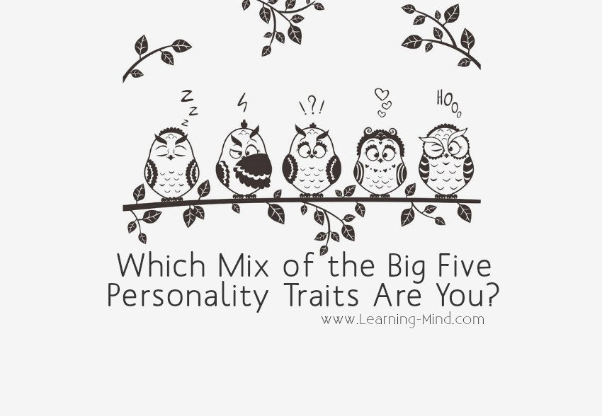

Personality traits are the enduring features that define an individual’s behavior. A personality trait is a unique feature in an individual. Psychologists resolved that there are five major personality traits and every individual can be categorized into at least one of them. These five personality traits are −

* Extrovert
* Neurotic
* Open
* Agreeable
* Conscientious

That makes someone who they are? Each person has an idea of their own personality type — if they are bubbly or reserved, sensitive or thick-skinned. Psychologists who try to tease out the science of who we are defining personality as individual differences in the way people tend to think, feel and behave.

There are many ways to measure personality, but psychologists have mostly given up on trying dividing humanity neatly into types. Instead, they focus on personality traits.

The most widely accepted of these traits are the Big Five:

* Openness
* Conscientiousness
* Extraversion
* Agreeableness
* Neuroticism

The Big Five were developed in the 1970s by two research teams. These teams were led by Paul Costa and Robert R. McCrae of the National Institutes of Health and Warren Norman and Lewis Goldberg of the University of Michigan at Ann Arbor and the University of Oregon.

The Big Five are the ingredients that make up each individual's personality. A person might have a dash of openness, a lot of conscientiousness, an average amount of extraversion, plenty of agreeableness and almost no neuroticism at all. Or someone could be disagreeable, neurotic, introverted, conscientious and hardly open at all. Here's what each trait entails:

## Openness



Openness is shorthand for "openness to experience." People who are high in openness enjoy adventure. They're curious and appreciate art, imagination and new things. The motto of the open individual might be "Variety is the spice of life."

People lows in openness are just the opposite: They prefer to stick to their habits, avoid new experiences and probably aren't the most adventurous eaters. Changing personality is usually considered a tough process, but openness is a personality trait that's been shown to be subject to change in adulthood.

## Conscientiousness



People who are conscientious are organized and have a strong sense of duty. They're dependable, disciplined and achievement-focused. You won't find conscientious types jetting off on round-the-world journeys with only a backpack; they're planners.

People low in conscientiousness is more spontaneous and freewheeling. They may tend toward carelessness. Conscientiousness is a helpful trait to have, as it has been linked achievements

## Extrovert



Extraversion is possibly the most recognizable personality trait of the Big Five. The more of an extravert someone is, the more of a social butterfly they are. Extraverts are chatty, sociable and draw energy from crowds. They tend to be assertive and cheerful in their social interactions.

Introverts, on the other hand, need plenty of alone time.Introversion is often confused with shyness, but the two aren't the same. Shyness implies a fear of social interactions or an inability to function socially. Introverts can be perfectly charming at parties — they just prefer solo or small-group activities.

## Agreeableness

Agreeableness measures the extent of a person's warmth and kindness. The more agreeable someone is, the more likely they are to be trusting, helpful and compassionate. Disagreeable people are cold and suspicious of others, and they're less likely to cooperate.

## Neuroticism

People high in neuroticism worry frequently and easily slip into anxiety and depression. If all is going well, neurotic people tend to find things to worry about.

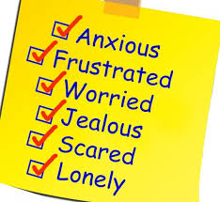

.

* **Characteristics –**

**The following elements should form the meaning of personality.**

1. Personality has both internal and external elements. The external traits are the observable behaviours that we notice in an individual. Personality internal states represent the thoughts values & genetic characteristic that we infer from the observable behaviours.

2. An individual’s personality is relatively stable. If it changes at all, it is only after a very long time or as the result of dramatic events.

3. An individual’s personality is both inherited as well as shaped by the environment our personality is partly inherited generically from our parents. However these genetic personality characteristics one altered somewhat by life experiences.

4. Each individual is unique in Behaviour. There are striking differences among individual.

Thus personality refers to the sum total of internal & external traits of the individual which are relatively stable & which make the individual different from others.

* **Personality factors/ determinants of Personality**
* Biological factors

• Heredity

• Brain

• Physical features

* Family & social factors
* Situational factors

• Culture

• Religion

* Other factors

• Temperament

• Interest

• Character

• Schema

• Motives

**Biological Factors**

**a. Heredity: It** has a great influence on biological and mental features. It means the transmission of the qualities from ancestor to descendant through a mechanism lying primarily in the chromosomes of germ cells. Physical stature facial attractiveness, sex, temperament, muscle composition, reflexes are inherited from one’s parent.

**b. Brain:** There is a general feeling that brain plays an important role in development of one’s personality persons with a broader forehead, big right hemisphere i.e. left handed have a learning towards truth, welfare beauty, justice, kindness artistic, emotional musician poet etc, similarly persons having broader left hemisphere i.e. right handed with sharp nose, big ears are logical, analytical, strong & have criminal

**c. Physical features**: An individual’s external appearance may have a tremendous effect on his personality. Some people give relatively higher weightage to the physical features of an individual while defining his personality. Such factors include height, weight, colour, facial features. Eg: - Good physical appearance is an asset for the job of a sales person & public relations.

**Family & Social factors:**

The family has considerable influence on personality development, particularly in early stages children learn from their parents, siblings etc.

• The mother is the first teacher in initiating personality development. Father motivates & modifies behaviour. Eg:- Mother - dressing, cooking, sense, father - driving

• Family and social factors shape a person’s personality through the process of socialization and identification. Socialization is a process by which an infant acquires, from the enormously wide range of behavioral potentialities that are open him at birth, those behaviour patterns that are customary & acceptable to family & social group.

• The identification process occurs when a person tries to identify himself with some person whom he feels ideal in family, generally a child in the family tries to behave like his father or mother.

**E.g.:-** of impact of socio economic factors on personality child nurtured under a warm, loving stimulating environment are positive & active as compared to children neglected by their parents are.

**Situational factors:**

An individual’s Personality may change in different situations. The demand of different situation may call for different aspects of one’s personality therefore we should not look at the personality factor in isolation.

a. Culture: The accepted norms of social behaviour are referred as cultural. The way in which people behave with others & the driving force of such functions are considered important components of culture children brought up in traditional norms, attitudes & values on the other hand. Modern cultural outlook of family & society has inspired children to become independent, free thinking of self-developing. (Ex of joint & nuclear family)

b. Religion: Religion plays a significant sole in shaping one’s personality from those of Muslims & Christians. The children in Hindu Societies learn from the very childhood learn about the value of Karma (hard work) and God-feasting attitudes.

The Protestants are taught about work ethics, family system, friendship & cooperation

The Sikh are hardworking, dogmatic aggressive.

The Muslims are ready to undertake any job & vocation & acquire personalities.

**Other factors**

**a. Temperament:** Temperament and other non-intellectual personality traits are distributive according to normally distribution. Temperament is the degree to which one responds emotionally.

**b. Interest:** The individual normally has many interests in various areas. The top executives in any organization do not have interest in common task and people. The organization should provide opportunities like job rotation & job enrichment & special training programmer to satisfy the Interest of executives.

**c. Character**: Character primarily means honesty & integrity. It is resistance to stealing and cheating others. Character integrity & morals of high standards is a very important requirement for responsible jobs. It is likely that an individual may not steal under normal circumstances for ex: If the family of an individual is starving, there is a great probability that one will steal.

**d. Schema**: It is an individual’s belief, frame of reference, perception and attitude which the individual possesses towards the management, the job, working conditions pay, fringe benefits, incentive system etc. The perception of individual depends upon his socio-economic conditions & particular culture he lives to follow. The Behaviour of an individual depends to a great extent upon his form of reference which he develops from childhood experience.

**e. Motives:** Motive is inner drives of individual. They represent goal directed behaviour of individual. A motive is a cognitive factor which operates in determining one’s behaviour towards a goal.

**Theories of Personality**

**A. Psycho Analytic Theory**

This theory was developed by Sigmund Freud

This theory is based on unconscious nature of personality, i.e. man is influence by unseen forces.

Freud saw that personality is composed of three elements:-

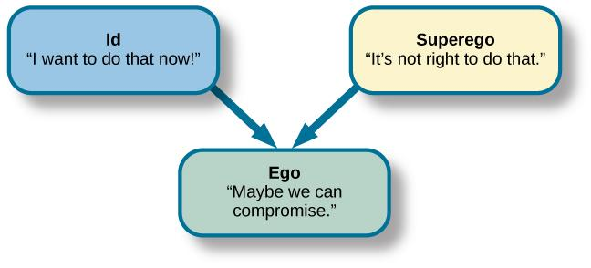

**The ID: -** Word ‘ID’ is the Latin word for ‘IT’ and refers to innate component of personality.

The ‘ID’ is the mental agency contains everything inherited and fixed & present in individual which is raw, animalistic, unorganized, knows no laws, rules and free from all in inhibitors & remains basic to individual throughout life.

ID helps to rid the personality out of tension through reflex actions & primary process refers to attempt of an individual to form a mental image of the object that will remove tension.

**Ex: -** Hungry man experiences partial relief of his hunger by imagining a delicious meal.

In reflex actions the ID responds automatically to sources of irritation by promptly removing the tension which irritant elicits.

**Ex: -** Coughing, Sneezing, Blinking etc.

**The EGO:** - Ego means development of the person out of the ID in order to deal with the real world.

**Ex: -** Man needs good to satisfy the hunger.

**The Super EGO: -** Super Ego third part of personality represents values and morals of society as taught to the child by parents and others super Ego judges whether an action is right or wrong according to the standards of society.

ID seeks pleasure, EGO test reality and super Ego strives for perfection. 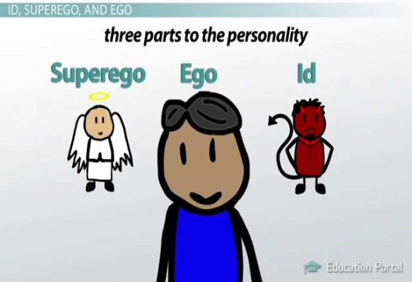

B. **Trait Theory**

Trait is a relatively enduring cross – situational consistent personality characteristic that is inferred from a person’s behavior. It is a predisposition to understand or to respond in an equivalent manner to various kinds of stimuli.

Personality traits are the reactions, of persons in different situational interaction. Under trait theory personality of individuals are determined & classified on the basis of certain set of features such as intelligence, emotional stability, aggressiveness, creativeness or any other dimensions.

**There are two ways of assessing personality traits:-**

1. The person describes himself by answering questions about this attitude, feelings and behaviours. (Personal Inventory)
2. Someone else evaluates the person’s traits either from what he knows about the individual or from direct observation of behaviour. (Rating scale Method)

Under personal inventory a questionnaire is been answered by an individual containing questions which can be rated to determine single dimension of personality or several personality traits (introvert & extrovert).

* **Humanistic Approach**

**1. Rogers Self Theory: -** Rogers approach to personality is described as phenomenological. Phenomenology is the study of the individual subjective experience, feeling and his view of the world & self.

According to Rogers behaviour is dependent upon how one perceives the world i.e. on perception & interpretation of individual. This theory helps in analyzing the behaviour and personality of individual reference to individual himself i.e. self-perception.

**2. Maslow Self-actualization:** Maslow is called as father of humanism in ‘American Psychology’. Humanistic Psychology of Maslow postulates man as a ‘Self-actualizer’. The drive of a man which is inherent in him is called self-actualization.

* **Big Five Model of Personality**

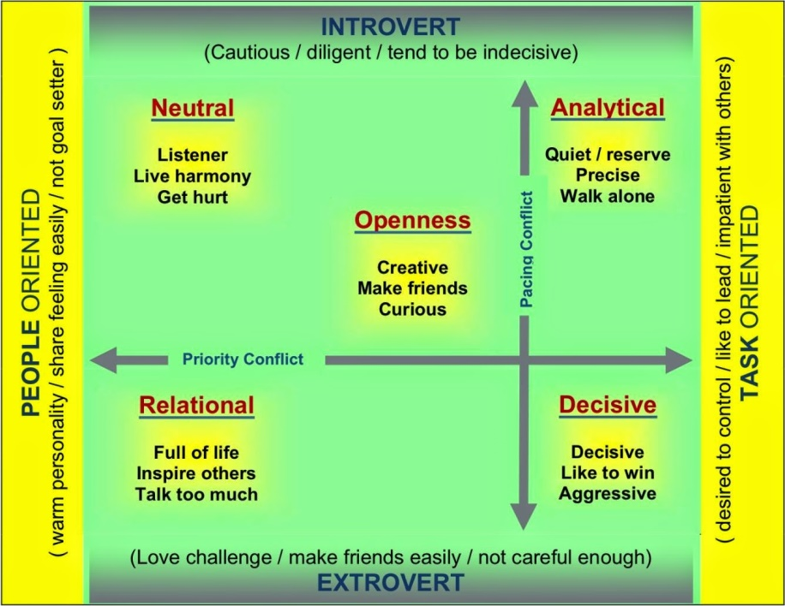

Personality is composed of external traits & no two individual possess identical characteristics. There are thousands of words representing personality characteristics which were reduced to five abstract personality dimension of personality defined in Big five model :

**1. Extroversion:** Person who score positive on this dimension have a comfort level of relationship & relatedness with others. They are sociable, talkative, assertive, open to establish new relationship with and who scores negative on this dimension are introverts and are less sociable, talkative and lack of establishing good relationship & relatedness with others.

**2. Agreeableness: -** Agreeableness shows person’s ability to get agreed with others. Person who scores positive in this dimension are co-operative, trusting and value harmony and agree on thoughts of others more than on their own saying & thoughts. Person who score low on agreeableness lacks of co-operation trust & harmony with others & only focus on their needs and thoughts.

**3. Conscientiousness: -** Conscientiousness refers to number of goals that a person focuses on. A highly conscientiousness person focuses on relatively few goals at one time. They are more organized, systematic, careful, thorough, responsible, self-disciplined and achievement oriented. A person scoring negative on this dimension focus on higher no. of goals are disorganized, less systematic, careless, irresponsible less thorough & self-disciplined.

**4. Emotional Stability: -** This dimension focuses on individual’s ability to cope with stress. Highly emotional stability in individual makes them calm, enthusiastic & secured. Person with low emotional stability are nervous, depressed & insecure.

**5. Openness to experience: -** This dimension shows one’s range of interest. Positively scoring people are open to new thoughts, ideas, and beliefs and are fascinated by novelty, innovation & creativity. They have positive attitude towards new ideas & information.

On the other hand people with low level of openness are less receptive to new ideas and less willing to change their minds towards new thoughts, ideas, beliefs & suggestions.

* **Myers-Briggs Indicator Model**

Myers Briggs type indicator (MBTI) model is mainly used in employee hiring process. The personality dimensions under this model are:

**Extroversion/Introversion:** How people focus their attention on others.

**Sensitivity/Intuition:** Deals in collecting information by people. Sensitive types use an organized structure to factual and preferably, quantitative details. They are able to synthesizing large volume of data and can draw quick conclusion.

Intuitive people collect information nonsystematic ally and hat able to draw conclusion on large no. of data.

**Thinking/Feeling: -** Thinking type rely on rational, logical & scientific of making decision & analyzing a situation Feeling types analyze the situation on their personal value rather thinking logically. More emotional approach towards a situation.

**Judging/Perceiving: -** Judging type personality enjoys the control of decision making and wants to resolve problems quickly. Perceiving types personality are more flexible and adopt spontaneously according to situations before giving decisions.

* **Other Personality Traits:**
* **Authoritarianism:-** Authoritarian personality individuals has a strong belief on established mechanism of formal authority, obedience to authority, follow traditional value systems, intellectually rigid, rigid in their positions, place high moral value on their beliefs, prefer stable & structural work environment governed by clean rules & regulations. They prefer autocratic & directive leadership.
* **Locus of Control:-** Locus of control refers to belief of individual regarding occurrence of events or situations either with one’s own control (internal locus of control) or by external forces beyond one’s control (external locus of control). Externals are less satisfied with their jobs, have higher absenteeism rate and are more alienated from work settings. Internals have more control on their behaviour & are good decision maker.
* **Machiavellianism:-** Machiavellianism is individuals habit to manipulate people. They highly participate in organizational politics, can handle matters related to negotiation & bargaining effectively.
* **Achievement Orientation:-** It is the trait in individuals to achieve anything in their life. People with high need to achieve continuous by focus on doing things in better way than others. They prefer doing something different or moderately difficulty tasks in comparison to others. They like challenges. They believe that success or failure is the result of their own actions.
* **Self-Esteem:-** Self-Esteem is the feeling of like or dislike of oneself. People with high self -esteem believe that they have abilities to do challenging jobs and choose unconventional jobs. They are more confident on themselves for getting success. People with low self-esteem are dependent on others for receiving positive evaluations & approval from others. They follow the beliefs & behaviours of those they respect.
* **Risk-Taking:-** This defines the manager’s ability to take risk high risk taking managers take rapid decisions and used less information in making their choice. These people are more suitable in stock market or trading firm. vice-versa is with the people who are less risk taking.
* **Self-Monitoring:-** It refers to the individual’s ability to adjust their behaviour according to external factors. It shows the adoptability of the individuals in external situations. These individuals have the capability of behaving contradictory in their public, personal life.
* Low self-monitors face difficulty deviating their behaviour in different situations.
* **Type A & B Personality**

**:**

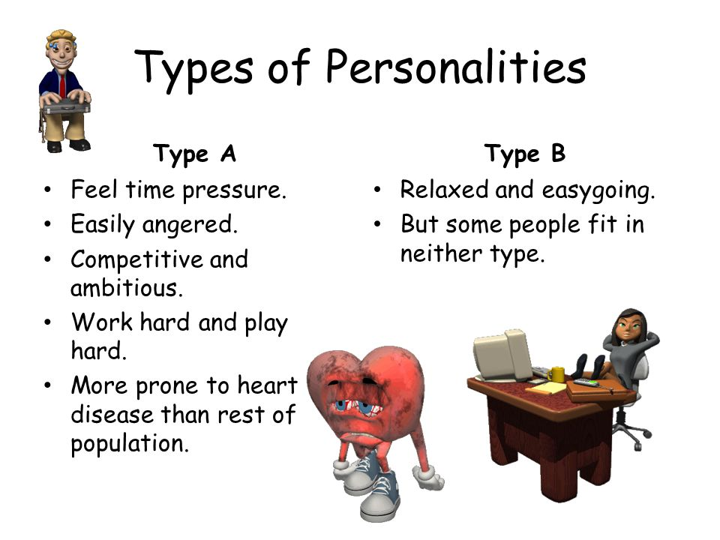

Type A personality are person who are competitive hostile, always prefer doing some work, cannot cope with leisure, think or do two or more things at one time. They are always in hurry to do things.

Type B personality people are relaxed, easy This people going, feel no need to display or discuss their achievements until or unless demanded by situation can relax without guilt.

**LEARNING**

Learning is natural act of living creature in which each change personality, performance and behavior. It is the process of acquiring new knowledge, skills and values which relatively changes the behavior of individual. In organization, various people with varieties of skills, knowledge and perception need to work jointly. They learn from each other. Managers, supervisors, lower level employees and even organization should learn. Learning is usually a need based activity. Learning is relatively permanent change in human behavior which can be measured.

People can learn through formal or informal programs. In organizational behavior, it is taken as vital process as without learning people resist changes in the organization. This means, to make employees ready to change, learning is essential

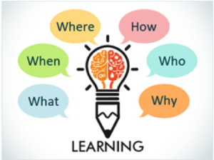

**Meaning of learning:**

Learning is the process by which individuals acquire knowledge & experience to be applied in future reaction to situation. Learning from particulars phenomenon depends upon one’s personality, perception, motivation & situation. The learning process involves motivation, eyes, responses & reinforcement.

**Three general definitions**

* Learning may be defined as a relatively permanent change in behaviour that occurs as a result of Prior Experience
* Generally learning is describes as the process of having one’s Behaviour modified more or less permanently by what he does & the consequences of his action or by what he observes.
* Learning can be defines as relatively permanent change in behaviour potentiality that results from reinforced practice of experience

**Definitions by Authors**

* Learning could be defined as a relatively permanent change in Behaviour that occurs as a result of prior experience

**E.R. Higard**

* Learning has taken place if an individual behaves, reacts, and responds as a result of experience in a manner different from the way he formally behaved.

**W. Mchehee**

* “Learning is the relatively permanent change in a person’s knowledge or behavior due to experience. This definition has three components:

1) The duration of the change is long-term rather than short-term;

2) The locus of the change is the content and structure of knowledge in memory or the behavior of the learner;

3) The cause of the change is the learner’s experience in the environment rather than fatigue, motivation, drugs, physical condition or physiologic intervention.”

–**From Learning in Encyclopedia of Educational Research, Richard E. Mayer**

* **Nature of Learning**

1. Learning invariably involves a change though not necessary improvement in Behaviour. The learning may be good or bad from an organizations point of view for ex., bad habits, prejudice, work restrictions may be learned by an individual.
2. Change in behaviour must be relatively permanent temporary changes may be only reflexive and fail to represent any learning. Changes called by fatigue or temporary adaptations are not covered in learning.
3. Change in behaviour should occur as a result of Experience, practice or training. The change may not be evident until a situation arises in which new behaviour can occur.

## Significance or importance of learning in OB

Learning has strategic importance in every organization as it directly related to their survival and prosperity. It is not only important to organization, but equally important to individual as it also serves personal growth. For people, learning changes the behavioral orientations such as knowledge, skills, values, personality and competency. In organizational setting, importance of learning can be justified with the following reasons:

### 1. Helps to understand and predict human behavior at work

Different roles, skills, and knowledge in the organization are acquired through learning. Managerial skills such as technical, human and conceptual are, however, learned and these skills are paramount for understanding and predicting behaviors of subordinates. Learning is essential to understand how other people behave in organization. This is equally important to middle level and operating level employees.

### 2. Helps to manage diversity

Diversity in human resources in terms of their gender, socio-economic background, social and national culture, physical abilities, level of skills and knowledge, etc. The issue of diversity has emerged in political as well as legal concern. Such diversities in people at work place create differences in their needs, attitudes, level of motivation and workplace behaviors. Such diversities are most essential to manage to increase productivity or organization and morale of employee. For this, learning is initiated to the managers and workers through training.

### 3. Helps to adapt changing technology

Frequently changing technology has not only changed the processing of converting input into output but also has affected the patterns of industrial relations. This is being one of the vital sources for resistivity to change. To work with a new technology, we need to learn new skills. Similarly, it is necessary to redefine workplace relations along with decentralization in work system, telecommuting, and virtual teams. Learning is important to manage knowledge workers, computer programmers, computer scientists and other processional workers in organizational settings. Learning boosts up the level of confidence of employees to adapt change. Thus, to initiate change, learning is essential.

### 4. Helps to maintain Total Quality Management

The objective of TQM can be achieved only by involving people concerned with quality management which is possible through adapting new knowledge continuously. In the process of implementing TQM, the role of leader is dominant to involve employees and enhance their sense of ownership and commitment at work. Moreover, in the process of implementing TQM and work processes successfully, behavioral dimensions such as leadership behavior, workplace decentralization, group dynamics, empowerment, communication and interpersonal relations are to be properly implemented. All these things are possible through learning.

### 5. Facilities organizational change and development

Learning facilitates organizational change and development. Some of these forces for organizational change and development are globalization, technology and demographics. Such change compels managers to reconfigure organizations processes. Technological changes in transportation and telecommunication have change job responsibilities and authority.

## Learning Process in OB

Learning is a process of acquiring skills, knowledge, attitude and behavior. It takes following four stages.

### 1. Stimulus (Meat Powder )

In learning process, there should be stimulus to the learner. Stimulus is the source of motivation or incentives. Learner should be clear about stimulus. There will be no learning takes place if there is no stimulus or learner has not understood the stimulus. Such stimulus can be -

* expansion of knowledge, skills and abilities,
* improving quality of work life,
* productivity and profitability,
* effectiveness,
* career advancement,
* Financial and non-financial rewards.

### 2. Response (Dog Salivating)

Response is the reaction of learner towards the stimulus. This means, response in learning process is the outcome of first step. To take place the learning, learner should have positive response. Only if learner is convinced for positive changes in behavior, s/he responds positive otherwise negative response. Thus, organization management must encourage employees for learning with ensuring the rewards. Employees should be allowed and encouraged to practice the performance response.

### 3. Motivation

Motivation is the drive to encourage individual to learn. Without drive or motivation, learning cannot take place. This provides interest and attitude to learn. Whatever learning and understanding ability of the person, without motivation, none of the person can learn.

### 4. Rewards

Rewards are incentives satisfying the motive. There should be proper reward system in learning process. It should be transparent and predictive. Employees should know what will be their return or rewards when they learn at different levels. For examples, praise is the incentive which satisfies the motive of social approval. Salary increment is the incentive which satisfies the motive of financial security. Rewards can be financial as well as non-financial.

## Components of Learning in OB

Learning becomes complete if it comprises following components:

### 1. Change in behavior

Learning should change the behavior of people. Such change can be positive or negative, good or bad but organization always seeks positive changes in behavior in employees. Negative behavior like high absenteeism, bad habits, prejudice, stereotype, misbehave to other employees as well as customers, etc. are expected to change by positive behavior. Whatever may be positive or negative, fast or slow, more permanent or relatively permanent, there should be change in learning.

### 2. Relatively Permanent

To be learning, the behavioral change should be relatively permanent. Temporary change (reflexive) cannot be supposed to be learning.

### 3. Experience

For learning to occur,some form of experience is necessary. Understanding and familiarity in know-how or concept of work areas are necessary in learning. For example, ability of work based on maturation cannot be considered as learning.

### 4. Reinforcement

In order to have permanent learning, there should be reinforcement in practice. Learning activities i.e. practices in activities must be regular or at least repeated at minimum possible time. If there is no reinforcement in practice or learning, changes in behavior gradually disappear and the original state may not be seen.

## Factors Influencing Learning OB

Learning cannot be in isolation. It is affected by several factors positively or negatively. Following major factors are responsible in influencing learning.

### 1. Psychological factors

Individual's psychology is one of the most influential factor in learning process. Interests and attention are such psychological factors. These factors are affected by individual needs, goals, beliefs, values, attitudes and perception. If individual is psychologically ready to learn, there will be effective learning. Such factors are under control of individual.

### 2. Physiological factors

Physiological factors are physical factors like age, health, learning ability, intelligence, fatigue, etc. Physical limitations like underdeveloped mental status, physically deprived, less healthy, over aged, etc. create obstacle in learning process. Growing age children and middle aged individual have good learning capability in comparison to old aged people. Nutrition and use of medicine can also affect learning process. Physiological factors are not under the control of person.

### 3. Social Factors

Social factors influence learning process both positively as well as negatively. Some of social taboos discourage individual in learning while some of social beliefs, cultures and values encourage for learning. Social needs, incentives, values, prestige, competition, cooperation, etc. are such factors.

### 4. Learning methods

Learning methods or techniques also influence on learning. Learning by doing is found to be more effective in comparison to reading or lecture method. Observation and participation are more effective for quick learning and long lasting memory. Nowadays, use of multimedia, workshops training, refreshment programs, presentation, case analysis, etc. are being popular in teaching - learning method as they are more effective.

### 5. Learning material and content

For effective learning, content or objective of learning must be specific and clear. Vague, over loaded, unclear learning content and boring material are less effective in learning process. Learning material and content influences in how much (fully, partially or no part) is learned, how easily and quickly learned, and to what extent one practices the learned knowledge after learning.

### 6. Environmental factors

Learning place, room, availability of learning materials, equipment, supplies, light, peace zone, temperature, etc. are environmental factors influencing learning. For effective learning, along with stimuli, there be sufficient space, materials and supplies, equipment like multimedia, computer and internet, light, complete silence, etc.

## Learning Theories in OB

1. **Classical Conditioning**

Learning through classical conditioning (C.C) was first studied by Ivan Pavlov, a famous Nobel Price winning physiologist, at the turns of 20th century. The C.C. theories deals with the association of one event with another desired event resulting in a desired behaviour of learning

Pavlov conducted an experiment on a dog to study the relation between the dog’s salivation and ringing of a bell. A simple surgical procedure helped him to measure accurately the amount of salvia secretes by dog. When Pavlov presented a piece of meat to the dog, he noticed a great deal of salivation. He termed the food unconditional stimulus (food automatically caused salivation)

And salivation – an unconditioned Response when the dog sew the meat it salivated during the second stage

Pavlov merely rang a bell (neutral stimulus) the dog did not salivate. Pavlov subsequently introduced the sound of bell each time the meat was given to dog. Thus meat & ringing of bell were linked together. The dog eventually leant to salivate in response to ringing bell even when there was no meat.

**Classical conditioning presented in figure**

A) Before Conditioning

Meat (US) → Salivation (UR)

Bell (Neutral stimulus) → No response

B) During Conditioning

Meat (US) + Bell (CS) → Salivation (UR)

C) After Conditioning

Bell (CS) → Salivation (CR)

US = Unconditioned Stimulus

UR = Unconditioned Response

CS = Conditioned Stimulus

CR - Conditioned Response

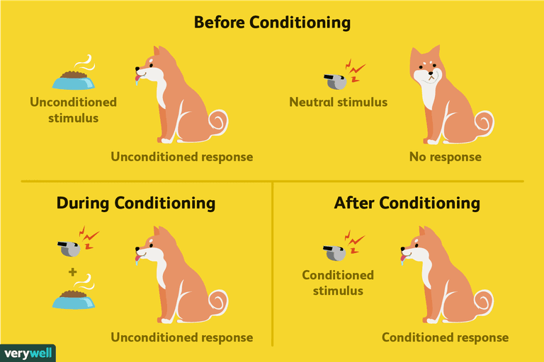

**Pavlov Experiment with dog**

Pavlov established this theory through findings of the experiment with dog. Pavlov presented piece of meat to dog. He noticed salivation in dog and the salivation is increased noticeably. He later, rang the bell without meat but the dog did not salivate. This means ringing bell did not stimulate for salivation. He then, linked ringing bell and serving meat of piece repeatedly. Dog repeatedly heard the bell just getting meat. Dog learnt that when the bell rings he will get meat. Thus, whenever dog hears ringing bell, starts salivating. Later, Pavlov stopped providing meat, but dog salivation on ringing bell. Pavlov described this phenomenon i.e. dog responded with ringing bell. The dog had learned an association between ringing bell and the food. In conclusion, this learning is conditional response involves association between conditioned stimulus (bell), unconditioned stimulus (food), and unconditioned response (salivation).

Unconditioned stimulus (UCS) in the theory represents the particular motivator or trigger to respond automatically or naturally without previous learning. For example, with we talk or see sour food or delicious food, salivation starts through it was not learned. Here sour or delicious food is unconditioned stimulus.

Unconditioned response (UCR) represents the act or output of unconditioned stimulus. Here, salivating is unconditioned response.

Conditioned stimulus (CS) is a motivating situation caused by unconditioned stimulus. Conditioned stimulus does not emerge automatically as unconditioned stimulus.

**Contributions and limitations of classical conditioning**

Classical conditioning theory is simple explanation of relation between stimulus and response. This explains that for learned behavior, there should be motivating factor (stimulus). It also makes the reflective or involuntary after the stimulus-response relationship has been established. In many situation, this theory explains the human behaviors.

But, this theory has some important limitations as well. Some of the limitations are as follows:

* Human behavior and behavior of dogs cannot be similar.
* Behavioral environment in organizations is complex in comparison to the experiment conducted by Pavlov.
* It does not provide significant part of total human learning.
* It explains the passive approach.
* Decision making process is complex in nature. Thus, simple conditioning cannot always work.
* **Operant Conditioning:**

Operant conditioning theory or model is developed by B.F. Skinner (1904-1990), a psychologist. Skinner suggested that learning of complex human behaviors can be explained or better understood with the help of operant conditioning. Operant conditions are explained for voluntary behaviors. Voluntary behaviors have some influence on the environment or they operate in the environment. Thus, the word operant is coined with operate. This theory can be used to explain complex human behavior.

Operant conditioning theory states that behavior is function of its consequences. According to this theory, habits can be learnt through reinforcement. After long experiment, Skinner has identified three types of responses or operant that can be follow behavior. He identified neutral operant, reinforcers, and punishers.

Neutral operant is the responses from environment which neither increases nor decreases the changes for repeating the behavior.

Rein forcer is the responses from environment which increases the changes for repeating the behavior. Rein forcer can be positive or negative.

Punisher is the responses from environment which decreases the chances of repeating the behavior. As people do not wish to get punishment, punishment weakens behavior.

Operant conditioning model, also called Behavior Modification is based on Response-Stimulus. People learn to behave to get something they want or to avoid something they don't want. This means, this theory explains that learning involves reinforcement for desired behavior as a central process in learning. Reinforcement strengthens behavior which increases the probability of repeating the behavior whereas punishment weakens the behavior and reduces the probability of repeating behavior.

**Operant conditioning model**

This model has following important aspects:

* A stimulus gives rise to a motive (or drive) which in combination with a habit (S-R connection) arouses a particular behavior.
* When the behavior is accompanied by a reward (or reinforcement), it leads to:

i. satisfaction of the need or motive arousing the behavior (law of effect), and

ii. Strengthening of the habit or S-R connection which enhances the possibility of repetition of behavior when situations are similar and the needs arise.

* Obviously, rewarding a particular habit does not merely strengthen that habit but also weakens alternative habits which were not rewarded.
* A reward strengthening a habit is designated as learning by instrumental conditioning.
* Accordingly, instrumental conditioning can be defined as the learning of a habit or S-R connection through reinforcement or reward.

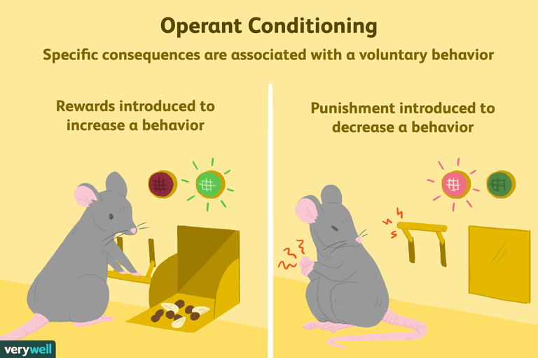

**Experiment of Operant Conditioning**

Skinner conducted experiment with rat and pigeon to conclude the operant conditioning theory. In an experiment with rat, he put rat inside a Skinner box having lever and feeder to serve food. There was provision that when rat pressure lever with its paws, food pellet is delivered from the feeder. The delivery of food is possible only on the response of pressing the lever. The contingently delivered food pellets act to reinforce the lever-pressing response. Rat repeats the behavior if the reinforcement i.e. food serving with lever pressing.

Similarly, Skinner conducted two experiments with pigeon. First experiment was with Cutaway, drawing of an operant chamber for pigeon with key pecking. When the pigeon pecks the key, a food tray comes up to the bottom of the food aperture, and the pigeon is allowed to eat for a few seconds. Here, food is the reinforcer. In the second experiment, the key was managed as translucent panel that can be illuminated perhaps in different colors by the key lights. Food tray was also different than the first. Here, pigeon learns with light when it will be reinforce. In all above experiments, behavior are repeated when there will be repetition of rewards.

**Contribution and limitations of operant conditioning theory**

This theory is modification in classical conditioning theory as it suggests that the reinforcement helps to repeat the behavior. People learn to behave to get something they want or to avoid something they don't want. This conclusion can importantly be utilized while designing, training and development programs. Redesigning job responsibilities and reward management.

But, in practice, once the respondent gets the stimulus, it will not show the desired behavior. People reflect voluntary behavior which is determined, maintained and controlled by consequences. Human being cannot be fit in Skinner's Box like animal. They can freely interact with external environment. Reinforcement cannot always work positively; it should be given only in correct responses made.

**Difference between Classical conditioning and Operant conditioning Model**

**Classical conditioning**

* A change in stimulus elicits particular response.
* The strength and frequency of classically conditioned behavior are determined mainly by the frequency of eliciting stimulus.
* The stimulus serving as reward is present every time.
* Responses are fixed to stimulus.

**Operant Conditioning**

* Stimulus serves as a clue for a person to emit the response.
* The strength and frequency of operant conditioned behaviors are determined mainly by the consequences.
* The reward is presented only if the organism gives the correct response.
* Responses are variable both in types and degrees.
  + **Social Learning**

Also called observational learning, social learning theory, emphasizes the ability of individual to learn by observing others. The important may include parents, teachers, Peers, Motion Pictures TV artists, bosses & others.

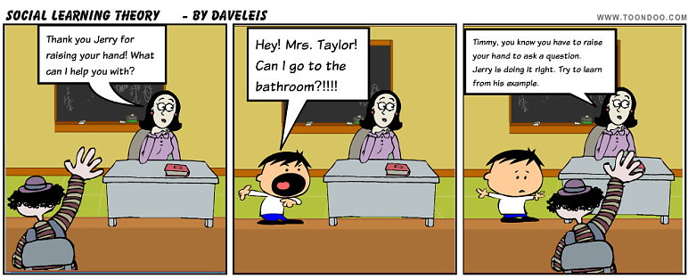

**Social Learning**

By Observation

By Experiment

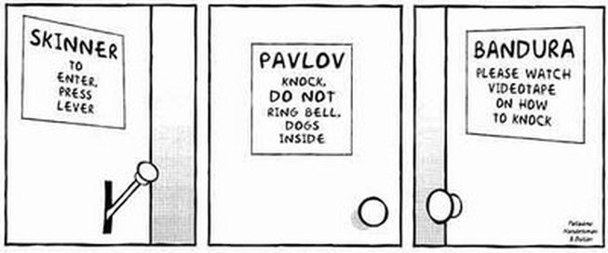

**Social learning can takes place through:**

* + **Modeling:** People acquire behaviour by directly observing and imitating other. Many pattern of behaviour are learned by watching the behaviour of model such as parent, teacher, film star etc. The following process determines the influence:
    - **Attention process:** People only learn from a model when they recognized and pay attention to its critical feature.
    - **Retention process:** A model’s influence will depend on how well the individual remember the model action, when after the model is no longer readily available.
    - **Motor Reproduction Process:** After a person has been a new behaviour by observing the no del the watching must be converted into doing.
    - **Reinforcement /process:** Individual will be motivated to exhibit the modeled behaviour if positive incentives or reward are provided.
  + **Symbolism:** It refers to learning through social action reaction symbolization and interaction.
  + **Self-Control:** Learning is self-development process; people are introduced in self-analysis, appraisal and improvement.
  + **Fore thought:** It issued by Person to anticipate, plan and guide their behaviour and action.
  + **Self-Efficiency:** It refers to the individual’s perception as he or her ability to perform a specific task in a particular situation
* **Cognitive Learning**

Cognitive learning theory establishes the relationship between cognitive environmental cues and expectation. The cognitive approach emphasizes the positive and free will aspect of human behaviour. Cognition refers to an individual’s ideas, thoughts, knowledge, interpretations understanding about himself and his environment. According to this theory learner forms a cognitive structure in memory, preserves and organics information about the various events that occur in a learning situation.

To prove cognitive approach Tolman trained a rat to turn right in a T maze in order to obtain food. Then he started the rat from the opposite part of the maze in order to obtain food. Then he started the rat from the opposite part of the maze, according to operant conditioning theory the rat should having turned right because of past conditioning. But the rat instead turned towards where the food had been placed. This experiment concluded that the rat formed a cognitive map to figure out how to get the food and reinforcement was not a precondition for learning to take place.

Relating to the mental process involved in knowing, learning and understanding

Feedback

Prior Learning

Behaviour choice

Perceived consequences

**MEANING OF PROBLEM SOLVING**

Problem solving is a set of activities designed to analyze a situation systematically and to generate, implement and evaluate solutions for solving a problem. Problem solving is a mental process and is part of the larger problem process that includes identification of problems and problem shaping.

**NEED FOR PROBLEM SOLVING**

When a situation or system needs to move from a given or current state to another desired goal state problem arises and then a systematic approach of problem solving system arises.

Desired goal state

To

Move

From

Given existing state

**STEPS FOR ANALYTICAL PROBLEM SOLVING**

1. **IDENTIFYING THE POBLEM: -** The foremost step of problem solving is to understand and to be clear about the problem arise. One should be very clear regarding the problem and all the detail information obtained from the problem which will help in providing appropriate solutions. views of different people on different issued related to problem must be identified.
2. **UNDERSTAND INTERESTS: -** Interests are the needs that is satisfied by any given solution. Solution to the problem should be such that can satisfies everyone’s interest.
3. **DEVISING A PLAN: -** After identifying the nature of problem and interests of related people next step is to devise a appropriate plan for solving the problem. List of all possible solutions (options) should be prepared. Lot of brainstorming, creativity and innovation should be adopted to generate appropriate solutions. Related problems should be examine to determine if some techniques can be applied use of table, diagram can be used.
4. **EVALUATE THE PLAN: -** Devised plan should be evaluated before its implementation. all the options or solutions should be carefully evaluated to ensure that options are suitable for solving problems. Best options from all the available options should be selected.
5. **IMPLEMENTATION OF PLAN: -** After properly evaluation plan should be effectively implemented in the way it is actually designed and decided. All the strategies and necessary actions should be performed to solve the problem. Each and every step of the plan should be checked and accurate record of all the activities should be established.
6. **MONITORING: -** Effective monitoring should be done regarding effectiveness of the solutions in relation to problem. If there is some alternative method of finding the solutions it should be determined. Other related or more general problems should be determined for which the techniques can be followed for solutions.

**LIMITATIONS OF ANALYTICAL PROBLEM SOLVING**

1. **Competition:-**Most people working in a group perceive the situation as competitive and this generates a destructive behaviour and drains the creative energy of the group. Eager to express their own ideas members try to totally ignore the suggestions of others. People holding powerful positions try to show, their expertise and supremacy and argue against others suggestion, this competitive behaviour creates incompatible atmosphere for effective problem solving.
2. **Conformity:-**Some individuals in a group wants to conform with all the members their solutions and options to obtain conformity as they like to get respected and valued among others. Members want to maintain their image of being knowledgeable and junior members want to avoid inexperienced upstarts so ideas are shared in the groups without exploring all the possibilities.
3. **Lack Of Objective Direction:-**Many traditional meetings and group directions held to solve problems are often held ineffectively having lack of objective and directions, ineffective leadership and undue – pressure on leader or chairman which results in deviation in understanding objective direction & content of problem which results in ineffective problem solving.
4. **Time Constraints: -** Time factor also creates barrier in effective problem solving. Group problem solving is a relatively slow process compared with working alone. Individuals need to gather at an agreed time and place which cause organizational problems and impatience among participants.
5. **Creativity:** Creativity is the ability to visualise, forsee, generate and implement new ideas. Creativity is a function of knowledge, imagination and evaluation.

**APPROACHES TO CREATIVE PROBLEM SOLVING**

Creative problem solving is a combination of innovation and creativity that involves different steps that are as follows:-

1. **Evolution:-**This the method of incremental or gradual improvement under which new ideas stems from other ideas and new solutions from previous solutions which are slightly improved over old ideas. This approach is mainly concerned of thinking new and creative out of old gradually for making something better or different from original.
2. **Synthesis:-**Under this approach two or more existing ideas are combined to produce a third creative & new idea

**For ex. (1)** People want to go for dinner and then to theatre. These two ideas can be combined in form of dinner theatre where people can first go to eat and then at same place they can enjoy movie.

(2) Shopping malls like Big Bazars etc.

1. **Revolution: -** Revolution means thinking of the best new idea which is completely a different one marked change from the previous ideas thought.
2. **Reapplication:-**Reapplication means to apply something old in a new and different way. By removing our preconceived thoughts, expectations and assumptions individuals concentrate in discovering how something can be reapplied creatively. One should see beyond previous or stated applications for some idea, solution or thing and to see what other application is possible.
3. **Changing Direction:-**Sometimes a creative solution to the problem can be provided by analyzing the problem from a different angle, when attention is shifted from one angle of a problem to another it is called creative insight. The goal is to provide a creative solution to problem. There is no specific path commitment.
4. **Brainstorming: -** Brainstorming is an activity where by all the individuals are allowed to provide different solutions to the problem by discussing and thinking over the problem. People are free to express their views and ideas under brainstorming its main goals are:-
5. to break is out our habit bound thinking.
6. To produce a set of ideas from which we can choose.
7. 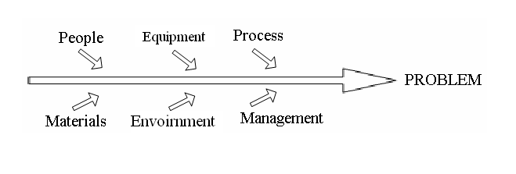**Root-Cause Analysis:-**Under root cause analysis all possible causes of the problem are been studied thoroughly rather than just the one that are obvious. Detail analysis of the problem is done and possible causes of problems are identified to find the creative solutions. These causes are depicted through fish bone diagram.
8. **Mind Mapping:-**By using mind maps structure of a subject can be quickly identified and understood. Recording of the facts and information can be done mentally. Mind maps encourage creative problem solving and they hold information in a format that mind (brain) finds easy to remember and quick to review.
9. **Forming Relationship:-F**orming relationship is one of the approach of creative problem solving. Under this individual form relationship with people from different fields who can help from to excel best and creative ideas.
10. **Learning Form Mistakes:-A**nother approach to creativity is learning from mistakes and negative experiences and taking them as a warning signals while thinking creative.

**CREATIVITY IS:-**

1. **Ability:-**Creativity is the ability to imagine or invent something new. Creativity is not the ability to create out of nothing, but the ability to generate new ideas by combining, changing or reapplying existing ideas.
2. **An Attitude:-**Creativity in an attitude to accept change and newness, a willingness to play with ideas and possibilities a flexibility of outlook etc.
3. **A Process:-** Creativity is a continuous process. Creative people work hard continually to improve ideas and solutions by making gradual alternations and refinements to their works.

**COMPONENTS OF CREATIVITY**

**CREATIVITY = KNOWLEDGE + CREATIVE THINKING + MOTIVATION.**

1. **Knowledge:-**All the technical procedural or intellectual expertise and relevant understanding an individual should have to think creative.
2. **Creative Thinking:-**Relates with flexibility, imagination skills of the people which depends on how people approach problems, their personality, thinking and working style.
3. **Motivation:-**Motivation is key to creative ideas. Intrinsic passion and interest are the most important motivators.

* **STAGES IN CREATIVE PROCESS**

These stages are also known as **"stages of creative thought"**

1. **Orientation:-**As a first step the problem must be defined and important aspects of problems should be identified.
2. **Preparation:-**This Stage involves gathering initial information, saturate information related to problem thinking. Generating alternatives, carefully, analyzing data relating to problem. All possible date information is been gathered at this stage.
3. **Incubation:-**This stage involves an internal and unconscious ordering of gathered informations personal conflict between what is currently accepted as reality and what may be possible. This stage allows the mind to search for possible issues or problems and involves exploring unusual innovative alternatives.
4. **Illumination:-**At illumination stage a new level of insight is achieved, new imaginative idea flashes into individual mind at an unexpected time and people always get new thoughts and ideas. Imagine a cartoon with a bulb flashing on head.
5. **Verification: -** This is the final step to test and verify the solution and ideas obtain during illumination. Logically all the solutions are evaluated to check there feasibility and most feasible idea is applied as the solution to the problem.

* **IMPEDIMENTS / OBSTACLES OF CREATIVITY**

1. **Prejudice:-**Prejudice is one on the barriers to creativity. People often have preconceived ideas about things and these preconceptions often prevent people seeing beyond their thoughts and inhibit them from accepting change.
2. **Stresses: -** Stress is the mental factor which creates distraction of mind, drains energy which could be used in creative thinking.
3. **Learned Helplessness:-**The feeling of people that they don't have tools, knowledge, materials, ability to do anything and so they don't try to think anything creative.
4. **Routines:-**Routines are the set ways of for performing tasks and once they become essential in one’s life then it becomes difficult to deviate from it and this creates hindrance in development of creative mind.
5. **Beliefs:-**People often belief that creativity is a god gift possessed by few people not all some of them belief that it requires talent and it starts in childhood but all these beliefs are the barriers of creativity as all the people possess creative mind, natural ability to think something new every time.
6. **Fear:-**Fear of self-expression and of judgments by others severally limits ones creativity.
7. **Negative Thinking:-**Negativity in thoughts and self-criticism sometimes creates hindrance in thinking something new.
8. **Conceptual Blocks:-**Conceptual blocks are the habit that prevents development of new creative ideas, thoughts and originality.

* **Intelligence**

Intelligence or Intellectual ability refers to the ability or capacity to understand & process complex ideas. Intelligence can be defined as "An ability to understand anything in a logical way".

A person needs to have Intelligence ability & capacity in order to succeed on a job. Intelligence is a kind of a mental process inherits in an individual.

Intelligence is "general mental ability used in complex information processing.

**Aspects of Intelligence**

Many researchers & psychologists believe that intelligence has many types and every individual has strong intelligence are-

1. Numerical Aptitude- The ability to handle mathematics.
2. Verbal Aptitude- The ability to understand written & spoken words.
3. Spatial visualization- The ability to imagine different physical configuration. For ex- Imagine room with the furniture arranged.
4. Deductive Reasoning- The ability to draw conclusions or make choice on the basis of assumption & data
5. Inductive Reasoning- The ability to identify after observing specific cases or instances the outcomes.
6. Memory- The ability to store and recall previous experiences.
7. Experiential- The ability of creative thinking. These aspects of intelligence govern & determine the performance of the individual.

**Kinds if Intelligence**

1. **Cognitive Intelligence –** The ability to understand complex ideas, to adapt effectively to the environment to learn from experience, to engage in various forms of reasoning and to overcome abstracts with careful thought. Above mentioned aspects are the parts of cognitive intelligence.
2. **Practical Intelligence** – The ability to devise effective ways of solving the practical problems of everyday life. This intelligence is based on tactic knowledge "Knowledge of how to get things done.
3. **Emotional Intelligence** – The ability to understand & regulate own emotion as well as of others and to behave appropriately in different situations.

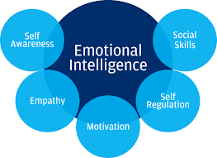

Intelligence is an important determinant of workplace performance and career success. People differ in their intellectual abilities and contributions to this ability are made by our genetic inheritance and by our environment as we grow.

**MOTIVATION**

* UNIT II
* Introduction To Motivation
* Definition
* Concepts
* Theories
* Power
* Politics
* Conflict
* **Introduction**

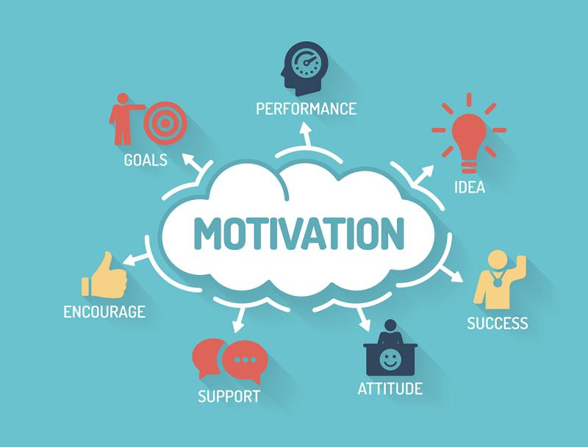

Motivation is the word derived from the word ’motive’ which means needs, desires, wants or drives within the individuals. It is the process of stimulating people to actions to accomplish the goals. In the work goal context the psychological factors stimulating the people’s behaviour can be -

* **desire for money**
* **success**
* **recognition**
* **job-satisfaction**
* **team work, etc**

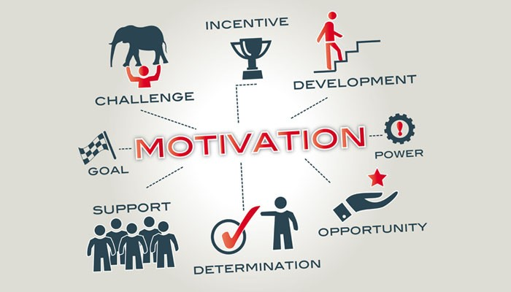

One of the most important functions of management is to create willingness amongst the employees to perform in the best of their abilities. Therefore the [role of a leader](https://www.managementstudyguide.com/role_of_a_leader.htm) is to arouse interest in performance of employees in their jobs. The process of motivation consists of three stages:-

1. A felt need or drive
2. A stimulus in which needs have to be aroused
3. When needs are satisfied, the satisfaction or accomplishment of goals.

Therefore, we can say that motivation is a psychological phenomenon which means needs and wants of the individuals have to be tackled by framing an incentive plan.

* **DEFINITION:**

**Some definitions are discussed as follows:**

“A motive is an inner state that energizes, activates, or moves and directs or channels behaviour goals.”

**-Berelson and Steiner:**

“It is the stimulation of any emotion or desire operating upon one’s will and promoting or driving it to action.”

-**Lillis:**

“Motivation refers to degree of readiness of an organism to pursue some designated goal and implies the determination of the nature and locus of the forces, including the degree of readiness.”

- **The Encyclopedia of Management:**

“Motivation represents an unsatisfied need which creates a state of tension or disequilibrium, causing the individual to make in a goal-directed pattern towards restoring a state of equilibrium by satisfying the need.”

**-Vitiles:**

“A willingness to expend energy to achieve a goal or reward. It is a force that activates dormant energies and sets in motion the action of the people. It is the function that kindles a burning passion for action among the human beings of an organisation.”

**-Memoria:**

Motivation in simple terms can be understand as the set of forces which causes people to behave in certain desired way. Motivation is an “urge” that drives us towards the road leading to our goal.

Every organization needs competent people for accomplishing its goals and objectives. But only competence or skill of the people alone is not enough for fulfilling this purpose. There has to be a willingness or desire or internal drive in the people to achieve the objectives and motivation means process of creating zeal, confidence and to stimulate people to work in the desire direction which leads to the achievements of organization as well as individuals goals and objectives.

“Motivation is the process that account for an individual is intensity, direction and persistence of efforts towards attaining a goal.”

**-ROBBINS**

“Motivation is the willingness to exert high level of effort towards organizational goal, conditional by the effort and ability to satisfy some individual needs.”

**NATURE OF MOTIVATION**

1. Motivation is an inner feeling which energizes a person to work more.
2. The emotions or desires of a person prompt him for doing a particular work.
3. There are unsatisfied needs of a person which disturb his equilibrium.
4. A person moves to fulfil his unsatisfied needs by conditioning his energies.
5. There are dormant energies in a person which are activated by channelizing them into actions.

**TYPES OF MOTIVATION**

1. Positive Motivation: Positive motivation or incentive motivation is based on reward. The workers are offered incentives for achieving the desired goals. The incentives may be in the shape of more pay, promotion, recognition of work etc.



1. Negative Motivation: Negative or fear motivation is based on force or fear. Fear causes employees to act in a certain way. In case, they do not act accordingly then they may be punished with demotions or layoffs. The fear acts as a push mechanism.

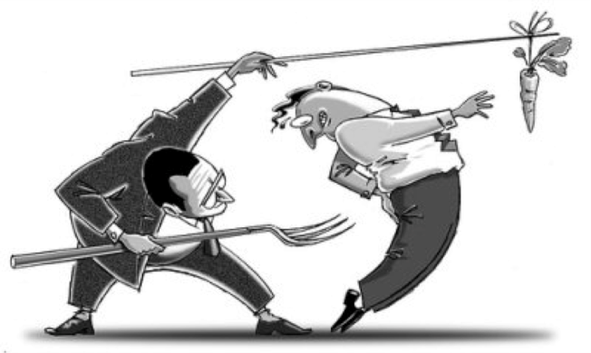

**TECHNIQUES TO INCREASE MOTIVATION**

1. Financial Motivator
2. Non-financial Motivator
   1. Recognition
   2. Participation
   3. Status
   4. Competition
   5. Job Enrichment

**IMPORTANCE OF MOTIVATION**

1. Increase employee’s productivity.
2. Greater satisfaction
3. Enhances job involvement
4. Reduce stress
5. Good human Relations
6. Reduces turnover and absenteeism
7. Reduces employee’s grievances.
8. Efficient utilization of physical and human resources.

* **THEORIES IN MOTIVATION:**

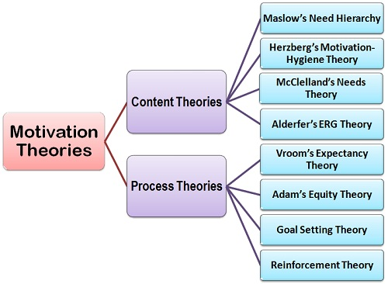

**Maslow’s Need Hierarchy Theory**

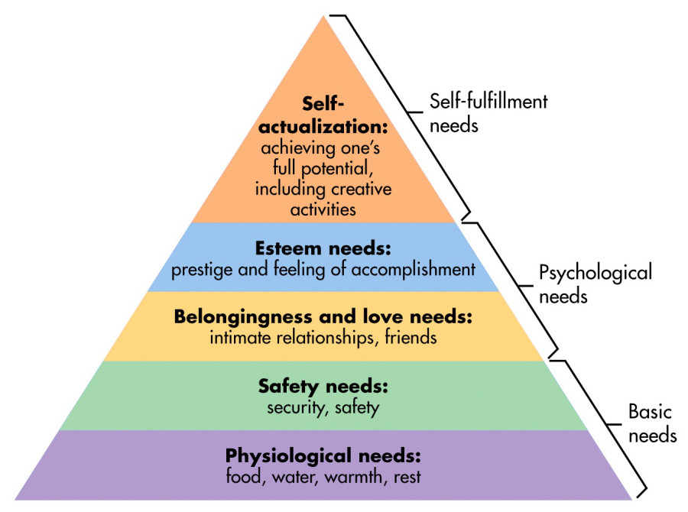

**MASLOW’S NEED HIERARCHY MODEL THEORY**

This theory has been developed by Prof. A.H. Maslow. According to which human beings have wants and desires which influence their behaviour. Only unsatisfied needs influence behaviour, satisfied needs cannot. The needs are arranged in order of importance from basic to the complex. Person advances, to the next level of needs only after the lower level need is satisfied.

Basic five needs which are describes in this theory are:

1. **Physiological needs:** these are the basic needs related to the survival and maintenance of human life. These are food, clothing, air, water, shelter and other biological needs which are Primary in nature.
2. **Safety needs:** These needs include safety and protection from physical and emotional harm. It includes job security, personal bodily security, security of source of income, provision of old age, insurance against risk etc.
3. **Social needs:** It includes affection belongingness, acceptance and friendship. It focuses on conversation, sociability, exchange of feelings and grievances, recognition, belongingness etc.
4. **Esteem needs:** These needs are also known egoistic needs. Needs includes self confidences independence, achievement. Knowledge and success, attention, self respect, status etc.
5. **Self-Actualization needs:** The drive to become what one is capable of becoming or want to achieve in their life. It is consider as primary mission of one’s life.

Maslow separated the five needs into a higher and lower order. Physiological and safety needs are described as lower order needs. Social esteem and self –actualization are classified as higher order needs. Higher order needs are satisfied internal and lower order needs are satisfied externally.

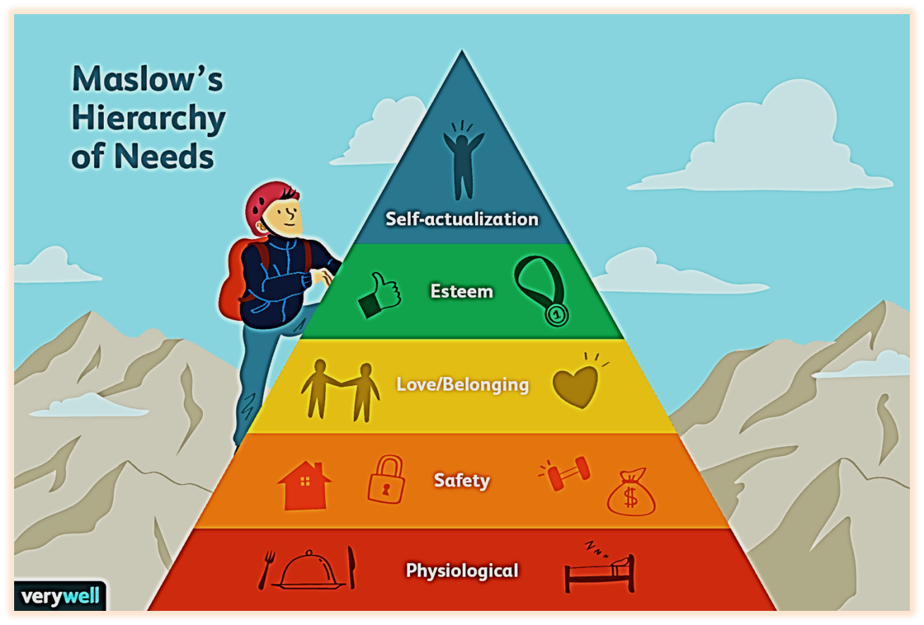

* **THEORY X & THEORY Y**

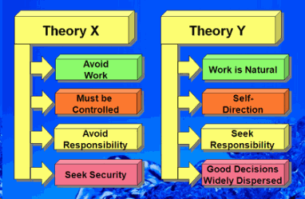

This is the participation model theory of motivation given by Douglas Mc Gregor. He argued that a managers view about the nature of human beings (subordinates) is based on certain assumptions which are grouped as theory x and theory y. Manager is required to mould their behaviour towards employees according to these assumptions to motivate them to work.

**THEORY X**- In this theory autocratic managers assumes that employees are-

* Inherently lazy and avoid work.
* Avoids taking responsibility and power.
* Indifferent to organizations goals.
* Little ambitious, Prefer to security above all other factors.

So managers according to this theory needs to follow the traditional method of closely supervising and establishing a comprehensive system of command and control along with a hierarchical structure to supervise workers and to motive them to work.

**THEORY Y-** Managers with theory y orientation make following assumptions about their subordinates-

* Employees are ambitious, self-motivated anxious to accept greater responsibility.
* Exercise self-control, self-direction autonomy and employment.
* Enjoy their mental and physical work duties.
* Desire to be creative and forward thinking at work place.
* Can be more efficient and productive if given freedom and participation to show their abilities and to give their views.

So managers follow a supportive and participative method of motivating these employees by providing them chance to explore themselves and their ability.

Theory x assumes that lower order needs are the basic needs for which individuals are motivated to satisfy and theory y assumes that individuals are also motivated to satisfy higher order needs of self-esteem and self-actualization along with lower order needs.

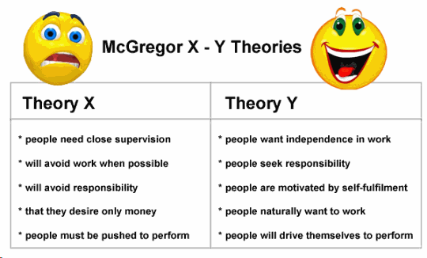

* **HERZBERG’S TWO FACTOR THEORY**

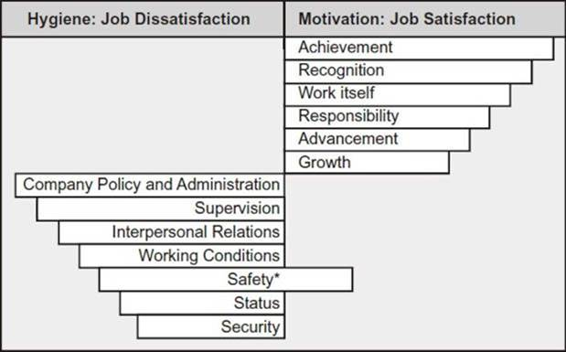

This theory was given by Herzberg (1959). This theory is also called as Motivation Hygiene model theory. This theory constructed a two-dimensional paradigm of factors which affects people attitude towards work. These two factors are Motivators and hygiene factors.

Motivators are intrinsic factors related with work (job) such as advancement recognition, responsibly and achievement. Presence of these factors ensures job satisfaction internally.

Hygiene factors are the extrinsic factors related to work (job) such as company policy, supervision, interpersonal relations, working conditions, salary etc.

Absence of hygiene factors can create job dissatisfaction, but their presence does not motivate or create satisfaction.

So it is stated that motivators describe the person’s relationship with what she or he does related with job performed whereas hygiene factors describe a person’s relation in context to environment in which she or he perform the job. Removing dissatisfying characteristics from a job does not necessary make job satisfying. Job satisfaction factors are separate and distinct from job dissatisfaction factors.

Presence of hygiene factors will not dissatisfied people but also cannot satisfy them. It is only the motivators i.e. intrinsic factors which are associated with work derived from individuals itself can satisfy and motivate individuals.

* **ERG – THEORY**

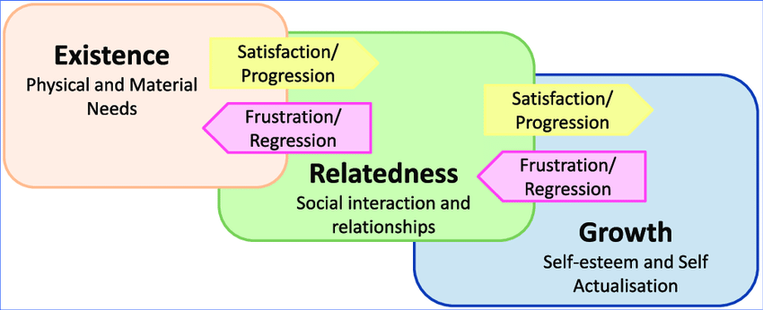

This theory of motivation was given by Alderfer (1972). This theory classifies needs into three categories in hierarchical order.

1. **The Existence Needs-** These needs include all our basic material existence requirements. It includes all the basic biological needs and shelter needs. They include Maslow’s Physiological and safety needs.
2. **The Relatedness Needs-** These needs include the desire for having good and important interpersonal relationships, social interrelation and good image in between others in external environment. It includes Maslow’s social needs.
3. **The Growth Needs-** These needs include an intrinsic desire for personal growth development, status, recognitions advancement, achievement etc. It includes Maslow’s esteem and self-actualization needs.

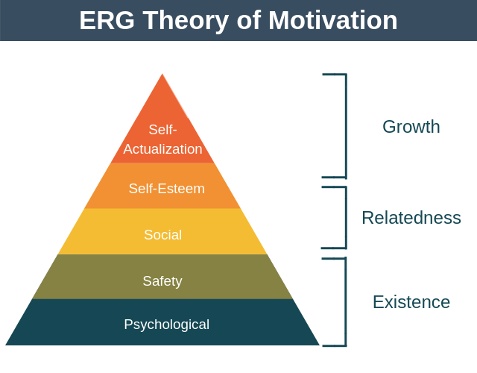

**This theory differs from Maslow’s theory in following arguments:**

1. Maslow’s said that needs are divided in 5 categories hierarchal from basic to complex and only one need is been work on one time whereas Alderfer said that more than one need may be operative at the same time.
2. ERG Theory does not assume the rigid hierarchy for the satisfaction of needs i.e. it is not necessary that when one need is satisfied them only another need can be satisfied. Person can be working on growth, existence or relatedness needs at same time or on existence and relatedness needs even if growth need is unsatisfied.

* **MC CLELLAND’S THEORY OF NEEDS**

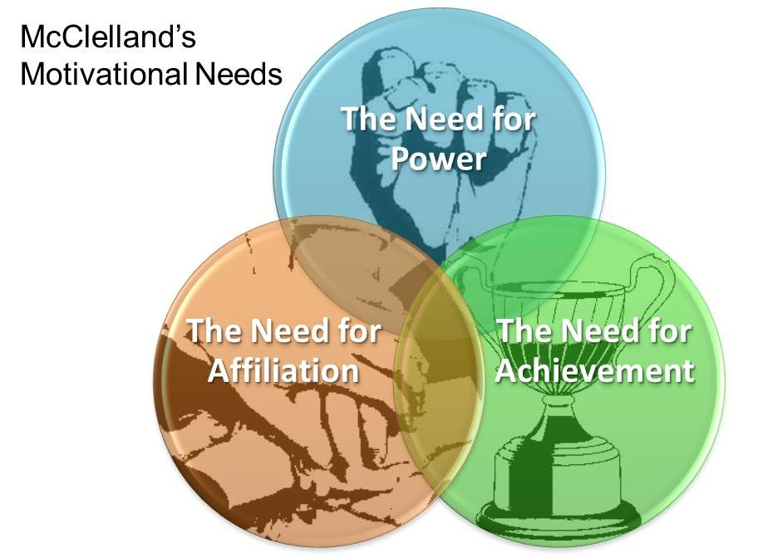

This theory was given David Mc Clelland (1961) which mainly focuses on three kinds of needs namely-

1. **Need for achievement (NACH) -** This need includes a drive to excel, advance and grow. It includes desire of individual to achieve something different from others in a different manner in relation to a set of standards.
2. **Need for power (NPOW) -** This need to have command and control to make other behaviour in a way that they have never behaved otherwise to change the situation accordingly.
3. **Need for affiliation (NAFF) -** This included desire for being friendly and to have a close interpersonal relations with others. People with this need want to have a good image & relationship with others.

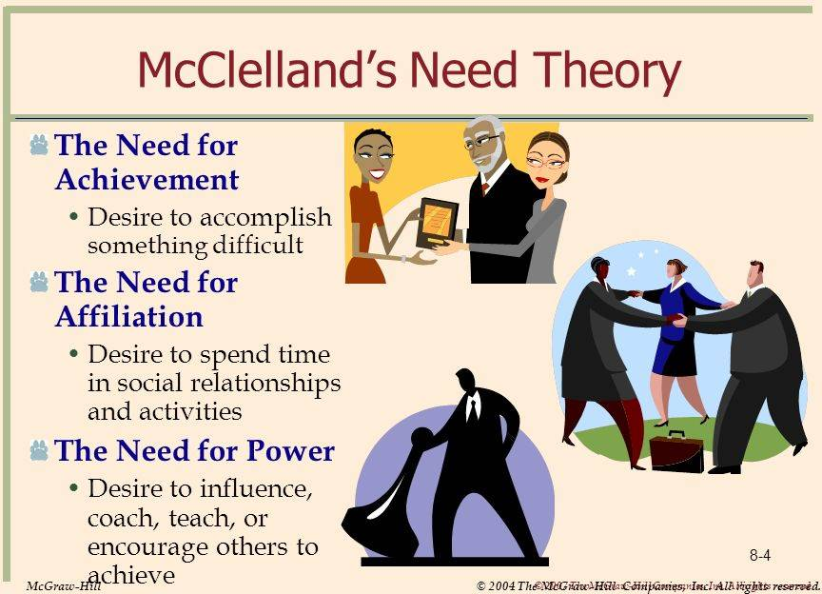

People with high need for achievement have a compelling drive to succeed. They strive to do something better and more efficiently that it has been done before by others. This is called achievement need. High achievers differentiate themselves from others by their desire of doing things better and differently. They seek situations in which they can attain personal responsibilities for finding solutions to problems. People with high need for power enjoy being “in-change” of any situation. They strive to have influence over others and prefer to be placed into a competitive and status-oriented situation. They believe to change the situations and thoughts of the people accordingly by influencing them.

People with high need for affiliation strive for maintaining friendship. Prefer co-operative situations and desire for a relationships that involve a high degree of mutual understanding.

Based on this theory following assumptions can be made-

1. Individuals with a high need to achieve prefer job situations with personal responsibility, feedback and an intermediate degree of risk. In these situations high achievers will be strongly motivated.
2. A high need to achieve does not necessarily lead to being a good manner, especially in large organizations. These people are interested in their personal development rather than influencing others to do well.
3. The needs for affiliation and power are closely related to managerial success. A good manager needs to be high in need of power, moderate in need of affiliation and low in need of achievement.

* **VICTOR VROOM’S EXPECTANCY THEORY**

It is given by victor vroom (1964) and is one of the most widely accepted explanations of motivation. According to this theory motivation is based on people belief, goals and linkage between effort, performance and reward and reward and individual goal satisfaction.

Determinants of motivation according to this theory are as follows-

Expectancy (Performance)- It is also called effort and performance determinant which shows the extent to which a person believes that particular level of efforts will lead to expected level of performance.

**Instrumentality-** It is called as performance determinant which shows that particular level of performance will lead to a desired reward. Ex: - superior performance leads to promotion in job.

Superior performance is first level of outcome promotion is the second level out come.

**Valence Reward value or Preferences-** It refers to the value a person places on the rewards that he or

She excepts to receive from an organization. The value attached to reward is subjective and varies from person to person. Ex: - A young and dynamic employee wants a promotion and value it. Similarly a retiring employee may have high valence for re-employment.

These determinants are expressed through following formula-

Motivation = Expectancy (Performance) x Instrumentality x Valence.

Effort – Performance linkage

(How hard will have to work?)

Performance – Reward linkage

(What is the reward?)

Attractiveness

(How attractiveness is the reward?)

**Values may range from**

Expectancy → 0 to 01

Instrumentality → 0 to 01

Valence → -01 to 01

* **GOAL – SETTING THEORY**

Goals are targets which are to be achieved in future. Goals play an important role in influencing the behaviour and motivational level of employee. This theory was given by Edwin Locke. He stated that when employees participate in goal setting they are more motivated that leads to efficient performance, rewards and also personal satisfaction.

**Goal-Setting theory emphasizes the following points:**

1. If factors such as ability and acceptance of the goals are held constant, it can be stated that the more difficult goal, the higher the level of performance. Once an employee accepts a hard task, he or she will exert a high level of effort until it is achieved, lowered or abandoned.
2. People will do better when they get feedback on how well they are progressing toward their goals because feedback helps to identify discrepancies between what they have done and what they want to do.
3. Feedback is not equally potent. Self-generated feedback-where the employee is able to monitor his or her own progress-has proved to be a more powerful motivator than externally generated feedback.
4. If people participate in goal setting, they are more likely to accept even a difficult goal than if they are arbitrarily assigned it by their boss. People are basically committed to choices in which they have a pat. A major advantage or participation may be increasing acceptance of the goal itself as a desirable one toward which to work.

**The four essential elements of goal setting model explained below:-**

1. **Goal Acceptance:** It states that employees should accept the goals assigned to them. If difficult goals are assigned to employees they may not feel attached to goals and this leads to non-acceptance low motivation and performance on the part of employees. Managers should follow participative approach in setting goals for subordinates.
2. **Goal Specificity**: goals should be specific, measurable, fixed and clear to the subordinates. It is be understandable by them. This enables the worker to evaluate his/her performance and to judge themselves.
3. **Goal Challenge:** goals must be feasible but challenging in nature. It should be competitive but achievable. All the directions, efforts and resources required to achieve a goal must be communicated and made available to subordinates.
4. **Performance Feedback:** Employees should be informed about how well they are doing and how successful they are. Proper feedback can motivate them further. It encourages better job performance and self-generated feedback is a very powerful motivational tool.

* **REINFORCEMENT THEORY**

Reinforcement theory is developed initially by the well-known psychologist B.F. Skinner. It is based on behaviour and learning of an individual. This theory basically states that behaviour is determined by its consequences i.e. positive or pleasant consequences leads to repetition of action and negative or unpleasant consequences are not likely to be repeated again. Reinforcement also influences our motivational level to door not to do certain things. Reinforcement is of four types:

1. **Positive Reinforcement:** It is the used of Rewards that stimulates the desired behaviour and strengthen the probability of repetition of such behaviour in future. It includes reinforces such as money, praise, promotion, recognitions etc.
2. **Negative Reinforcement:** This strategy is also called “avoidance learning”. It implies use of unpleasant rewards to avoid the undesirable behaviour of an individual. It includes warnings, penalty alert counselling etc.
3. **Extinction:** To avoid the undesirable behaviour to extinguish it completely. It is to withdraw all far of reinforcement to completely dissolve undesirable behavior.
4. **Punishment:** This tool is used when an unpleasant or undesirable behaviour needs to reduced or eliminated. For ex: worker’s wages may be deducted if performance is not done.

**Equity theory of motivation:**

According to this theory, employees make comparisons of their job inputs and outcomes relative to those of others. If, an individual perceives the input-outcome ratio to be equal to that of the input- outcome ratios of others a state of equity exists. Person perceives the situation to be fair. If the ratio appears to be unequal, the individual experience inequity. There are four referent comparisons that an employee can make to find out the ratio of equity or inequity:

1. **Self- Inside:** An employee’s experiences in a different position inside his or her current organization.
2. **Self- outside:** An employee’s experience in a situation or position outside his or her current organization.
3. **Other – inside:** position of another individual or group of individuals inside the organization.
4. **Other- outside:** position of another individual or group of individuals outside the organization.

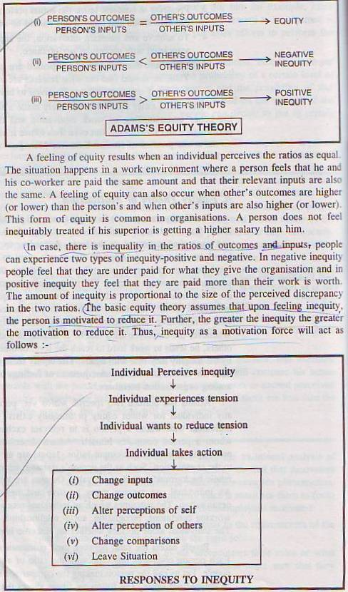



When employee perceives inequity, they can make one of the following six choices of behavior:

1. **Change their inputs:** Increase or decrease their inputs. Ex- can work hard or work less hard.
2. **Changing outcomes:** Person can request to ask his or her outcome. Ex- ask for salary, office, recognition etc.
3. **Changing perception of self:** Can leave that situation and to focus on other. Ex- if a person feels that he was not given proper rewards for the work he done and state of inequity is existing in a person’s mind then person can focus on the other task where he got the equality in terms of rewards or can get equal rewards.
4. **Change the comparison person:** To compare with a person who is equal to or less than the person who is making comparison.
5. **Changing the inputs outcomes of others:** Ask other person to reduce his or her inputs to the task or to reduce their outcomes. Distort the perception of others.
6. **Leave the situation:** Can transfer, change location, leave the job to avoid uncomfortable feelings and inequity.

* **Motivating employees in an organization:**

1. Recognizing individual differences: managers need to understand the different and important needs of the individual employee and should try to connect it with the organizational goals. This results into high level of involvement and motivation of employees.
2. Use goals ad feedbacks: employees should have the specific and achievable goals. Feedbacks should be provided regularly to inform the employees about their performance in pursuit of those goals.
3. Include employees in decision making: participation of employees in the decision making to choose their benefits, solving productivity and quality problems.
4. Link rewards to performance: rewards should be contingent on performance and employee must perceive a clear linkage.
5. Maintain equity: rewards should be perceived as equal by the employees according to their inputs to the job. This motivates the employees.
6. Motivating professionals: professionals likely to seek more intrinsic satisfaction than extrinsic rewards. Proper intrinsic rewards like challenging jobs, problem solving situations, growth and development should be provided to them.
7. Motivating low skilled and temporary workers: temporary workers can be motivated if proper training an permanent job opportunity is provided to them an low skilled workers will be motivated if proper work schedules, environment and higher pay package will be provided.

* **Practical Application of Motivational Techniques**

**Management by Objectives (MBO)**

Management by objectives emphasis participative set goals that are tangible, verifiable and measurable. Four ingredients common to MBO programs are: Goal specificity, participative decision-making, an explicit time period and performance feedback.

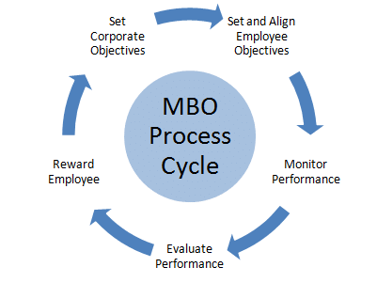

**Goal Specificity:**

* The objectives in MBO should be concise statements of expected accomplishments.

Participative decision making:

1. The manager and employee jointly choose the goals and agree on how they will be measured.

An explicit time period:

* Each objective has a specific time period in which it is to be completed.

Performance feedback

* Continuous feedback on progress towards goals is provided so that workers can monitor and correct their own actions.

**Employee Recognition Programs**

Employee recognition program consist of personal attention, expressing interest, approval and appreciation for a job well done. They can take numerous forms. Employee Recognition Programs has close link with Reinforcement Theory.

**Employment Involvement**

Employee involvement includes participative management, workplace democracy, and empowerment and employee ownership. Employees’ involvement in the decision making would positively affect them and by increasing their autonomy and control over their work lives, employees will become more motivated, more committed to the organization, more productive and more satisfied with their jobs.

**Participative management**

The logic behind participative management is:

1. Managers often do not know everything their employees do.
2. Better decisions
3. Increased commitment to decisions
4. Intrinsically rewarding employees make their jobs more interesting and meaningful.

The two common forms of participative management are:

1. Work councils- They are groups of nominated or elected employees who must be consulted when management makes decisions.
2. Board representatives- They are employees who sit on a company’s board of directors and represent the interests of the firm’s employees.

**Quality circles (QC)**

QC consists of a work group of eight to ten employees and supervisors who have a shared area of responsibility. Key components of QC are (Robbins, 2003):

They meet regularly on company time to discuss their quality problems, investigate causes of the problems, recommend solutions, and take corrective actions.

They take over the responsibility for solving quality problems and they generate and evaluate their own feedback.

Management typically retains control over the final implementation decision.

**Employee stock ownership plans (ESOPs):**

In the typical ESOP, an employee stock ownership trust is created. Companies contribute either stock or cash to buy stock for the trust and allocate the stock to employees. Employees usually cannot take physical possession of their shares or sell them as long as they are still employed at the company.

**Power & Politics**

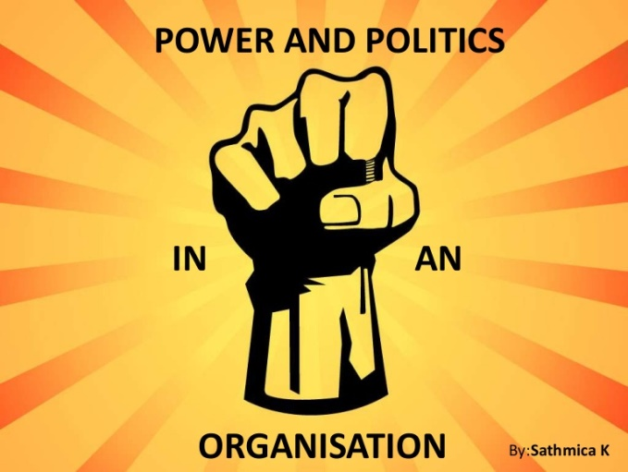

Power is the ability to make things happen in the way an individual wants, either by self or by the subordinates. The essence of power is control over the behavior of others.

Managers derive Owes from both organizational and individual sources. These sources are called position power and personal power, respectively. Power also refers to a capacity that A has, to influence the behavior of B, so that B acts in accordance with A’s wishes. The, greater B's dependence on A, the greater is A's power in the relationship. Therefore, power is function of dependency.

* **Bases of Power**

Power can be categorized into two types: Formal and informal

1. **Formal Power:**

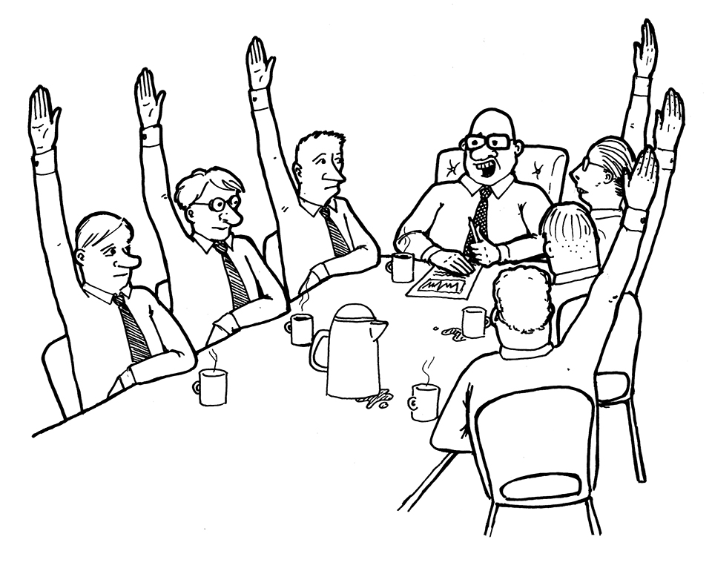

It is based on the position of an individual in an organization. Formal power is derived from either one's ability to coerce or reward others or is derived from the formal authority vested in the individual due to his/ her strategic position in the organizational hierarchy. For example, a manager may threaten to withhold a pay raise, of or even recommend the firing of a subordinate who does not act as desired. Such coercive power is the extent to which a manager can deny desired rewards or administer punishments to control other people. The availability of coercive power also varies across organizations. The presence of unions and organizational policies on employee treatment can weaken this power base significantly. Formal power may be categorized into four types which are as follows:

1. **Coercive Power:**

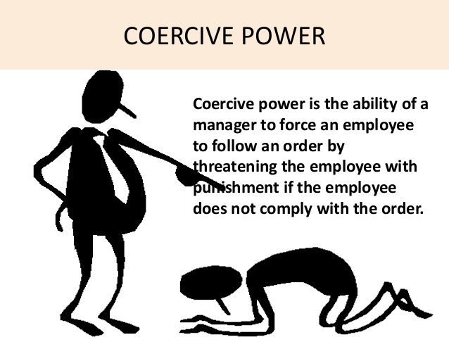

The coercive power base is being dependent on fear. It is based on the application, or the threat of application, of physical sanctions such as the infliction of pain, the generation of frustration through restriction of movement, or the controlling by force of basic physiological or safety needs. In an organization one can exercise power over another if they have the power to dismiss, suspend, demote another assuming that the job is valuable to the person on who power is being unleashed.

1. **Reward Power:**

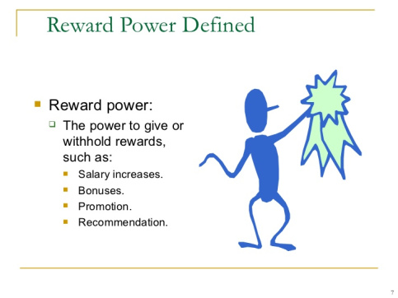

The Opposite of coercive power is reward power. Reward power is the extent to which a manager can use extrinsic and intrinsic rewards to control other people. Examples of such rewards include money, promotions, compliments, or enriched jobs. Although all managers hate some access to rewards, success in accessing and-tainting rewards to achieve influence varies according to the skills of the manager.

1. **Legitimate Power:**

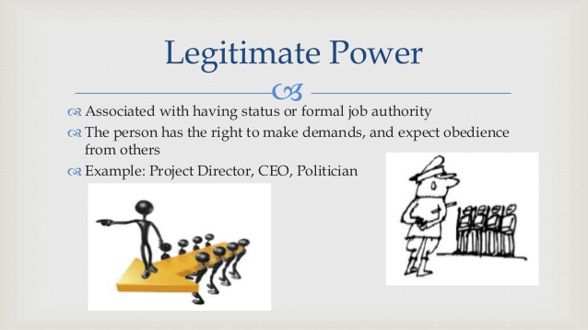

The third base of "position" power is legitimate power, or formal authority. It stems from the extent to which a manager can use subordinates' internalized values or 'beliefs that the "boss" has a "right of command" to control their behavior. For example, the boss may have the formal authority to approve or deny such employee requests as job transfers, equipment purchases, personal time off, or overtime work. Legitimate power represents a special kind of power a manager has because subordinates believe it is legitimate for a person occupying the managerial position to have the right to command. The lack of this is legitimacy will result in authority not being accepted by subordinates.

Thus this type of power has the following elements:

* It represents the power a person receives as a result of his/her position formal hierarchy.
* Positions of authority include coercive and reward powers.
* Legitimate power, however, is not limited to the power t coerce and reward. It encompasses the acceptance of the authority of a position by members of an organization.

1. **Information Power**:

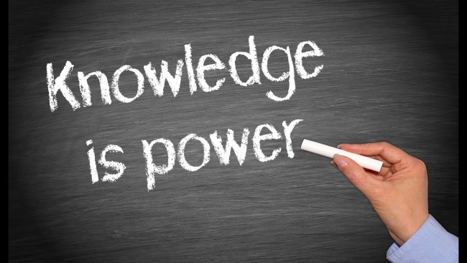

This type of power is derived from access to and control over information. When people have needed information, others become dependent on them,: For example, managers have access to data that subordinates do not have). Normally the higher the level, the more information would' be accessed by managers.

1. **Personal Power:** Personal power resides in the individual and is independent of that individual's position. Three bases of personal power are expertise, rational persuasion, and reference.

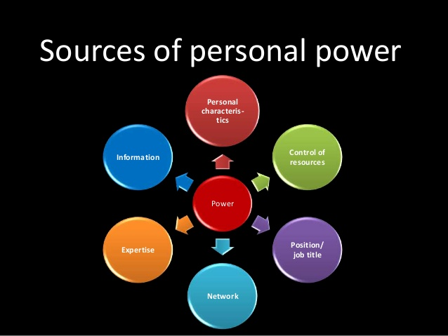

Expert power is the ability to control another person's behavior by virtue of possessing knowledge, experience, or judgment that the other person lacks, but needs. A subordinate obeys a supervisor possessing expert power because the, boss ordinarily knows more about what is to be clone or how it is to be done than does the subordinate. Expert power is relative, not absolute. However the table may turn in case the subordinate has superior knowledge or skills than his/her boss. In this age of technology driven environments, the Second opposition holds true in many occasions where the boss is dependent heavily on the juniors for technologically oriented support.

Rational Persuasion is the ability, to control another's behavior, since, through the individual's efforts; the person accepts the desirability of an offered goal and a viable way of achieving it. Rational persuasion involves both explaining the desirability of expected outcomes and "showing how specific actions will achieve these 'outcomes.

Referent power is the ability to control another's behavior because the person wants to identify with the power source. In this case, a subordinate obeys the boss because he or she wants to behave, perceive, or believe as the boss does. This obedience may occur, for example, because the subordinate likes the boss personally and therefore tries to do things the way the boss wants them done. In a sense, the subordinate attempts to avoid doing anything that would interfere with the pleasing boss-subordinate relationship.

Followership is not based on what the subordinate will get for specific actions or specific levels of performance, but on what the individual represents—a path toward lucrative future prospects.

**Empowerment**

Empowerment is the process by which managers help others to acquire and use the power required to make decisions affecting both themselves and their work. Moreover, today, managers in progressive organizations are expected to be competent at empowering the people with whom they work. Rather than concentrating power only it higher levels as found in the traditional "pyramid" of organizations, this concept views power to be shared by all working in flatter and more collegial structures The concept of empowerment is part of the decentralized structures which, are found in today's corporations. Corporate staff is being cut back; layers of management are being eliminated the number of employees is being reduced as the volume of work increases. The trend clearly" is towards creating leaner and more responsive organizations which are flexible and capable of taking decisions with minimum bottlenecks created out of power struggles, typical of bureaucratic tall structures. The need clearly is towards having fewer managers who must share more power as they go about their daily tasks. Hence, empowerment is a key foundation of the increasingly popular self-managing work teams and other creative worker involvement groups.

**CONFLICT**



* **Introduction**

Conflict occurs whenever disagreements exist in a social situation over issues (work related or personal). Conflict is a process, that begins when one party perceives that another party has negatively affected, or is about to negatively affect, something that the first party cares about (Thomas, 1992). Conflict can be either constructive or destructive. Constructive conflict prevents stagnation, stimulates creativity, and allows tensions to be released. However, excessive level of conflict can hinder the effectiveness of a group or an organization, lessens satisfaction of group members, increases absence and turnover rates, and, lowers productivity

* **Functional vs. Dysfunctional Conflict**

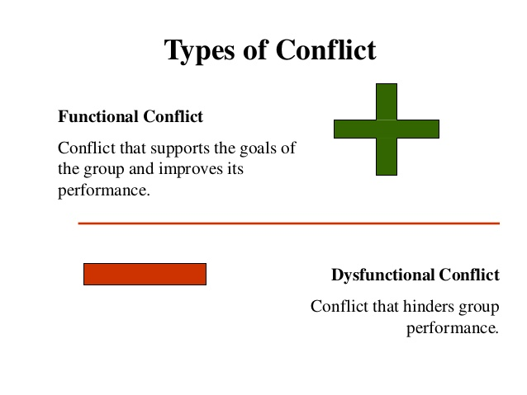

Functional, constructive forms of conflict support the goals of the group and improve its performance. Conflicts that hinder group performance are dysfunctional or destructive forms of conflict. Task conflict relates to the content goals of the work.

Low to moderate levels of task conflict are functional and consistently demonstrate a positive effect on group performance because it stimulates discussion, improving group performance. Relationship conflict focuses on interpersonal relationships. These conflicts are almost always dysfunctional and the friction and interpersonal hostilities inherent in relationship conflicts increase personality clashes and decrease mutual understanding.

* **Levels of Conflict**

At work people may encounter conflict at the interpersonal level (conflict within the individual), the interpersonal level (individual to individual conflict), the intergroup level, or the inter-organizational level.

**Intrapersonal conflict**

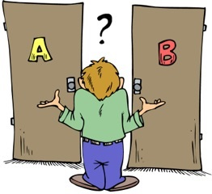

Some conflicts that affect behavior in organizations involve the individual alone. It can be of three types-

* Approach–approach conflict occurs when a person must choose between two positive end equally attractive alternatives. An example has to choose between a valued promotion in the organization or a desirable new job with another firm.
* Avoidance–avoidance conflict occurs when a person must choose between two negative and equally unattractive alternatives. An example is being asked either to accept a job transfer to another town in an undesirable location or to have one's employment with an organization terminated.
* Approach–avoidance conflict occurs when a person Must decide to do something that has both positive and negative consequences. An example is being offered a higher paying job whose responsibilities entail unwanted demands on one's personal time. .

Interpersonal conflict occurs between two or more individuals who are in opposition to one another. It may be substantive or emotional or both.

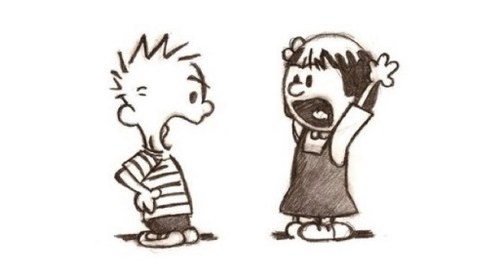

Intergroup conflict occurs among Members of different teams or groups.

Inter-organizational conflict occurs as the competition and rivalry that characterizes firms operating in the same markets.



* **The Conflict Process**

The process of conflict management has the following steps (Schermerhorn et al, 2002):

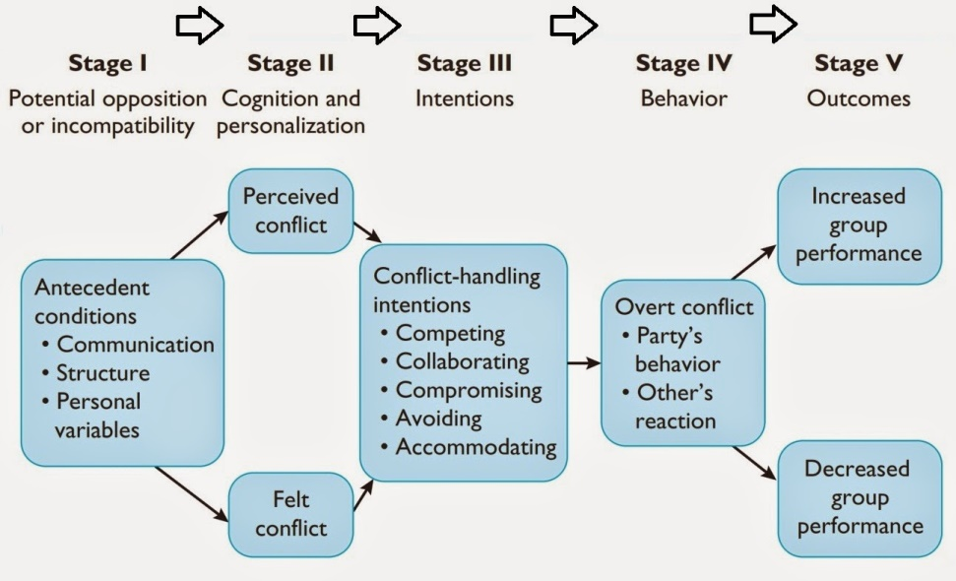

1. **Stage I: Potential Opposition or Incompatibility**

This stage concludes the conditions that create opportunities for Conflict to arise. The conditions are a as follows:

1. **Communication:** Communication becomes a source of conflict due to semantic difficulties, misunderstandings, and "noise" (distortion) in the communication channels. Differing Word connotations, jargon, insufficient exchange of information, and noise in the communication channel are all barriers to communication and potential antecedents to conflict.
2. **Structure:** The term structure includes variables such as size, degree of specialization, jurisdictional clarity, member –goal compatibility, leadership styles; reward systems, and the degree of dependence. Size and specialization act as forces to stimulate conflict. The larger the group and more .specialized its activities, the greater the likelihood of conflict. The potential for conflict is greatest where group members are younger and turnover: is high. The greater the ambiguity in responsibility for actions lies, the greater potential for conflict.
3. **Personal variables Personal:** The variables include individual value systems and personality characteristics. Certain personality types lead to potential conflict. Value differences are the best explanation for differences of opinion on various matters.
4. **Sage II: Cognition and Personalization**

Antecedent conditions lead to conflict only when the parties are affected by and aware of it. Conflict is personalized when it is felt and when individuals become emotionally involved. Emotions play a major role in shaping perceptions. Negative emotions produce oversimplification of issues, reductions in trust, and negative interpretations of the other party's behavior. Positive feelings increase the tendency to see potential relationships among the elements of a problem, to take a broader view of the situation, and to develop more innovative solutions (Robbins, 2003).

1. **Stage III: Intentions**

The primary conflict handling intentions are represented as follows:

Cooperativeness—"the degree to which one party attempts to satisfy the other party's concerns."

Assertiveness—"the degree to which one party attempts to satisfy his or her own concerns."

**Competing:** When one person seeks to satisfy his or her own interest, regardless of the impact on the other parties to the conflict.

**Collaborating:**  When the parties to conflict each desire to fully satisfy the concerns of all parties. The intention is to solve the problem by clarifying differences rather than by accommodating.

**Avoiding:** A person may recognize that a conflict exists and want to withdraw from it or suppress it.

**Accommodating:** When one party seeks to appease an opponent, that party is willing to self-sacrificing.

**Compromising:** When each party to the conflict seeks to give up something, sharing occurs, resulting in a compromised (income. There is no clear winner or loser, and the solution provides incomplete satisfaction of both parties' concerns.

1. **Stage IV: Behavior**

The behavior stage includes the statements, actions, and reactions made by the conflicting parties. These conflict behaviors are usually over attempts to implement each party's intention. It is a dynamic process of interaction with a continuum. At the lower part of the continuum, conflicts are characterized by subtle, indirect, and highly controlled forms of tension. Conflict intensities; escalate as they move upward along the continuum until they become highly destructive. Functional conflicts area typically confined to the lower range of the continuum.

1. **Stage V: Outcomes**

Outcomes may be functional—improving group performance or dysfunctional in hindering it. Conflict is constructive when it (Robins, 2003):

1. Improves the quality of decisions.
2. Stimulates creativity and innovation.'
3. Encourages interest and curiosity.
4. Provides the medium through which problem can be and tensions released.
5. Fosters an environment of self-evaluation and change.

Outcomes may be dysfunctional as well. They are as follows:

Uncontrolled opposition breeds discontent, which acts to dissolve common ties and eventually leads to the destruction of the group. Undesirable consequences include a retarding of communication, reductions in group cohesiveness, subordination of group goals to the primacy of infighting between members. Conflict can bring group functioning to a halt and potentially threaten the group's survival. The demise of an organization as a result of too much conflict is not as unusual as it might first appear.

**Conflict Management Approaches**

There are two types of conflict management approaches:

* Direct
* Indirect

**Direct conflict management approaches**

There are five approaches to direct conflict management. They are based on the relative emphasis on cooperativeness and assertiveness in the relationship between the conflicting parties. They are as follows:

**Avoidance —** it is an extreme form of inattention; everyone simply pretends that the conflict does not really exist and hopes that it will go away.

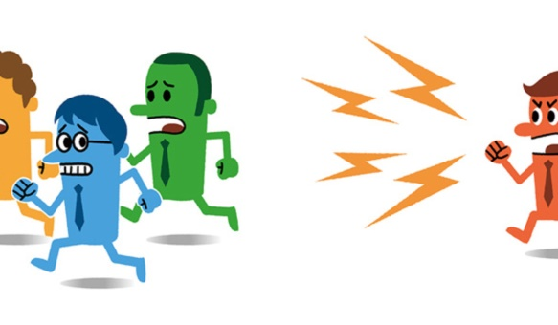

**Accommodation** involves playing down differences among the conflicting parties and highlighting similarities and areas of agreement. This peaceful coexistence ignores the real essence of a given conflict and often creates frustration and resentment.



**Compromise** It occurs when each party gives up something of value to the other. As a result of no one getting its full desires, the antecedent conditions for future conflicts are established.

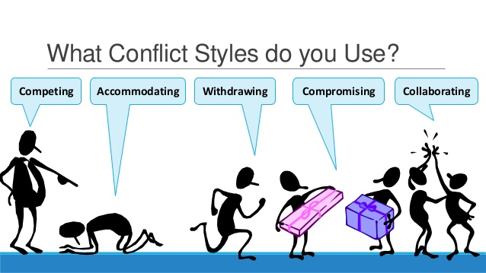

**Competition —** here a victory is achieved through force, superior skill, or domination by one party. It may also occur as a result of authoritative command, whereby formal authority simply dictates a solution and specifies what is gained and what is lost by whom. This is a case of win lose situation and as a result, future conflicts over the same issues are likely to occur.

**Collaboration —** it involves recognition by all conflicting parties that something is wrong and needs attention. It stresses gathering and evaluating information in solving disputes and making choices.

**LEADERSHIP**

* UNIT III
* Introduction To Leadership
* Definition
* Concepts
* Theories

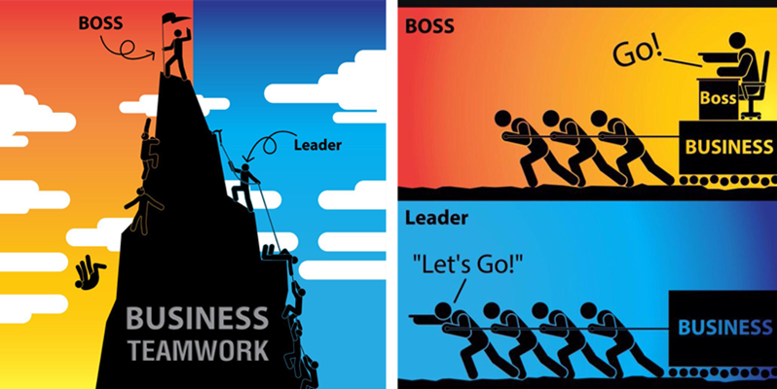

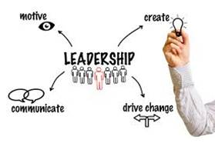

**Introduction**

Leadership is the potential to influence behaviour of others. It is also defined as the capacity to influence a group towards the realization of a goal. Leaders are required to develop future visions, and to motivate the organizational members to want to achieve the visions.Leadership is a process by which an executive can direct, guide and influence the behavior and work of others towards accomplishment of specific goals in a given situation. Leadership is the ability of a manager to induce the subordinates to work with confidence and zeal.

**Definition**

* Leadership can be defined as the ability of the management to make sound decisions and inspire others to perform well. It is the process of directing the behavior of others towards achieving a common goal. In short, leadership is getting things done through others.
* According to Keith Davis, “Leadership is the ability to persuade others to seek defined objectives enthusiastically. It is the human factor which binds a group together and motivates it towards goals.”

Leadership is a process by which an executive can direct, guide and influence the behavior and work of others towards accomplishment of specific goals in a given situation. Leadership is the ability of a manager to induce the subordinates to work with confidence and zeal.

* **Characteristics of a Good Leader**

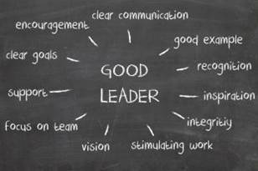

* **characteristics of LEADERSHIP:**

1. **Personal Ability:** Leadership is basically a person ability and skill. It is a personal power which arises out of knowledge, expertise and personality. According to Koontz and others, it is the ability induces subordinates to work with confidence and zeal towards the achievements of organizational goals.
2. **Followership.** Leadership requires followers. It is inseparable from followers. Involves other people, usually in the form of subordinates. It cannot exist without group of followers. Koontz and D’Donnel say, “The essence of leadership is followership. It is the willingness of people to follow that makes a person a leader.”
3. **Influencing Behaviour:** Leadership envisages “the power of influence.” It involves an attempt to influence another group member.
4. **Interpersonal Relationship:** Leadership involves group behaviour. It is interaction between a leader and one or more followers. It is a reciprocal relationship.
5. **Mutual Goals:** Leadership involves a community of interest between the leader and his followers. It exists from the realization of common goals.
6. **Its Essence is Performance.** Leadership depends on doing. Most people agree that leadership is not a personality trait, but doing something-guiding, directing, influencing or mobilizing actions. Peter Drunker has rightly remarked, “Leadership has little to do with ‘leadership qualities’ and even less do with ‘charisma’. It is mundane, unromantic and boring. It is work. Its essence is performance.”
7. **Exemplary conduct:** Leaders not only but also influence by their behaviour. They put example in their actions before the subordinates. Urwick has rightly said, “It is not what a leader says, still less what he writes, that influences subordinates. It is what he is. And they judge what he is by what he does and what he behaves.”
8. **Leadership is Situational:** It assumes that leaders are the product of given situations. Leader emerges out of situation. Leadership is dynamic art. The most effective way to lead is a dynamic and flexible process that adapts to the particulars situation.
9. **Assumption of Responsibility:** The leader assumes full responsibility for all actions of his followers. He remains responsible in all situations.
10. **Importance of Communication:** Leadership is established through the communication process. Communication affects the behaviour and performance of followers. The inability to communication is a serious deficiency in influencing people.
11. **All Managers are not Leaders:** Manager are appointed and have legitimate power that allows them to reward and punish. In contrast, leaders may either be appointed or emerge from within a group. Leaders can influence others to perform beyond me actions dictated by formal authority. They have personal capabilities to influence others. However, not all leaders necessarily hold managerial positions.
12. **Leadership may be Formal or Informal:** Managers who influence the behaviour of their assigned group are the formal leaders of organizations. Their ability to influence is founded upon the formal authority inherent in their positions. Within the organization, informal groups develop, and within those groups informal leaders who influence the behaviour of other group members.
13. **Four-faceted Concept:** Leadership involves four elements - leader, followers, organization and the environment (social, economic and political conditions.) These affect one another in determining appropriate leadership behaviour. To Terry, it implies that “almost everyone can at times show leadership behaviour.”
14. **Process:** Leadership is a process engaged in by certain individual. It is an ongoing activity in an organization. Its outcome is some form of goal accomplishment.

* **In brief, some important functions of a leader are as follows:**

1. **Formulate Purpose:** A leader defines institutional mission and role. He not only formulates the purpose of the group, he also advances it. His approach is goal-oriented.
2. **Inspire and Initiate Actions:** A leader inspires individuals to make their optimum contribution to organization goals. According to Urwick, the leader initiates all those measures necessary to keep the undertaking healthy and progressive within a competitive economy.
3. **Administer the Organization:** To administer and undertaking, a leader performs the functions of forecasting planning, organizing, direction, coordination and control.
4. **Interpret Reasons:** Leaders make sense of dynamic environment and interpret it to employees. They redirect their efforts to adapt to changing conditions. Urwick says, “Leaders interpret the reasons for everything to everybody.
5. **Represent the Institution.** Representing his institution in dealings with outside groups: government officials, suppliers, customers and the public in general is another function of a leader.
6. **Group Interaction:** The leader facilitates interaction and exchange of idea among organization members. This is done through communication system, which is maintains in the organization.
7. **Goal Accomplishment:** The leader persuades all subordinates to contribute to organizational goals in accordance with their maximum capability and zeal.
8. **Develop Teamwork:** A good leader always attempts to gain an understanding of group dynamics and to develop and nurture voluntary co-operation. He develops trust and friendliness by bringing consistency and fairness in his actions.
9. **Direct and Discipline the Employees:** The leader gives necessary instructions and guidance to the individuals in a formal way. He develops devoted and loyal followers and maintains obedience through discipline.
10. **Ordering of Internal Conflict:** The leader seeks to maintain harmony among the members of the organization. He tries to prevent his group breaking up into opposing factions.
11. **Defend the Organization’s Integrity:** The leader integrates the group with the organization. He protects the ethical values, human ideals and working principles.
12. **Maintain Stability.** The leader also helps maintain the stability of an organization in a turbulent environment. He assists in internal coordination and maintains a stable work force.



* **Distinction between Leadership and Management**

|  |  |  |
| --- | --- | --- |
|  | **Management** | **Leadership** |
| 1 | Management cannot function without formal organization structure and roles. | Leadership can exit in both organized and unorganized group. |
| 2 | A manager directs people though he use of normal authority. | But a leader may or may not have formal authority. He directs people through the use of informal and personal power. |
| 3 | Management is a special kind of leadership in which achievement of organizational goals is important. | Leadership is a broader concept than management. It occurs any time one attempts to influence the behaviour of others regardless of the reasons. |
| 4 | Management is related to the attainment of organizational goals. | It may be for one’s goal or for those of others. It may or may not be congruent with organizational goals. |
| 5 | A manager has to perform five functions of management – planning, organizing, staffing directing, and controlling | Leadership functions come under directing. A leader directs followers by influencing their behaviour. Thus, from a functional angle, leadership is a part of management but not all of it. |
| 6 | Management implies the existence superior-subordinate relationships. | Leadership behaviour an occur anywhere. It does not require manager-managed relationship. |
| 7 | Its authority arises out of a job position. | Its power arises out of personal ability, knowledge, expertise, performance or situations. |
| 8 | Managers are accountable for the job behaviour of their subordinates. | A leader is not accountable for the behaviour of followers. |
| 9 | The manager administers. | The leader innovates. |
| 10 | The manager is copy. He imitates. | The leader is original. He originates. |
| 11 | The manager accepts the status quo. | The leader challenges it. |
| 12 | The manager is the classics good soldier. | The leader is his own person. |

* **Styles and Patterns of Leadership**

1. **Style based on attitude**
2. **Positive Leadership-** In this style of leadership leader use positive rewards like recognition, pride & Praise as well as extrinsic rewards like salary hike, promotion, increase of perks & allowances to get the work done from people. Positive leader has a mindset that rewards will make employees happy & satisfied and will motivate them to work effectively and efficiently as desired from them. People will always focus on improving their performance for getting more rewards. This style of leadership leads to higher job satisfaction and performance.
3. **Negative Leadership-** In this style of leadership leaders use negative rewards like fear loss of job, reprimand, demotion, fear of suspension, force, threats penalties or a few days off without pay on people to get the work done from them. This style can help in getting good results in many situations but it is not human in nature and creates a negative & non- acceptable image of a leader in the mind of followers. It leads of more of bossism than leadership.
4. **Style based on use of Authority**
5. **Autocratic style-** This style of leadership is also known as authoritarian or directive style. This style involves retention of full authority by the leader. Leader makes all the decisions without even consulting and involving employees. In this style of leadership leader only gives order & instructions to their subordinates for getting the work done and also expects from subordinates to follow the orders and instructions. Leaders assume full responsibility for all the actions. There are basically four types of autocratic leaders.
6. **Pure Autocrat-** Pure autocrat is a dictator and decides everything without consultation from his subordinates. He uses negative motivation, criticism, penalties coercion etc to get work done. This type of leader is ineffective in democratic organization & people remain insecure and uninformed under him.
7. **Benevolent Autocrat-** This type of leaders centralizes decision making power in their hands and used positive rewards and manipulative styles to get the work done from their subordinates.
8. **Paternalistic Autocrat-** Such leaders plays the role of father for their subordinates such leaders provide benefits but do not respect their employees. They do not treat their subordinates as mature & responsible. This style of leadership is considered as unsuccessful in many work organizations.
9. **Incompetent Autocrat-** Such leaders adopts an autocratic style of leadership just to hide their incompetence before their subordinates. This style cannot be adopted for long time.

**Advantages**

1. This style of leadership leads to quick decision making as leaders does not need to consult their group members.
2. It allows the use of less competent subordinates.
3. It provides security & structure to employees.
4. It provides strong motivation to self-centered leaders.
5. It is useful to those subordinates who are not interested to assume responsibility.

**Disadvantages**

1. It creates fear & frustration & provides less freedom of work & self development to employees.
2. It gives adverse effect on productivity.
3. It restricts the development of future leaders.
4. It leads to defensive behavior from subordinates.
5. **Democratic or Participative Style-** A participative or democratic style of leadership is one in which managers involve their subordinates in decision making. There is decentralization of authority by leaders and they consult & encourage subordinates for participation in decision making process. There is high regard for people and sufficient freedom is allowed to people to work. Participative leaders are basically of three related types-
6. **Consultative leaders-** This type of leader takes the opinion from group before making a decision but they do not have the obligation to accept the group’s thinking and these leaders make it clear that they alone have final authority to make final decisions.
7. **Consensual leaders-** this type of leaders encourage a group discussion on an issue and then make a decision that reflects the general opinion (consensus) of all group members. Consensual leaders delegate more authority to the group than consultative leaders.
8. **Democratic leaders-** Democratic leaders delegate full authority to their subordinates for decision making. They function as collectors of opinion and take a vote before making a decision.

**Advantages**

1. This leadership leads to qualitative decision making as number of people are encouraged to express their ideas.
2. A positive & human relationship is established between the leader and followers.
3. It creates job satisfaction motivation and morale & also reduces employees’ grievances.
4. It creates an environment of trust, confidence, mutual co-ordination & loyalty.
5. It improves talent, productivity employees and also increases their acceptances to management ideas & actions.

**Limitations**

1. It leads to delay in decision making.
2. This style works well if employees are skilled & well informed about organizational problems.
3. This style can result into complete loss of leaders control over the employees.
4. **Free-rein Style-** This style of leadership is also called as laissez- faire. In this style of leadership leaders abdicates from leadership position and depends mostly upon the group to establish its own goals and to solve their own problems. Subordinates are given high degree of freedom in their operations. They are their own trainees and source of motivation. Free rein leader avoids power & responsibility and only provides information & represents the group to outsiders. This type of leadership is effective only when the group members are highly knowledgeable, independent, motivated and fully dedicated to the firm.

**Advantages-**

1. It helps in the personality development of subordinates.
2. It gives the feeling of responsibility among group members
3. It creates climate of work freedom & team spirit.

**Disadvantages-**

1. It may result in disorganized activities.
2. It leads to absence of centralized authority which results in group conflict & loss of group cohesiveness.
3. Some leaders use this style to avoid responsibility.
4. It leads to “non-leadership” and lack of control of leaders over employees.
   * 1. **Style based on Behaviour of leader-** This type of leadership focus on behavior of leader towards the task as well as the people who are performing the task. A four combination style of leadership can be based on behavior of leader.
5. **High-task and Low-Relationship-** This type of leadership leader has the main emphasis on the accomplishment of tasks and spends very less time to maintain relations & to provide psychological support to employees. This is more of work-oriented approach and is suitable where the employees are in experiences with the work to be performed. This type of leaders is not necessarily rude or discourteous.
6. **High-Task and High Relationship-** In this type of leadership style a leader gives high emphasis to both task accomplishment as well as Relationship building with employees. Leader spends considerable time to get work done and provide psychological support to employees. This leadership style is best in situations where people need an active & involved leader as well as in case of lack of self-confidence, or technical in employees.
7. **High Relationship and Low Task-** A leader using this type of leadership style gives much encouragement & psychological support to employees but gives a minimum guidance about the task accomplishment.
8. **Low Relationship and Low Task-** These leaders have a free-rein leadership style and give very little support, encouragement, praise as well as guidance to do work to employees. This style can be followed where subordinates are highly skilled & mature.
   * 1. **Style based on assumptions about people-** Here leadership style depends upon the assumption which a leader has about his subordinates. This two way classification of leadership is based on MC Gregor’s theory X & theory Y of motivation. This style is basically of two types-
9. **Job-Centered Leadership-** This is a task oriented style of leadership where by a leader focus on getting work done effectively by employees. It is concerned with work designing, production, planning, development of incentives, resource allocation to increase work productivity. This type of leaders focus on making employee work and plan out for worker’s job tasks and job out comes. This style of leadership is suitable for theory X leaders who distrust people and believe in close supervision.
10. **Employee- Centered Leadership-** This is people where leaders treat subordinates as person, avoids close supervision, and actively considers needs of employees and encourages them to glow, develop. This leadership style is for theory y leaders who trust their subordinates and encourage their participation and development.
    * 1. **Style based on decision making –**

Renises likert classified four styles of leadership-

|  |  |  |  |
| --- | --- | --- | --- |
| **System 1** | **System 2** | **System 3** | **System 4** |
| Exploitive Authoritative | Benevolent Authoritative | Consultative Authoritative | Participative Authoritative |

1. **Exploitive Authoritative-** He is highly autocratic, little trust on subordinates; limits decision-making at the tap, avoid upward communication & motivate people through fear.
2. **Benevolent authoritarian-** This kind of leader has a patronizing attitude towards employees, invites new ideas from subordinates allow some delegation and motivate then by rewards and some use of punishment.
3. **Consultative Authoritarian-** Leaders have substantial but not complete trust in employees. They invite ideas from subordinates, allow for decision making by subordinates in some case but act consultatively in various matters.
4. **Participative authoritarian-** Leaders have complete trust in decision-making of employees in all matters. He involves high level participation of subordinates, set high performance of goals & act a source of knowledge & guidance for subordinates. According to Likert those who apply 4th style of leadership are more successful as leaders.
   * 1. **Style based on concern for production versus concern for people:**

**Managerial Grid Style-** This leadership style was given by Blake & Mouton. This grid classifies leaders as having five dimensions- concern for people and concern for production. Grid shows five combination of leadership style.

1. **Impoverished Management-** It has low concern for both people and production. The leader has minimum involvement in his job and only act as a messenger for communicating information from superiors to subordinates.
2. **Country club Management-** Under this style a leader has no concern for production but has only concern for people. He concentrates on warm human relations.
3. **Task Management-** Under this style leads is highly concern for task management and little or no concern for subordinates needs & motivation
4. **Team Management-** Leaders has strong regard for both people and production. Team leader’s leads to high morale and high efficiency.
5. **Middle Road Management-** Leader give medium concern for production and for people and leader attains adequate level of performance by balancing efficiency with reasonable goods human relations. Blake & Mouton suggests that the team leaders’ style (9, 9) is most effective because it combines a high degree of concern for people as well as production.

**Theories of Leadership**

**Trait Theory**

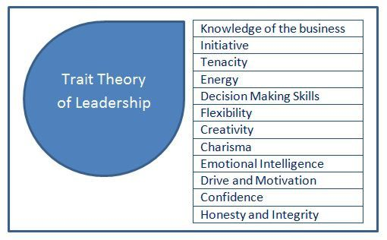

Trait theory of leadership focus on the individual characteristics or set of trait or features which all the successful leaders have and which make them distinct from their followers. The criteria for becoming a leader depends on the set of features or personality traits which a person posses. A broad category of traits of successful leaders are as under-

1. Physical characteristics such as age, weight, height.
2. Background characteristics such as education, social status, motivation and experience.
3. Intelligence- ability, judgment, knowledge.
4. Task-oriented characteristics-achievement needs responsibility, initiative and persistence.
5. Social characteristics-popularity, Prestige, tact, diplomacy acceptance of social responsibility.
6. Maturity, human relations attitude, fairness, adaptability and open-mindness.

**Merits of Trait Theory**

1. This theory focus on certain traits which a leader should have which make them differentiated from non-leaders.
2. This theory relate to the influence of personality on one’s effectiveness.
3. This theory has certain practical implications. If proper leadership traits could be identified be able to get good leaders. This theory differentiates leaders from non-leaders on the basis of personality traits.

**Limitations of Trait Theory**

1. List of personality traits of successful as not specific.
2. This theory assumes that a leader is born and not trained.
3. Leadership effectiveness does not depend on personality of a leader alone.

* **Behavioral Theories**

Behavioral theories give an emphasis on the behaviour of leaders rather than on the traits or personality features of a leader. This approach differs from trait approach is two ways-

1. Emphasis is made on leaders’ behaviour instead of personal traits.
2. Trait studies separate leaders from non-leaders whereas behavioral studies whereas behavioural studies emphasize on impact of leaders behavioural on employees’ performance & satisfaction. There are two important Behavioural theories-

**OHIO STATE UNIVERSITY STUDIES-** These studies were stated shortly after World War II. The main objective of this study was to determine the major dimensions of leadership and to investigate on employee performance & satisfaction. Two dimensions of leadership were identified in this study to identify the behaviour of leaders-

1. **The initiating Structure-** It refers to leader behaviour that defines & organizes the group tasks, assigns the task to employees and supervises their activities. Leader follows task-oriented behaviour.
2. **Consideration-** It refers to leaders’ behaviour characterized by friendliness, respect, supportiveness, openers, trust and concern for welfare of people. This study states that both consideration and initiating structure are not been seen as being placed continuously. A leader can be high or low on both the dimensions or could be high on one & low on other dimensions.

|  |  |
| --- | --- |
| High Relationship & low task (Supporting Style)  Low  High  Task Emphasis  People Emphasis  High  Low | High task & High Relationship (Participation style) |
| Low task & Low Relationship (Free-rein) | High task & Low Relationship (Autocratic) |

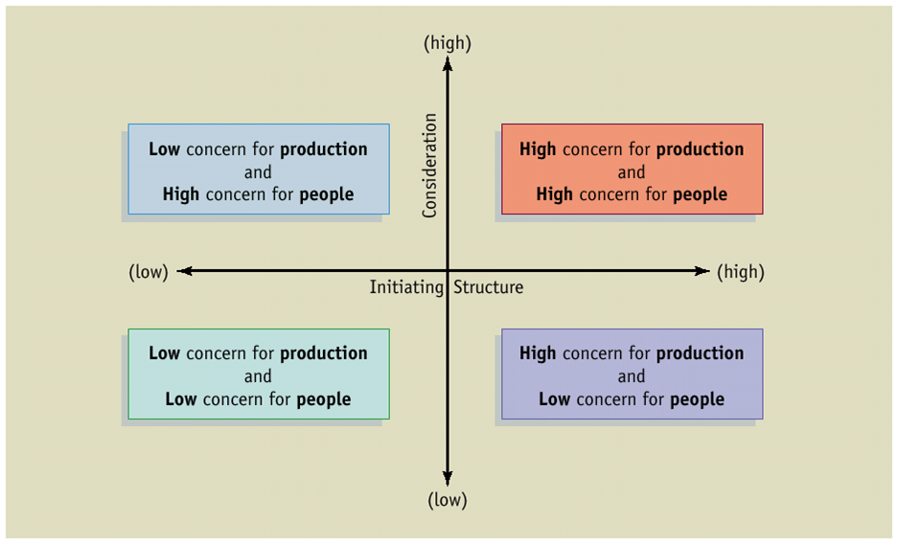

**Main findings of Ohio state studies are-**

1. Consideration was positively related to low absenteeism and grievance, but it was negatively or neutrally related to performance.
2. Initiating structure was positively related to employee performance but was also associated with such negative consequences as absenteeism and grievances as absenteeism and grievances.
3. When both consideration & structure were high, performance and satisfaction was high but in some cases high productivity was accompanied by absenteeism and grievances.

**THE UNIVERSITY OF MICHIGAN STUDIES-** These studies were conducted during same period as at Ohio state and resulted in identical conclusions. Researchers at university of Michigan distinguished between two dimensions of leadership.

1. **Production centered-** Where leader set rigid tasks, standards describe work methods & closely supervise subordinates.
2. **Employee centered-** Where leaders encourage employee participation in goal setting & work decisions, have respect and trust and ensure high performance from employee.

Michigan study’s findings were same like Ohio studies analysis that employee and work orientation are two separate dimensions and that a leader can be either high or low one the dimension or both and these dimensions cannot be placed continuously in leader.

Production Centered

Employee Centered

Two styles developed by Michigan researchers were similar to Ohio state people.

Production centered → initiating structure. Employee centered → consideration.

**Managerial Grid Theory-**

This leadership theory is given by Blake & Mouton. This grid classifies leaders as having five dimensions- concern for people and concern for production. Grid shows five combination of leadership style.

1. **Impoverished Management-** It has low concern for both people and production. The leader has minimum involvement in his job and only act as a messenger for communicating information from superiors to subordinates.
2. **Country club Management-** Under this style a leader has no concern for production but has only concern for people. He concentrates on warm human relations.
3. **Task Management-** Under this style leads is highly concern for task management and little or no concern for subordinates needs & motivation
4. **Team Management-** Leaders has strong regard for both people and production. Team leader’s leads to high morale and high efficiency.
5. **Middle Road Management-** Leader give medium concern for production and for people and leader attains adequate level of performance by balancing efficiency with reasonable goods human relations. Blake & Mouton suggests that the team leaders’ style (9, 9) is most effective because it combines a high degree of concern for people as well as production.

(1, 9)

Country club

(9, 9)

Team

Management

(5, 5)

(1, 1)

Impoverished

Management

Middle Road

(9, 1)

Task Management

Low

High

Concern for Production

Concern for People

High

Low

1 2 3 4 5 6 7 8 9

9

8

7

6

5

4

3

2

1

0

**Evaluation of Behavioural Theory**

Behaviour theories focus on what leader did, how they delegate task, communicate & motivate subordinates and how they carry on their work. They focus that behaviour can be learnt and individual having appropriate behaviour can become a effective leader.

**Leader- member Exchange (LMX) Theory-** This theory is also called vertical dyad model. This approach also focuses on leader behaviours. A vertical dyad consists of two persons who are linked hierarchically such as superior & a subordinate and a leader’s behaviour depends upon who is a subordinate. According to LMX theory a leader form two groups-

1. **In-GROUP-** Consist of those subordinates or group members who are similar to the leader and get greater responsibilities, more attention and more rewards. They work within the leaders inner circle of communication.
2. **Out-Group-** Consist of those members who are outside the circle and receive less attention and fewer rewards. They are managed by formal rules & policies. In –group members are more satisfied have lower turnover and have high organizational commitment & vice-versa.

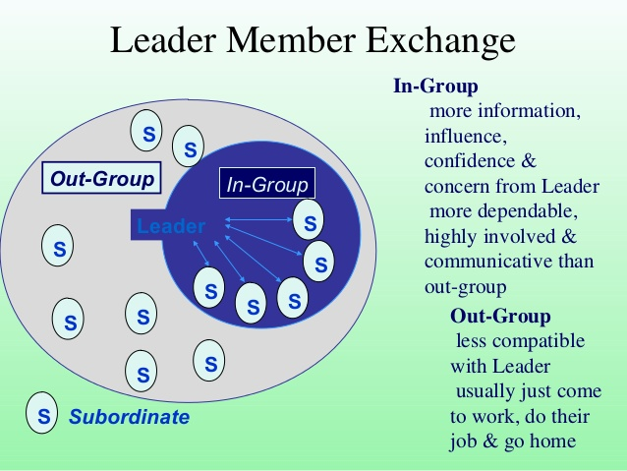

**Implication of the Theory**

1. Leadership can be better understand by farming & examining dyads (Pair of relationship) model by leader & member rather than focusing on average leadership style.
2. Theory focused that average leadership style (same or average behaviour of leader to all the group members) is impractical & traditional in approach.
3. Theory focus that leader behave differently with in-group members & out group members.

Traditional view

Leader

In Group Subordinates

Out group subordinate Panel B

LMX view

Leader

Panel A

Subordinates

In this figure (Panel a) shows the traditional view of leaders & Subordinates where equality in behaviour of leader to subordinate is shown. (Panel b) reflects the vertical dyad where in-group members enjoy a better relationship with leader than out group members which can be shown b differing distances as well as differences in equality of working relationship, influence, authority and access to information

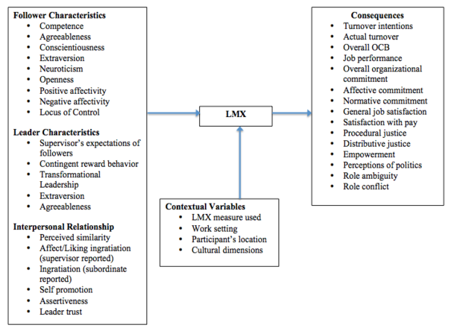

.

* **Path-Goal Theory of Leadership-**

This approach to leadership was developed by Robert House. The essence of this theory is that leader uses organizational structure, rewards, resources and support to create a favorable work environment where subordinates can work to achieve organizational goals and also clear the path for the goal achievement for subordinates. The theory is called as path goal theory because its major concern is how the leader influence the subordinates perception regarding their work goals, personal goals and path to achieve goals.

Theory suggests that a leader’s behaviour is motivating or satisfying to the degree that the behaviour increases the goal attainment and clarifies the path to these goals. Path -goal theory is one of the contingency models. The leader’s effectiveness, according to the path goal theory in influencing rewards and expectancies depends on the characteristics of the environment and subordinates.

Leader Behaviour style

* Directive
* Supportive
* Participative
* Achievement oriented

Follower Path Perception towards

* Effort
* Performance
* Rewards

Follower motivation & Satisfaction

Situational Factors

Follower characteristics

Work place characteristics

In figure the ultimate effect of leadership behaviour on motivation and satisfaction is contingent upon the characteristics of environment and of subordinates and follower perceptions about effort reward linkage.

Evaluation of Theory- The path-goal theory deserves appreciation as the theory suggest that leader should first assess the situation and then select a leadership behaviour appropriate to situation for linking effort to performance expectancies performance to reward expectancies or valance to outcome.

Example-situation leader follower outcomes

* **The situational leadership Theory**

This theory of leadership was developed by Paul Hersey & Kenneth Blenchard. This theory focuses on ‘maturity’ of followers for deciding the appropriate leadership style. Theory focus on that situational leadership requires adjusting the leader’s emphasis on task behaviour (guiding & direction) and relationship behaviour (offering socio-emotional support) according to the maturity of followers in performing their tasks. Maturity according to this theory means desire for achievement, willingness to accept responsibility etc.

Herey and Blachard believe that the relation between leader and subordinates moves through four phases like a life cycle as subordinates develop and mature. Leaders or managers need to change their leadership styles with each phase.

**Style of leader**

|  |  |  |  |
| --- | --- | --- | --- |
| Low  High  Task Behaviour  Low  High  Task Behaviour  High relationship & low task  S3 • | S4  •  Low relationship and low task | S1  •  High task & low relationship | High task and high relationship  S2  • |

S1 = Telling

S2 = Selling

S3 = Participating

S4 = Delegation

1. In first stage in a figure i.e. at initial phase subordinates enter in a organization so manager should follow the directive or task oriented approach to clear the goals, task, rules & procedures in an organization to subordinates.

This style is also called as “Telling’ approach of leadership

1. In the second stage subordinates start learning their tasks but task-orientation still remains essential as subordinates are not yet willing or able to accept full responsibility. Managers become familiar with subordinates so that can follow employed oriented behaviour. This is called as ‘selling’ or coaching approach to leadership.
2. In third phase subordinates involvement, ability and achievement motivation are increases so managers is not required to be directive manager will trust subordinates. This is called as ‘participating’ style.
3. In fourth phase manager can reduce the amount of support & encouragement as subordinates gradually become more confident, self-directing & experienced. Subordinates are ‘on their own’ and no longer need to expect a directive relationship with their manager. This is also called as ‘delegating style.

# GROUP DYNAMICS

A group can be defined as several individuals who come together to accomplish a particular task or goal. Group dynamics refers to the attitudinal and behavioral characteristics of a group. Group dynamics concern how groups form, their structure and process, and how they function. Group dynamics are relevant in both formal and informal groups of all types. In an organizational setting, groups are a very common organizational entity and the study of groups and group dynamics is an important area of study in organizational behavior.

The following sections provide information related to group dynamics. Specifically, the formation and development of groups is first considered. Then some major types or classifications of groups are discussed. Then the structure of groups is examined.

## GROUP DEVELOPMENT

As applied to group development, group dynamics is concerned with why and how groups develop. There are several theories as to why groups develop. A classic theory, developed by George Homans, suggests that groups develop based on activities, interactions, and sentiments. Basically, the theory means that when individuals share common activities, they will have more interaction and will develop attitudes (positive or negative) toward each other. The major element in this theory is the interaction of the individuals involved.

Social Exchange Theory offers an alternative explanation for group development. According to this theory, individuals form relationships based on the implicit expectation of mutually beneficial exchanges based on trust and felt obligation. Thus, a perception that exchange relationships will be positive is essential if individuals are to be attracted to and affiliate with a group.

Social Identity Theory offers another explanation for group formation. Simply put, this theory suggests that individuals get a sense of identity and self-esteem based upon their membership in salient groups. The nature of the group may be demographically based, culturally based, or organizationally based. Individuals are motivated to belong to and contribute to identity groups because of the sense of belongingness and self-worth membership in the group imparts.

Group dynamics as related to development concerns not only why groups form but also how. The most common framework for examining the "how" of group formation was developed by Bruce Tuckman in the 1960s. In essence, the steps in group formation imply that groups do not usually perform at maximum effectiveness when they are first established. They encounter several stages of development as they strive to become productive and effective. Most groups experience the same developmental stages with similar conflicts and resolutions.

According to Tuckman's theory, there are five stages of group development: forming, storming, norming, performing, and adjourning. During these stages group members must address several issues and the way in which these issues are resolved determines whether the group will succeed in accomplishing its tasks.

1. **Forming**. This stage is usually characterized by some confusion and uncertainty. The major goals of the group have not been established. The nature of the task or leadership of the group has not been determined.

Thus, forming is an orientation period when members get to know one another and share expectations about the group.

Members learn the purpose of the group as well as the rules to be followed. The forming stage should not be rushed because trust and openness must be developed. These feelings strengthen in later stages of development. Individuals are often confused during this stage because roles are not clear and there may not be a strong leader.

1. **Storming.** In this stage, the group is likely to see the highest level of disagreement and conflict. Members often challenge group goals and struggle for power. Individuals often vie for the leadership position during this stage of development.

This can be a positive experience for all groups if members can achieve cohesiveness through resolution. Members often voice concern and criticism in this phase. If members are not able to resolve the conflict, then the group will often disband or continue in existence but will remain ineffective and never advance to the other stages.

1. **Norming**. This stage is characterized by the recognition of individual differences and shared expectations. Hopefully, at this stage the group members will begin to develop a feeling of group cohesion and identity. Co-operative effort should begin to yield results. Responsibilities are divided among members and the group decides how it will evaluate progress.
2. **Performing.** Performing, occurs when the group has matured and attains a feeling of cohesiveness. During this stage of development, individuals accept one another and conflict is resolved through group discussion. Members of the group make decisions through a rational process that is focused on relevant goals rather than emotional issues.
3. **Adjourning**. Not all groups experience this stage of development because it is characterized by the disbandment of the group. Some groups are relatively permanent .Reasons that groups disband vary, with common reasons being the accomplishment of the task or individuals deciding to go their own ways. Members of the group often experience feelings of closure and sadness as they prepare to leave.

## GROUP TYPES

One common way to classify group is by whether they are formal or informal in nature. Formal work groups are established by an organization to achieve organizational goals. Formal groups may take the form of command groups, task groups, and functional groups.

### COMMAND GROUPS.

Command groups are specified by the organizational chart and often consist of a supervisor and the subordinates that report to that supervisor. An example of a command group is an operations department chairman and the members in that department.

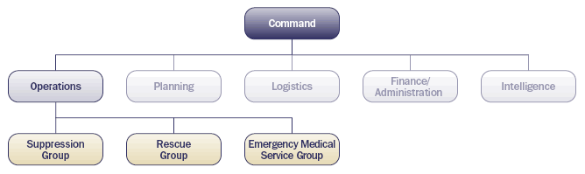

### TASK GROUPS.

Task groups consist of people who work together to achieve a common task. Members are brought together to accomplish a narrow range of goals within a specified time period. Task groups are also commonly referred to as task forces. The organization appoints members and assigns the goals and tasks to be accomplished. Examples of assigned tasks are the development of a new product, the improvement of a production process, or the proposal of a motivational contest. Other common task groups are ad hoc committees, project groups, and standing committees. Ad hoc committees are temporary groups created to resolve a specific complaint or develop a process. Project groups are similar to ad hoc committees and normally disband after the group completes the assigned task. Standing committees are more permanent than ad hoc committees and project groups. They maintain longer life spans by rotating members into the group.

### FUNCTIONAL GROUPS.

A functional group is created by the organization to accomplish specific goals within an unspecified time frame. Functional groups remain in existence after achievement of current goals and objectives. Examples of functional groups would be a marketing department, a customer service department, or an accounting department.

In contrast to formal groups, informal groups are formed naturally and in response to the common interests and shared values of individuals. They are created for purposes other than the accomplishment of organizational goals and do not have a specified time frame. Informal groups are not appointed by the organization and members can invite others to join from time to time. Informal groups can have a strong influence in organizations that can either be positive or negative. For example, employees who form an informal group can either discuss how to improve a production process or how to create shortcuts that jeopardize quality. Informal groups can take the form of interest groups, friendship groups, or reference groups.

### INTEREST GROUPS.

Interest groups usually continue over time and may last longer than general informal groups. Members of interest groups may not be part of the same organizational department but they are bound together by some other common interest. The goals and objectives of group interests are specific to each group and may not be related to organizational goals and objectives. An example of an interest group would be students who come together to form a study group for a specific class.

### FRIENDSHIP GROUPS.

Friendship groups are formed by members who enjoy similar social activities, political beliefs, religious values, or other common bonds. Members enjoy each other's company and often meet after work to participate in these activities. For example, a group of employees who form a friendship group may have an exercise group, a softball team, or a potluck lunch once a month.

### REFERENCE GROUPS.

A reference group is a type of group that people use to evaluate themselves. According to Cherrington, the main purposes of reference groups are social validation and social comparison. Social validation allows individuals to justify their attitudes and values while social comparison helps individuals evaluate their own actions by comparing themselves to others. Reference groups have a strong influence on members' behavior. By comparing themselves with other members, individuals are able to assess whether their behavior is acceptable and whether their attitudes and values are right or wrong. Reference groups are different from the previously discussed groups because they may not actually meet or form voluntarily. For example, the reference group for a new employee of an organization may be a group of employees that work in a different department or even a different organization. Family, friends, and religious affiliations are strong reference groups for most individuals.

## GROUP STRUCTURE

Group structure is a pattern of relationships among members that hold the group together and help it achieve assigned goals. Structure can be described in a variety of ways. Among the more common considerations are group size, group roles, group norms, and group cohesiveness.

### GROUP SIZE. Group size can vary from 2 people to a very large number of people. Small groups of two to ten are thought to be more effective because each member has ample opportunity to participate and become actively involved in the group. Large groups may waste time by deciding on processes and trying to decide who should participate next. Group size will affect not only participation but satisfaction as well. Evidence supports the notion that as the size of the group increases, satisfaction increases up to a certain point. In other words, a group of six members has twice as many opportunities for interaction and participation as a group of three people. Beyond 10 or 12 members, increasing the size of the group results in decreased satisfaction. It is increasingly difficult for members of large groups to identify with one another and experience cohesion.

## GROUP ROLES

In formal groups, roles are usually predetermined and assigned to members. Each role will have specific responsibilities and duties. There are, however, emergent roles that develop naturally to meet the needs of the groups. These emergent roles will often replace the assigned roles as individuals begin to express themselves and become more assertive. Group roles can then be classified into work roles, maintenance roles, and blocking roles.

Work roles are task-oriented activities that involve accomplishing the group's goals. They involve a variety of specific roles such as initiator, informer, clarifier, summarizer, and reality tester. The initiator defines problems, proposes action, and suggests procedures.

The informer role involves finding facts and giving advice or opinions. Clarifiers will interpret ideas, define terms, and clarify issues for the group. Summarizers restate suggestions, offer decisions, and come to conclusions for the group. Finally, reality testers analyze ideas and test the ideas in real situations.

Maintenance roles are social-emotional activities that help members maintain their involvement in the group and raise their personal commitment to the group. The maintenance roles are harmonizer, gatekeeper, consensus tester, encourager, and compromiser. The harmonizer will reduce tension in the group, reconcile differences, and explore opportunities. Gatekeepers often keep communication channels open and make suggestions that encourage participation. The consensus tester will ask if the group is nearing a decision and test possible conclusions. Encouragers are friendly, warm, and responsive to other group members. The last maintenance role is the compromiser. This role involves modifying decisions, offering compromises, and admitting errors.

Blocking roles are activities that disrupt the group. They make take the form of dominating discussions, verbally attacking other group members, and distracting the group with trivial information or unnecessary humor. Often times the blocking behavior may not be intended as negative. Sometimes a member may share a joke in order to break the tension, or may question a decision in order to force group members to rethink the issue. The blocking roles are aggressor, blocker, dominator, comedian, and avoidance behavior. The aggressor criticizes members' values and makes jokes in a sarcastic or semi-concealed manner.

Blockers will stubbornly resist the group's ideas, disagree with group members for personal reasons, and will have hidden agendas. The dominator role attempts to control conversations by patronizing others. They often interrupt others and assert authority in order to manipulate members. Comedians often abandon the group even though they may physically still be a part. They are attention-getters in ways that are not relevant to the accomplishment of the group's objectives. The last blocking role, avoidance behavior, involves pursuing goals not related to the group and changing the subject to avoid commitment to the group.

Role ambiguity concerns the discrepancy between the sent role and the received role, Supervisors, directors, or other group leaders often send (assign) roles to group members in formal groups. Group members receive roles by being ready and willing to undertake the tasks associated with that role. Ambiguity results when members are confused about the delegation of job responsibilities. This confusion may occur because the members do not have specific job descriptions or because the instructions regarding the task were not clear. Group members who experience ambiguity often have feelings of frustration and dissatisfaction, which ultimately lead to turnover.

Role conflict occurs when there is inconsistency between the perceived role and role behavior. There are several different forms of role conflict.

**Inter-role** conflict occurs when there is conflict between the different roles that people have. For example, work roles and family roles often compete with one another and cause conflict.

**Intra-role** conflict occurs when individuals must handle conflicting demands from different sources while performing the tasks associated with the same role.

### GROUP NORMS.

Norms are acceptable standards of behavior within a group that are shared by the members of the group. Norms define the boundaries of acceptable and unacceptable behavior. They are typically created in order to facilitate group survival, make behavior more predictable, avoid embarrassing situations, and express the values of the group. Each group will establish its own set of norms that might determine anything from the appropriate dress to how many comments to make in a meeting. Groups exert pressure on members to force them to conform to the group's standards. The norms often reflect the level of commitment, motivation, and performance of the group.

Performance norms determine how quickly members should work and how much they should produce. They are created in an effort to determine levels of individual effort. They can be very frustrating to managers because they are not always in line with the organization's goals. Members of a group may have the skill and ability to perform at higher levels but they don't because of the group's performance norms. For example, workers may stop working a production machine at 20 minutes before quitting time in order to wash up, even though they produced fewer items that day than management intended.

### GROUP COHESIVENESS.

Cohesiveness refers to the bonding of group members and their desire to remain part of the group. Many factors influence the amount of group cohesiveness. Generally speaking, the more difficult it is to obtain group membership the more cohesive the group. Groups also tend to become cohesive when they are in intense competition with other groups or face a serious external threat to survival. Smaller groups and those who spend considerable time together also tend to be more cohesive.

Cohesiveness in work groups has many positive effects, including worker satisfaction, low turnover and absenteeism, and higher productivity. However, highly cohesive groups may be detrimental to organizational performance if their goals are misaligned with organizational goals. Highly cohesive groups may also be more vulnerable to groupthink.

**ORGANISATIONAL STRUCTURE**

* UNIT IV
* Introduction To Organisational Structure
* Definition
* Concepts

**Introduction:**

Organizational structure is a system used to define a hierarchy within an organization. It identifies each job, its function and where it reports to within the organization. This structure is developed to establish how an organization operates and assists an organization in obtaining its goals to allow for future growth. The structure is illustrated using an organizational chart.

# 5 Main Types of Organisation Structure

#### Line Organisation:

Line organisation is the simplest and oldest form of organisation structure. It is called as military or departmental or scalar type of organization. Under this system, authority flows directly and vertically from the top of the managerial hierarchy ‘down to different levels of managers and subordinates and down to the operative level of workers.

Line organisation clearly identifies authority, responsibility and accountability at each level. The personnel in Line organization are directly involved in achieving the objectives of the organization.

**The line organisation structure is given below:**

[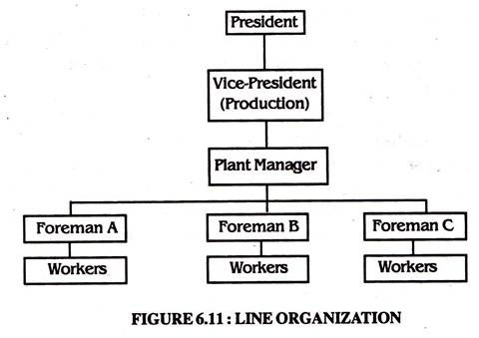](http://cdn2.businessmanagementideas.com/wp-content/uploads/2016/06/clip_image002-25.jpg)

**Advantages of Line Organization:**

a. The line organization structure is very simple to understand and simple to operate.

b. Communication is fast and easy and feedback can be acted upon faster.

c. Responsibility is fixed and unified at each level and authority and accountability are clear-cut, hence each individual knows to whom he is responsible and who is or in truth responsible to him.

d. Since it is especially useful when the company is small in size, it provides for greater control and discipline in the organization.

e. It makes rapid decisions and effective coordination possible. So it is economic and effective.

f. The people in line type of organization get to know each other better and tend to feel close to each other.

g. The system is capable of adjusting itself to changing conditions for the simple reason that each executive has sole responsibility in his own sphere.

**Disadvantages of Line Organization:**

a. It is a rigid and inflexible form of organization.

b. There is a tendency for line authority to become dictatorial.

c. It overloads the executive with pressing activities so that long-range planning and policy formulation are often neglected.,

d. There is no provision for specialists and specialization, which is essential for growth and optimisation.

e. Different departments may be much interested in their self-interests, rather than overall organizational interests and welfare.

f. It is likely to encourage nepotism.

g. It does not provide any means by which a good worker may be rewarded and a bad one punished.

#### Line and Staff Organization:

This type of organization structure is in large enterprises. The functional specialists are added to the line in line and staff organization. Mere, staff is basically advisory in nature and usually does not possess any command authority over line managers. Allen has defined line and staff organization as follows.

“Line functions are those which have direct responsibility for accomplishing the objectives of the enterprises and staff refers to those elements of the organization that help the line to work most effectively in accomplishing the primary objectives of the enterprises.”

In the line and staff organisation, staffs assist the line managers in their duties in order to achieve the high performance. So, in an organization which has the production of textiles, the production manager, marketing manager and the finance manager may be treated as line executives, and the department headed by them may be called line departments

On the other hand, the personnel manager who deal with the recruitment, training and placement of workers, the quality control manager who ensure the quality of products and the public relations manager are the executives who perform staff functions.

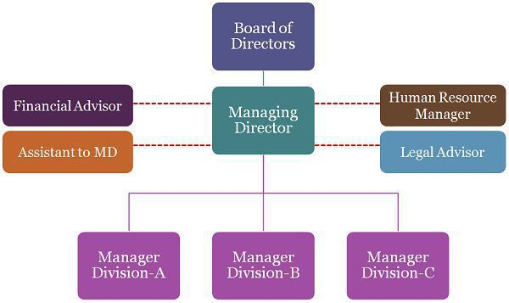

**Advantages of Line and Staff Organisation:**

a. Line officers can concentrate mainly on the doing function as the work of planning and investigation is performed by the staff. Specialisation provides for experts advice and efficiency in management.

b. Since the organisation comprises line and staff functions, decisions can be taken easily.

c. The staff officers supply complete factual data to the line officers covering activity within and without their own units. This will help to greater co-ordination.

d. It provides an adequate opportunity for the advancement of workers.

e. The staff services provides a training ground for the different positions.

f. Adequate organisation a balance among the various activities can be attained easily.

g. The system is flexible for new activities may be undertaken by the staff without forcing early adjustments of line arrangements.

h. Staff specialists are conceptually oriented towards looking ahead and have the time to do programme and strategic planning and analyse the possible effects of expected future events.

**Disadvantages of Line and Staff Organisation:**

a. Confusion and conflict may arise between line and staff. Because the allocation of authority and responsibility is not clear and members of the lower levels may be confused by various line orders and staff advices.

b. Staff generally advise to the lines, but line decides and acts. Therefore the staffs often feel powerless.

c. Too much reliance on staff officers may not be beneficial to the business because line officials may lose much of their judgment and imitative.

d. Normally, staff employees have specialised knowledge and expert. Line makes the final decisions, even though staff give their suggestions. Staff officers, therefore, may be resented.

e. Staff officers are much educated so their ideas may be more theoretical and academic rather than practical.

f. Although expert advice is available it reaches the workers through the managers. Here it is liable to create a greater deal of misunderstanding and misinterpretation.

g. Since staff specialists demand higher payments, it is expensive.

h. The staff are unable to carry out its plan or recommendations because of lack of authority. So they become ineffective sometimes, it will make them careless and indifferent towards their jobs.

i. Since the line are performed, with the advice provided by the staff, if things go right then the staff takes the credit and if things go wrong then the line get the blame for it.

#### Functional Organisation:

#### 

A functional organization structure is a hierarchical organization structure wherein people are grouped as per their area of specialization. These people are supervised by a functional manager with expertise in the same field. This expertise helps him effectively utilize the skills of employees, which ultimately helps organizations in achieving its business objectives.

In this kind of organization structure, people are classified according to the function they perform within the organization. The organizational chart for a functional organization structure shows the president, vice president, finance department, sales department, customer service, administration, etc.

Each department will have a department head who will be responsible for the performance of his section. This helps the organization control the quality and uniformity of performance

#### Project Organisation:

This organisational structure are temporarily formed for specific projects for a specific period of time, for the project of achieving the goal of developing new product, the specialists from different functional departments such as production, engineering, quality control, marketing research etc., will be drawn to work together. These specialists go back to their respective duties as soon as the project is completed.

Really, the project organisation is set-up with the object of overcoming the major weakness of the functional organisation, such as absence of unity of command, delay in decision-making, and lack of coordination.

**The project organization chart may be shown as follows:**

[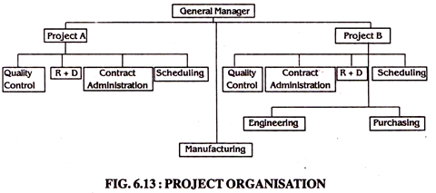](http://cdn3.businessmanagementideas.com/wp-content/uploads/2016/06/image-1.png)

**Advantages of Project Organisation:**

a. It is a remarkable illustration of relationship between environment, strategy and structure.

b. The grouping of activities on the basis of each project results in introduction of new authority patterns.

c. Since the specialists from different departments is drawn to work together under the project organisation it helps to coordination.

d. It makes for meaningful control and fixation of individual responsibility.

**Disadvantages of Project Organisation:**

a. The uncertainty may be attributed to the diverse backgrounds of the professional who are deputed to the project.

b. The project manager finds it difficult to motivate and control the staff in a traditional way in the absence of well-defined areas of responsibility lines of communication and criteria to judge performance.

c. Delay in completion of the project may occur.

d. Effective project management may also be hindered by the top management who may not be wholly are of the problems at the project centre.

#### Matrix Organisation:

According to Stanley Davis and Paul Lawrence matrix organisation is “any organisation that employs a multiple command system that includes not only the multiple command structure, but also related support mechanism and an associated organisational culture and behaviour pattern.”

A matrix organisation, also referred to as the “multiple command system” has two chains of command. One chain of command is functional in which the flow of authority is vertical.

The second chain is horizontal depicted by a project team, which is led by the project, or group manager who is an expert in his team’s assigned area of specialisation.

Since the matrix structure integrates the efforts of functional and project authority, the vertical and horizontal lines of authority are combination of the authority flows both down and across. The matrix form of organisation is given below.

[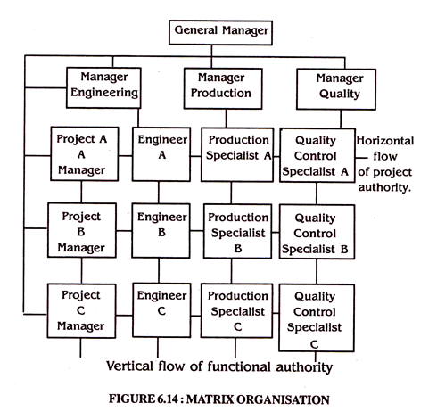](http://cdn3.businessmanagementideas.com/wp-content/uploads/2016/06/image-2.png)

**Advantages of Matrix Organisation:**

1. Since there is both vertical and horizontal communication it increases the coordination and this coordination leads to greater and more effective control over operations.

2. Since the matrix organisation is handling a number of projects, available resources will be used fully.

3. It focuses the organisational resources on the specified projects, thus enabling better planning and control.

4. It is highly flexible as regards adherence to rules, procedures etc. Here experience is the best guide to establishing rules and procedures.

5. As any department or division has to harness its effort towards accomplishment of a single project, employees are effectively motivated.

**Disadvantages of Matrix Organisation:**

1. Since, there is more than one supervisor for each worker, it causes confusion and conflicts and reduce effective control.

2. There is continuous communication both vertically as well horizontally, which increases paper work and costs.

3. It is difficult to achieve a balance below on the projects technical and administrative aspects.

**Organisational Culture**

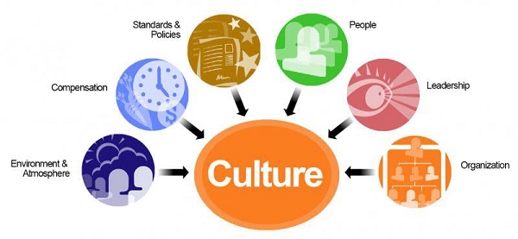

Organizational culture, also known as corporate culture, is a strategic intangible scheme that incorporates basic assumptions and values which define the behavior, operation, and activities of an organization. In other words, it’s the general attitude, mood, and motivation, or lack thereof, of the people in the company.

## What Does Organizational Culture Mean?

Organizational culture represents an company’s common beliefs and concepts that create the social and psychological environment of an organization. In the contemporary business environment, the company culture often contributes to its success, as it is unique and it cannot be transferred to competitors. It can also contribute to its failure. Based on corporate culture, members know how they should perform their jobs, behave, and dress.

Furthermore, culture dictates the freedom of participation in the managerial decision-making. A strong culture has a strong influence on organizational members and creates committed employees by instilling clear cultural values and beliefs. A weak culture can breed apathy, resentment, and unproductive workers.

**Meaning and Definition**

“Culture is the set of important understanding that members of a community share in common". It consists of basic sets of values, ideas, perception, concept of morality, code of conduct etc. which create distinctiveness among human groups.

"Organizational culture can be defined as a system of shared beliefs and attitudes that develop within an organization and guide the behaviour of its members."

**Changing Organizational Culture**

The following condition may be present only then a cultural change can take place:

1. **Dramatic Crisis:** Any Dramatic crisis in the organisation like a major financial setback, loss of a major customer or a technological breakthrough by a competitor may force the management to look into relevance of the existing culture
2. **New Top Leadership:** IF some top executives leave the organization and new leadership takes over, they may provide an alternative set of key values or a new culture. This new leadership may be more capable of responding to the crisis.
3. **Young and Small Organization:** When the organization is new and its size is small, it will be easier for the management to change the culture.

**Weak Culture:** Weak cultures are more amenable to change than strong ones. The higher the agreement among the members on the organizational values, the more difficult it will be to change.

* **Dimensions of Organisational Culture**

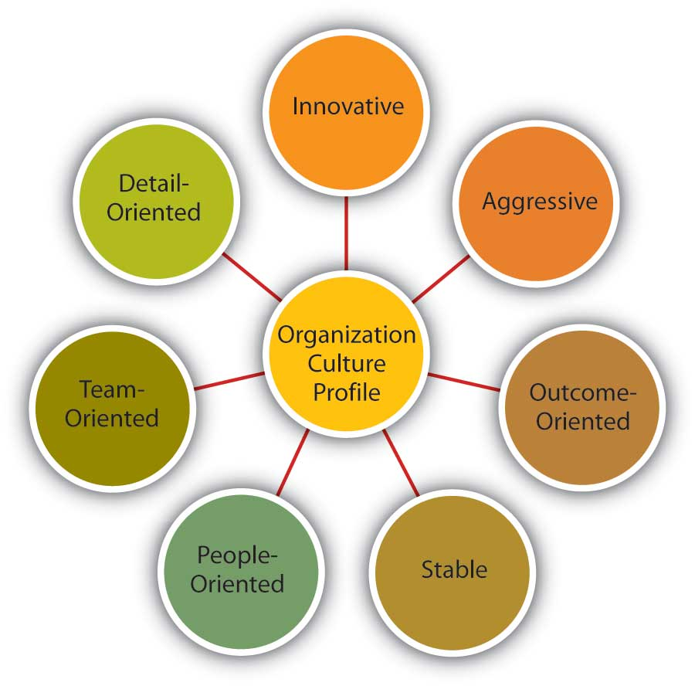

**Attitudes and values**

**Introduction**

Attitudes constitute an important psychological attribute of individuals which shape their behaviour. **Schermerhorn**, have defined attitude as a predisposition “**to respond in a positive or negative way to someone or something in one’s environment”**.

When a person says that he likes or dislikes something, an attitude is being expressed. Attitude can be defined as a persistent tendency to feel & behave in a particular way towards some object.

**Some of the important definitions of attitudes are as follows:**

“An attitude is a mental and neutral state of readiness, organized through experience, exerting a directive or dynamic influence upon the individual’s response to all objects and situation with which is it related. **G.W. Allport**

“An attitude is a tendency or predisposition to evaluate an object or symbol of that object in a certain. **—Katz and Scotland**

**Components of attitudes**

There are three basic components of an attitude and these are described below:

1. **Cognitive or Informational Component**. It consists of beliefs and value, idea and other information a person has about the attitude object. For instance, a person seeking a job may learn from newspapers and other people that a particular company is a good pay-master.
2. **Affective or Emotional Component**. It involves the person’s feelings of likes and dislikes towards the attitude object.
3. **Behaviour Component**. The tendency of a person to behave in a particular manner towards the attitude object is the behavioural component of an attitude.

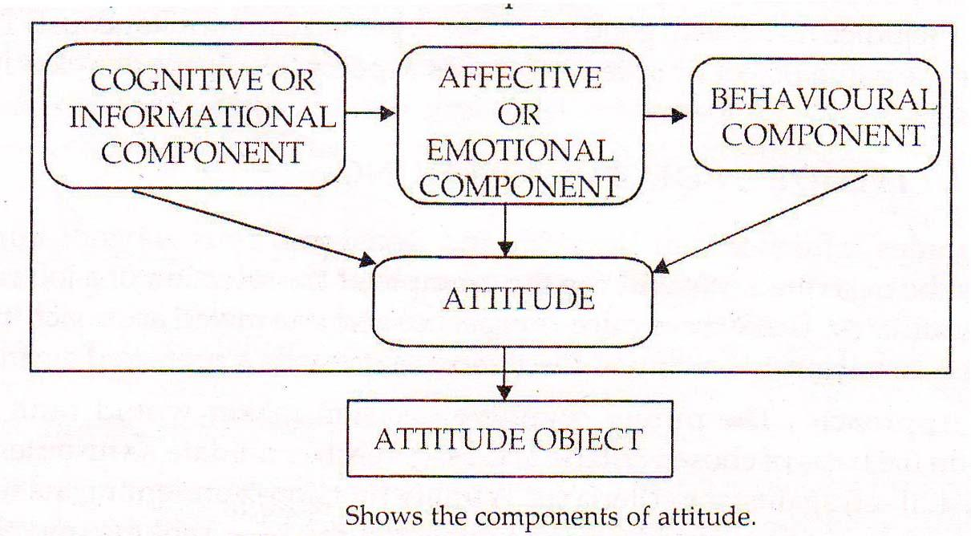

Those components show that an attitude can be considered as a way of thinking, feeling and behaving. For example, if someone has favorable thoughts about his supervisor at the job, her would develop feelings of consideration and respect for him and, as a result, may dislike to associate more frequently with him.

**Features of Characteristics of Attitudes**

The important characteristics of attitudes are as follows:

1. **Attitudes affect Behaviour**. People have the natural tendency to maintain consistency between two attitudes or attitude and behaviour. Attitudes can lead to intended behaviour if there is no external intervention.
2. **Attitudes are Invisible**. Attitudes constitute a psychological phenomenon which cannot be observed directly. However, we may observe an attitude indirectly through observing its consequences.
3. **Attitudes are Acquired**. Attitudes are gradually learnt over a period time. The process of learning attitudes starts right from childhood and continues throughout the life of a person.
4. **Attitudes are Pervasive**. Attitudes are formed in the process socialization and may relate to anything in the world. For example, a person may have positive or negative attitude towards religion, politics, politicians, countries, and so on.
5. **Attitude is effective and behavioural**. Attitudes refer to feelings and beliefs of individuals or group of individuals. The feelings and beliefs are directed towards other people, objects or idea.
6. **Attitude is evaluative**. Attitudes are evaluative statements, either favourable or unfavourable. When a person says he likes or dislikes something somebody, an attitude is being expressed.
7. **Attitude is unconsciously held**. An attitude may be unconsciously held. Most of our attitudes may be about those objects which we are not clearly aware of.

**Sources of attitudes**

1. **Direct Personal Experience**. The quality of a person’s direct experience with the attitude object determines his attitude toward it. For example, if a worker finds his work repetitive, inadequately paid, supervisor too tough, and co-workers not so cooperative, he would develop negative attitude towards his job because the quality of his direct experience with the job is negative.
2. **Association**. A new attitude object may be associated with an old attitude object and the attitude towards the latter may be transferred towards the former.
3. **Social Learning**. Attitudes are also learnt from other as for example, from parents, teachers, superiors, models etc. An individual y learn by having contact with others or even watching models over the T.V. In fact, social learning makes it possible for a person to develop attitude towards something even when he has no direct experience the attitude object.
4. **Institutional Factors**. Religious institutions, social organisations educational institutions, etc. also help in shaping the attitudes of people.
5. **Mass Media**. Attitudes are generally less stable as compared to value. Advertising message, for example, attempts to alter the attitude of the people toward a certain product over. Similarly social messages on TV and in newspapers can have mass appeal among the people.
6. **Economic Status and Occupations**. Our economic and occupational positions so contribute to attitude formation. They determine, in part, our attitudes towards unions and management and our belief that certain laws are “good” or “bad” .

**Formation of Attitudes**

The above mentioned source are the important ways in which attitudes are learnt. But what type of attitudes will ultimately develop is dependent on the following factors:

1. **Psychological Factors**. The psychological make-up of a person is made up of his perceptions, idea, beliefs, value, information, etc., It has a crucial role in determining a person’s attitudes.
2. **Family Factors**. During childhood, a person spends a major part of his time in the family. Thus, he learns from the family members who provide him with ready-made attitudes on a variety of issues such as education, work, healthy, religion, politics, economics, etc.
3. **Social Factors**. Societies differ in terms of language, culture, normal, value, beliefs, etc., all of which influence a person attitudes. For example, people in India in general hold different attitude towards communism than people of China.
4. **Organisational Factors**. It should be remembered that a worker spends a major part of his life in the institution in which he works. Thus, organisational factors such as nature of job, factory or office layout, fellow workers, quality of supervision, monetary rewards associated with the job, trade unionism, informal groups, organisation’s policies and practices, play an important role n shaping the job attitudes of a person.
5. **Economic Factors**. A person’s attitude towards a host f issues such as pleasure, work, marriage, working women, etc., is influenced y economic factors such as his economic status in the economic conditions.
6. **Political Factors**. Politics plays a crucial role in the administration of a country. Therefore, political factors such as ideologies of the political stability and the behaviour of he political leaders greatly influence the attitude of the people.

**Functions of attitude**

Katz has suggested that attitudes and motives are inter-linked and, depending on an individual’s motives, attitudes can serve four main functions. These are as under;

1. **Knowledge Function:** One of the major functions of attitude is to provide a frame of reference which form the basis for interpretation and classification of new information. Attitudes provide a knowledge base and framework within which new information can be placed.
2. **Value Expressive Function:** Attitudesare means of expression of values. They enable individuals to indicate to other the value that they hold and thus to express their self-concept and adopt internalize the value of a group.
3. **Adjustment Function:** Attitudes often help people adjust to their work environment. When employees are well treated they are likely to develop a positive attitude towards the management and the organization, otherwise they are likely to develop a negative attitude towards management and the organization. These attitudes help employees adjust to their environment and are a basis for future behavior.
4. **Ego-Defensive Function:** Attitudes may be held in order to protect the ego from an undesirable truth or reality. People often form and maintain certain attitudes to protect their own self images. For example, workers may feel threatened by the employment or advancement of minority or female workers in the organisation.

**Concept of Values**

Value is ever encompassing concepts. Value are tinged with moral flavour, involving an individual’s judgment of what is right, good or desirable. They are at the core of personality of an individual and, therefore, are powerful, though silent, force affecting behaviour. Values are so embedded that they can be inferred from person’s behaviour and their expressed attitudes.

A value is defined a s a “concept of the desirable, an internalized criterion or standard of evaluation a person possesses. Values are defined as global beliefs that guide actions and judgments across a variety of situations. Values represent basic convictions that a specific mode of conduct (or end-state of existence) is personally or socially preferable to an opposite mode of conduct (or end-state of existence)”.

* **Difference between attitudes and values**

|  |  |
| --- | --- |
| **Attitudes** | **Values** |
| 1. Attitudes represent predispositions to respond. | 1. Values represent judgment of what ought to be. This judgment is basic to respond in a given way. |
| 2. Attitudes are derived from personal experiences. | 2. Value are derived from social and cultural mores. |
| 3. An attitude represents several beliefs focused on a specific object or situation. | 3. A value represents single belief that guides actions and judgment across objects and situation. |

**Characteristics of values**

1. Value provides standards of morality.
2. Value is relatively permanent and resistant to change.
3. Values are most central to the core of a person.
4. Value have two attributes-content and intensity. The content attribute stresses that a particular code of conduct is important. The intensity attribute specifies how important that particular code of conduct is.
5. Value transcend specific objects, situations or persons.
6. Value are fewer in number than attitudes.

**Types of Values**

All port and his associates have categorized values into six major types as follows:

1. **Theoretical**: Interest in the discovery of truth through reasoning and systematic thinking.
2. **Economic:**. Interest in usefulness and practicality, including the accumulation of wealth.
3. **Aesthetic**. Interest in beauty, form and artistic harmony.
4. **Social**: Interest in people and human relationships.
5. **Political**: Interest in gaining power and influencing other people.
6. **Religious**: Interest in unity and understanding the cosmos as a whole.

Different people place different importance to the above six value types. In other words, every individual has a system of value ranking from first to sixth. This very important from the point of view of understanding the behaviour of people.

**Sources of Values**

1. **Familial factors**. A significant factor influencing the process of socialization of an individual role of the family. The child rearing practices that parents use shape the individual’s personality. The learning of social behaviour, values and norms come through these practices. For example, through reward and punishment, parents show love and affection to children, indicating the typical ways in which a child should behave in difficult conditions.
2. **Social Factors**. Of the societal factors, school has a major role to play in the development of values. Through discipline in school, a child learns desirable behaviour important in the school setting. Interactions with teachers, classmates and other staff members in the educational institutions makes the child inculcate value important to the teaching-learning process.
3. **Personal Factors**. Personal attributes such as intelligence, ability, appearance and educational level of the person determine his development of values. For example, one’s higher level of intelligence may result in faster understanding of value.

UNIT V

**ORGANISATIONAL DVELOPMENT**

**Organization Development**

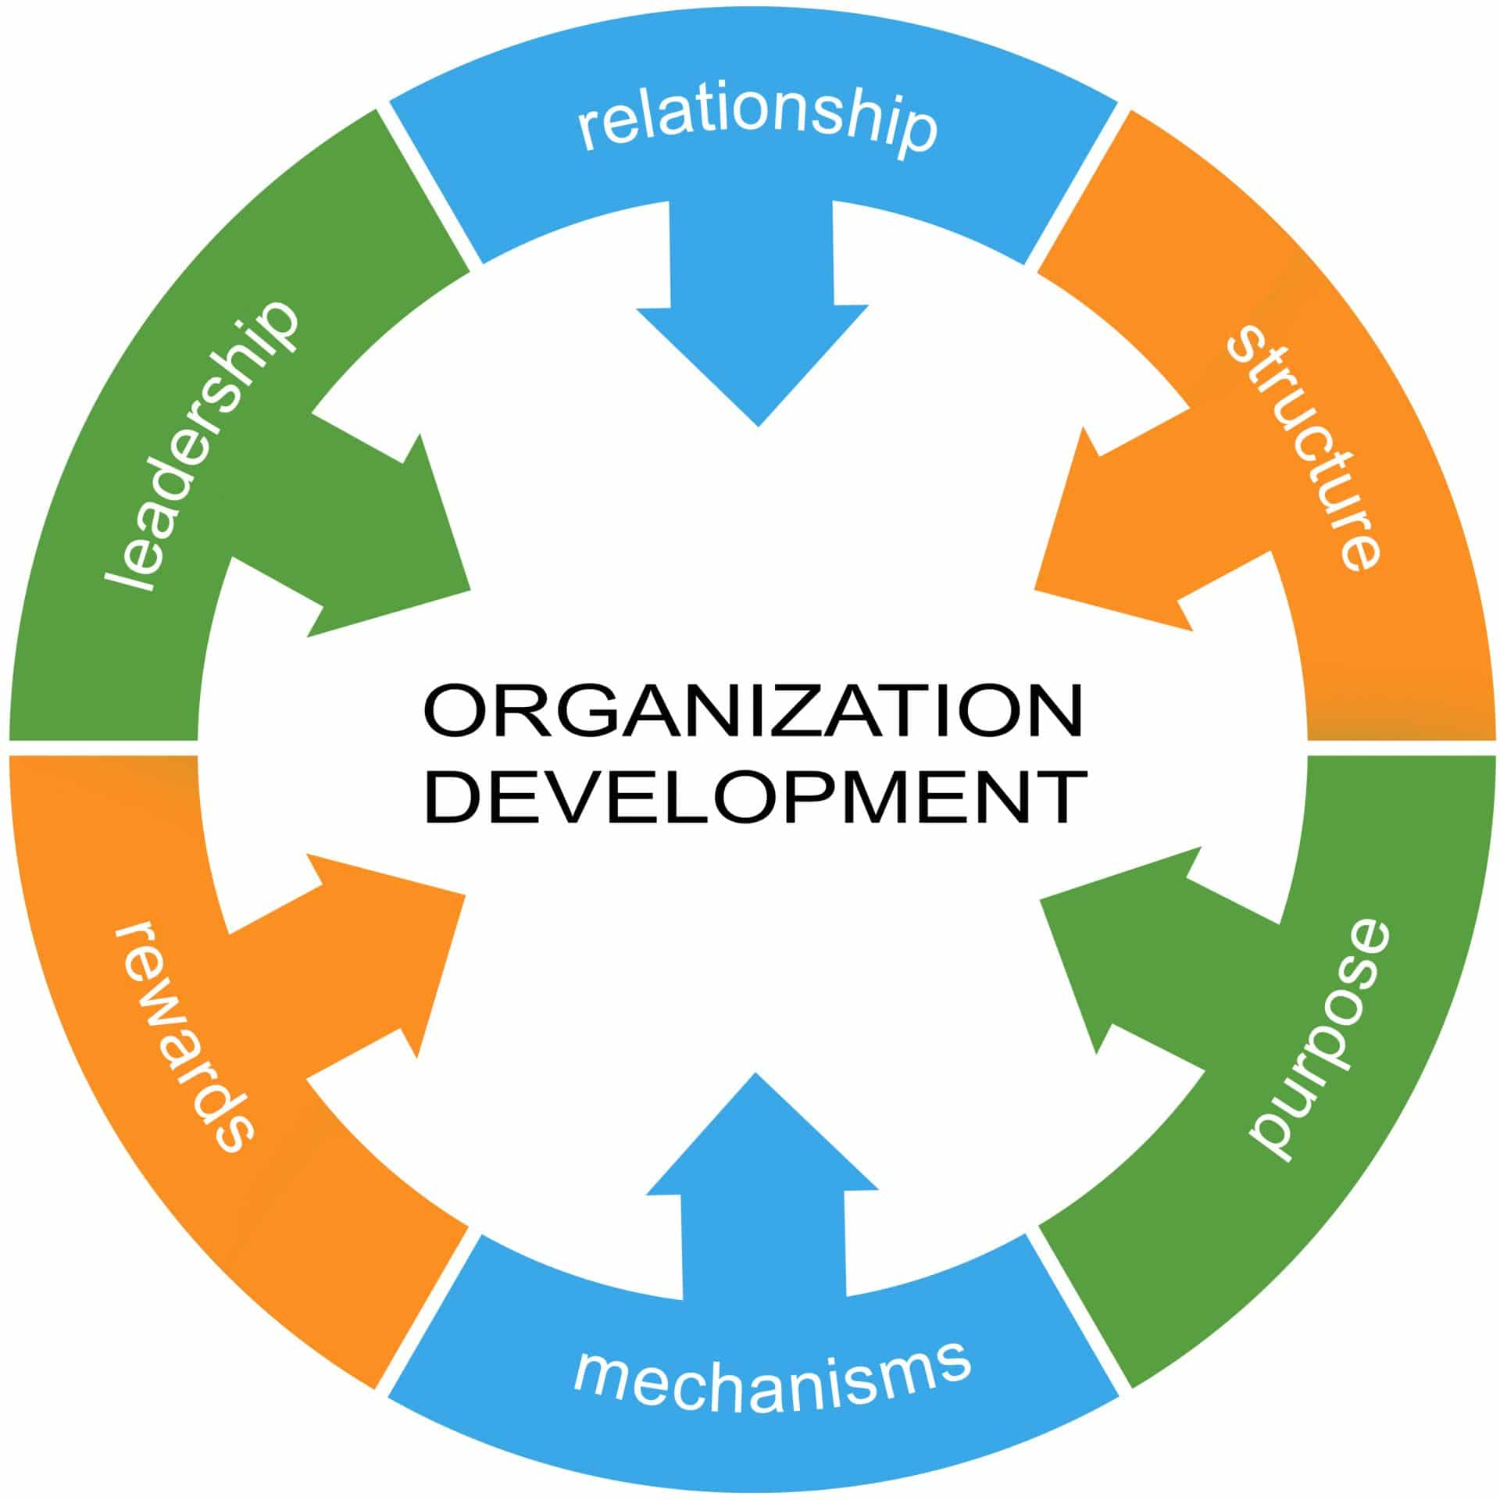

**Introduction**

Organization development (OD) is a planned approach to improve employee and organizational effectiveness by conscious interventions in those processes and structures that have an immediate bearing on the human aspect of the organization. OD is an organization wide planned effort managed from the top, to increase organizational effectiveness and health through planned interventions in the organizational processes, using behavioural science knowledge. In the initial phase of the development of OD, primary focus was on human as well as the process aspect of the organizations with a view to improve trust, communication, teamwork and interpersonal relationship.

**Characteristics of Organization Development**

A number of special characteristics together distinguish organization development from others approaches to managing and improving organizational function.

* **Behavioral science base -** It is primarily concerned with improving the organization by focusing out aspects that have a bearing on human and social improvement. Its principles have been drawn largely from the field of organizational behaviour and social sciences.
* **Normative approach to organizational change -** OD is a normative process grounded in value-laden assumption of what constitutes ideal individual and organizational growth. Development for the OD practitioners means the movement of individuals and organizations in certain directions consistent with democratic and humanistic values and ideals such as autonomy, self-actualization, etc.
* **Deliberate intervention in the organization -** OD implies deliberate intervention in the ongoing processes of an organization. While all the social systems, in the ordinary course of revenue, tend to grow in predictable patterns, they may fail to optimize their capabilities due to an inability to recognize their potential or to anticipate and effectively cope wilt internal and crisis. Development implies planning and action to ensure that growth takes consistent with values.
* **Normative deductive strategy -** It is based on the assumptions that the social norms arc one of the strong reinforces of behaviour. The culture of the organization is affected by those norms and hence, to change the existing organizational culture prevalent norms have to be reduced, modified and replaced by more effective ones. This approach talks about the change in the organization, which looks forward, to a long term improvement through internalization of new norms of behaviour.
* **Systems approach to change -** Leavitt (1972) has viewed an organization as a social system consisting of different subsystems such as task, structure, technology and human resource, interlinked by various processes. Any change in one part or process has implications for other parts or processes relevant to the system. OD techniques are used to change or modify the processes to change the system consequently.
* **Using action research model -** Action research model is a "data based, problem solving model that replicated the steps involved in the scientific method of inquiry". OD, using this model, involves a systematic process of diagnosing organizational problems through data collection and analysis feeding the data back to the organizational client group, discussing the findings, planning collaborative action and implementing proposed solutions.
* **Use of external consultant -** Here, the assumption in OD is that the presence of a qualified behaviour scientist as an external consultant can help the process of OD in the following manner:

The specialized knowledge of that consultant becomes available to the organization.

* The consultant, as a neutral outsider, is likely to face lesser resistance during the process of change.
* He is less likely to have a personal stake in implement of proposed change.

**Process of Organization Development**

A typical OD process can be divided into the following phases:

* **Problem identification:** The first step in OD press involves understanding and identification of the existing and potential problems in the organization. The awareness of the problem includes knowledge of the possible organizational problems of growth, human satisfaction, the usage of human resource and organizational effectiveness.
* **Data collection:** Having understood the exact problem in this phase, the relevant data is collected through personal interviews, observations and questionnaires.
* **Diagnosis:** OD efforts begin with diagnosis of the current situation. Usually, it is not limited to a single problem. Rather a number of factors like attitudes, assumptions, available resources and management practice are taken into account in this phase. According to Rao and Hari Krishna, four steps in organizational can be identified:
  + **Structural analysis**: Determines how the different parts of the organization are functioning in terms of laid down goals.
  + **Process analysis:** Process implies the manner in which events take place in a sequence. It refers to the pattern of decision-making, communication, group dynamics and conflict management patterns within organization to help in the process of attainment of organizational goals.
  + **Function analysis:** This includes strategic variables, performance variables, results, achievements, and final outcomes.
  + **Domain analysis:** Domain refers to the area of the organization for organizational diagnosis.
* **Planning and implementation:** After diagnosing the problem, the next phase of OD, with the OD interventions, involves the planning and implementation part of the change process.
* **Evaluation and feedback:** Any CID activity is incomplete without proper feedback. Feedback is process of relaying evaluations to the client group by means of specific report or interaction.

**OD Interventions or Techniques**

OD intervention refers to an activity that is carried on in an organization with the help of an internal or external OD consultant for achieving a given goal or objective

These interventions are aimed at the social processes occurring within organizations. Some of important interventions are discussed below.

**1) T-groups**

T-groups are designed to provide members with experiential learning about group dynamics, leadership and interpersonal relationships. The basic T-group training or sensitivity training to change the standards, attitudes and behaviour of individuals by 'using psychological techniques and programs. Sensitivity training involves group confession where the individual’s problems become the problems of the group, which in turn tries to find a solution. After critiquing others and being critiqued, doubt is introduced into the mind of each individual as to whose standards are really proper. The objectives of T-group training are:

* Increased understanding, insight and self–awareness about one’s own and others' behaviour and its impact on self and others.
* Better understanding about the group and intergroup process (facilitating and inhibiting group function).
* Increased diagnostic skills.
* Increased ability to transfer learning into action;

**2) Process Consultation**

It has been defined as a set of activities on the part of the consultant that helped the client to perceive, understand and act upon the process of events that occur in the client's environment in order to improve the situation as defined by the client. It deals primarily with five important group processes:

* Communication.
* The functional roles of group members
* The way in which the group solves problems and makes decisions.
* The development and growth of group norms
* The use of leadership and authority.

**3) Third Party interventions**

It focuses on interpersonal or intergroup conflicts. Conflicts can arise from two sources:

* Substantive issues like work methods, pay rates and conditions of employment.
* Interpersonal issues such as differences in personality, task orientations, perceptions among group members, completion over scarce resources.

**4) Team building**

It is an effective approach to develop and nurture a team culture m an organization, which helps the group members to enhance their interpersonal and problem solving skills. It also helps group members to develop a higher level of motivation to carry out the group decisions by overcoming specific problems like apathy, general lack of interest among members, loss of productivity, increasing complaints within the group, contusion about assignments, low participation in meetings, lack of innovation and initiation, increasing complaints front those outside the group about the quality, timeliness, effectiveness of services and products is, etc. This intervention can be used for the following types of teams:

* Groups reporting to the same supervisor, manager/executive.
* Groups involving people with common organizational goals;
* Temporary group formed to perform a specific, onetime task:
* Groups consisting of people whose work roles are interdependent.
* Groups whose members have no formal links in the organization, but whose collective purpose is to achieve task they can achieve as individuals.

**Depending on the types of teams, there are a number of factors that affect the outcome of a specific teambuilding activity:**

* The length of time allocated to the activity.
* The team's willingness to look at the way in which it operates.
* The length of time the team has been working together.
* The permanence of the teams.

**5) Survey feedback:** The intervention provides data and information to the managers. In information on Attitudes of employees about wage level, and structure, hours of work, working conditions and relations are collected and the results are supplied, to the top executive teams. They analyze the data, find out the problem, evaluate the results and develop the means to correct the problems identified. The teams are formed with the employees at all levels in the organization hierarchy i.e., from the rank and file to the top level.

**6) Goal setting and planning:** Each division in an organization sets the goals or formulates the plans for profitability. These goals are sent to the top management which in turn sends them back to the divisions after modification. A set of organization’s goals thus emerge thereafter.

**7) Job enrichment:**

Job enrichment is currently practiced all over the world. It is based on the assumption in order to motivate workers; job itself must provide opportunities for achievement, recognition, responsibility, advancement and growth. The basic idea is to restore the elements of interest that were taken away. In a job enrichment program the worker decides how the job is performed, planned and controlled and makes more decisions concerning the entire process.